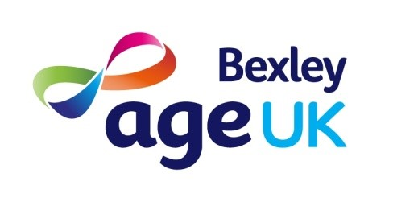
Role Description
Age UK Bexley Trustee and member of the board

Becoming a trustee
The role of trustee in the governance of a charitable organisation is a crucial one. The board oversees the business of the organisation, ensures it adheres to its charity objects and takes responsibility for its financial sustainability
Description of charity
Age UK Bexley is a charity limited by guarantee providing advice, support and services to people over the age of 55 in the London Borough of Bexley.
Our charitable objectives are as follows:
- preventing or relieving the poverty of older people
- advancing education.
- preventing or relieving sickness, disease or suffering in older people (whether emotional, mental or physical)
- promoting equality and diversity
- promoting the human rights of older people in accordance with the Universal Declaration of Human Rights
- assisting older people in need by reason of ill-health, social exclusion or another disadvantage; and
With 25 staff and 55 volunteers we currently operate services that include a range of community support, information and advice.
Turn over last year was circa £700K with a mix of contractual, grant and earned income.
Description of Role
As part of the charity’s drive to diversify the knowledge and membership of its board of trustees we are looking for a range of skills and aptitudes to ensure our organisation stays relevant to the needs of older people in the borough. Trustees will be expected to bring an understanding of and willingness to challenge the issues affecting older people in particular those of social isolation, systemic discrimination, poverty and ill health.
- Trustee(s) will be expected to support other members of the board and the charity's senior managers in shaping the organisations future, restructuring its operations, and developing options for new funding and business development. You will be committed to the values of the charity and its core aims.
- We ask that trustees are willing to challenge barriers to participation and inclusion, particularly where these barriers reflect systemic obstacles based on ethnicity, disability and age.
- Board members are required to attend 6 board meetings a year with occasional events and activities an additional demand. Trustees are a critical part of the organisation’s governance and leadership. They should have a good grasp (or a willingness to learn) of both this charity's and the Charity Commission's oversight obligations and responsibilities.
Building a diverse and dynamic organisation
We recognise that as an organisation embedded in its community, we have to work hard to ensure our staff, volunteers and trustees are representative of the people who live and work in it. The charity has strived to build systems and support that fully embrace diversity and inclusion, we know that there is still some way to go before we get this right.
So, if you have skills, knowledge and abilities that meet the following requirements we want to hear from you:
- Experience and understanding of the issues affecting older people, particularly those from Black Asian and Minority Ethnic Backgrounds.
- An understanding or willingness to learn about charitable governance, financial and operational oversight.
- A commitment to work with other trustees, to value their opinions and the opinions of other in shaping our work and community relationships.
- Bring skills and knowledge related to business development, income generation, human resources and financial governance.
NB: This position is not remunerated but reasonable out of pocket expenses incurred fulfilling the duties of the role are reimbursed.

For more information about Age UK Bexley, please visit our website at Age UK Bexley
For an informal conversation please email Geraldine Powell our current chair here with your phone number.

