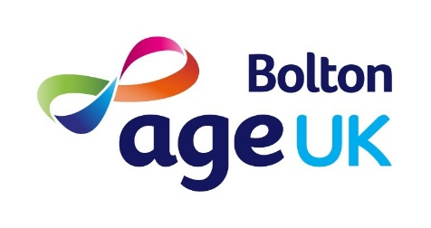

VOLUNTEER APPLICATION FORM

Thank you very much for your interest in volunteering for Age UK Bolton. If you need assistance with completing this form, please email us at volunteering@ageukbolton.org.uk.

All the information you provide on this form is confidential and will not be passed on to a third party. Age UK Bolton complies fully with current Data Protection and Freedom of Information legislation.

PERSONAL DETAILS
Title |  |  |  | Name
Address
Postcode
Telephone No | Home / Work |  |  |  |  | Mobile
Email Address
Date of Birth |  |  | Gender

Volunteer role interested in
Your Availability
Please tell us on what days and times you are likely to be available to volunteer.
Days | Mon | Tues | Weds | Thurs | Fri
AM
PM

How did you find out about our volunteering opportunities?
Poster / Leaflet |  | Do-it website
Volunteer Centre |  | Age UK Bolton website
Talk / Presentation / Event |  | Word of mouth
Other

Please tell us about any work, volunteering, personal experience or skills that you have that are relevant to the role you are interested in.

Do you have any particular needs that we should be aware of so as to best support your volunteering with us?

I confirm that all the information in this application form is true and accurate.
Signature |  | Date

Please return this form, together with the Data Consent form to: volunteering@ageukbolton.org.uk or, Age UK Bolton, The Square, 53-55 Victoria Square, Bolton, BL1 1RZ.

You can change your mind at any time by contacting us on either 01204 382411, by email on volunteering@ageukbolton.org.uk, or in writing to Age UK Bolton, The Square, 53-55 Victoria Square, Bolton, BL1 1RZ. You can find out more information in our privacy notice on our website at www.ageukbolton.org.uk. We can also provide a hard copy upon request, as above.

