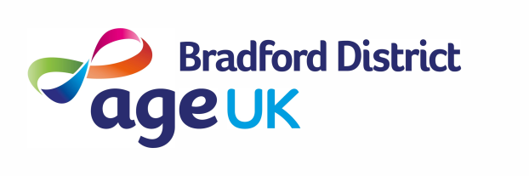
InformationPlus Assistant – Role Description
Focus of the Role
To cover the provision of the InformationPlus phone-line (including emails and web contacts) and InformationPlus Drop-In sessions in the Community Hubs across the District. The role will involve exploring each individual’s situation, ensuring they access and receive the right support to address their needs.

Key Relationships
Age UK Bradford District (AUKBD) staff and volunteer teams, Partners across the VCS and statutory sectors

Key Responsibilities | - To be responsible for the telephone/email/web information service  - To assess each person’s situation and provide the most appropriate response – information, signposting, referring internally or externally (with consent).  - To hold InformationPlus drop-in sessions at our community hubs  - Updating all contacts onto the Charitylog Database  - Deliver information and awareness events  - To be responsible for coordinating the maintenance and development of Information Points  - Working with the hub teams to maintain information points to the required standards, in AUKBD Community Hubs and other locations.  - To support the development of volunteers, in the delivery of basic information provision in the hubs.  - Maintain records, case studies and details of work, including equality, diversity and inclusion data to enable effective reporting and promoting of the scheme and AUKBD’s work  - Ensure compliance with quality standards, legal requirements and the policies and procedures of AUKBD. This will include safeguarding, lone working, health and safety and GDPR requirements.  - Carry out training relevant to the role, attend team meetings and other duties that may from time to time be required to meet the needs of AUKBD.  - Be actively involved with the in the charity’s wider activities such as fundraising and events  - Any other duties commensurate with the role

Experience, Knowledge and Skills
Experience | - Previous customer service experience  - Experience using spreadsheets and databases  - Experience of providing information | Desirable  Desirable  Desirable
Knowledge | - Awareness of the issues facing older people  - Understanding of the Charity sector and volunteering | Essential  Desirable
Skills | - Excellent verbal communication skills  - Excellent organisational skills  - Proficient computer skills in MS Office (Word, Excel, Outlook, Teams)  - Ability to work on own initiative  - A positive energy and the ability to find solutions  - A commitment to the values and vision of AUKBD and to equality, diversity and inclusion  - Driving License | Essential  Essential  Essential  Essential  Essential  Essential  Desirable

Age UK Bradford District – Vision, Mission & Values
Vision | Valuing everyone’s future, developing age friendly communities and putting people first.
Mission | We will enable, empower, and support people to live well as active, engaged and influential members of their communities. We will work to ensure that everyone’s contribution is valued and that individuals and their communities provide mutual support which promotes independence, inclusion, choice and control.
Values | Person Centred, Inclusive, Empowering, Connected, Authentic

