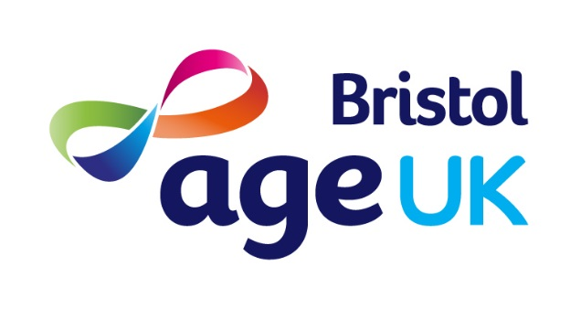

**You can donate any amount you want. Whether its £5, £50 or £500 everything raised will go straight to Age UK Bristol to help tackle loneliness and isolation within the older community of Bristol.**

**I would like you to come to my …………………………….. to help raise money for   
Age UK Bristol #TheBigEat**

**Date:**

**Time:**

**Place:**