Calendar and Card Order Form
It is now possible to order copies of our calendar 2023 and greetings cards of some of the images. All images have been created by our Art on Zoom group; a group of amateur artists, all aged 50+, who come together to enjoy being creative. The original paintings are on display at our exhibition at John Wesley’s New Room café, The Horsefair, Bristol BS1.
The images below show the picture for each month. It is indicated on the right if the image is available as a greeting card. Cards are blank inside. All cards come with an envelope and are wrapped in cellophane.
Cards cost £2.50 each, or 5 cards for £10. Calendars cost £7 each.
 |  |  | Price  each | Quantity ordered
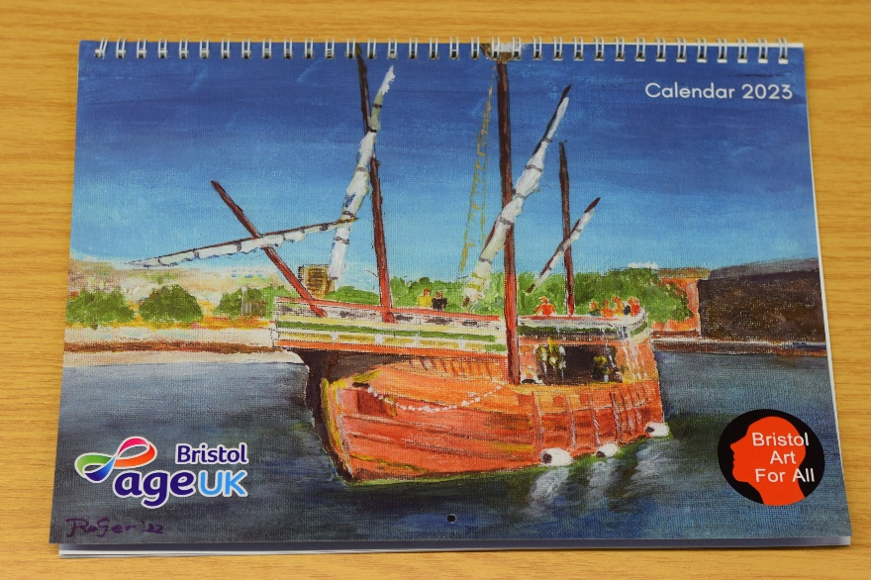  Calendar. A4 closed, A3 open. |  |  | £7.00
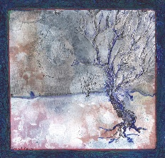 |  | Tree  (January) | Not available as a card.
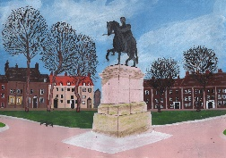 |  | Queen Square (February) | Not available as a card.
 |  | Clifton Suspension Bridge (March) | £2.50
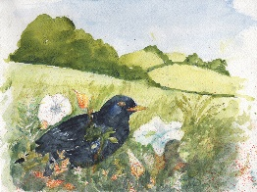 | Blackbird  (April) |  | £2.50
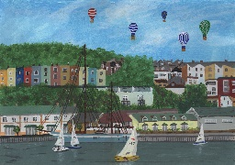 | Bristol Harbour  (May) |  | £2.50
 | Bristol  (June) |  | £2.50
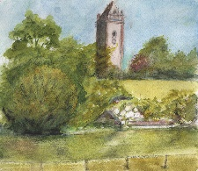 | Cabot Tower  (July) |  | Not available as a card.
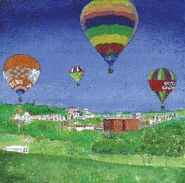 | Balloons over Ashton Court (August) |  | Not available as a card.
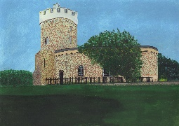 | Clifton Observatory (September) |  | Not available as a card.
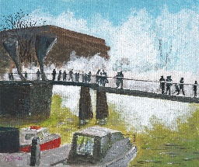 | Pero’s Bridge  (October) |  | Not available as a card.
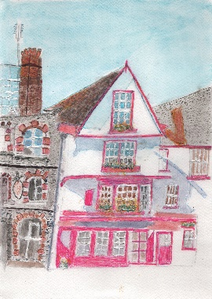 | Old Bristol Building (November) |  | Not available as a card.
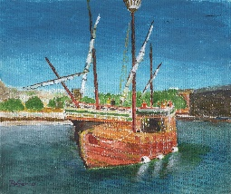 | John Cabot’s Matthew (December) |  | £2.50
Total price:

To Order;
- Return order form to Jo Stokes at jostokes@ageukbristol.org.uk or post to Age UK Bristol, Canningford House, 38 Victoria St, Bristol, BS1 6BY.
- Jo will contact you for payment.
- Your order will then be posted out.
Payment can be made the following ways:
  - Bank transfer:
Age UK Bristol Reg Charity 1042548
Sort Code: 08 90 02
Acc No: 65021053
Reference: ‘surname’/cards.

  - Card payment over phone – Jo can take payment over the phone if that is preferable. Tel number 07754 124 479.
  - Cheque – Made payable to Age UK Bristol.
Post to Canningford House, 38 Victoria St, Bristol, BS1 6BY.
Ensure your name and contact details are enclosed and what you are paying for.
Your name:

Your address:

Tel number:

