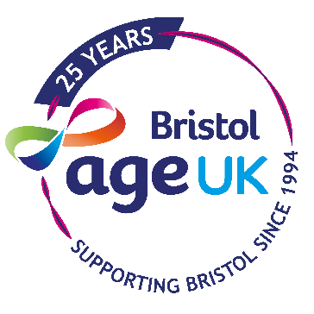
Tai Chi Shibashi Instructor Training Application Form
Firstly, thank you for your interest in training in Tai Chi Shibashi. We are offering this training for free in partnership with Tai Chi for Better Health, because we want more people over 50 to have access to this form of Tai Chi. By undertaking this training, you can help us bring Tai Chi to more communities in Bristol to help support people’s health and wellbeing.
We are looking for people from all walks of life and stages of life, all you need is a commitment to train and practice and to take what you have learnt to others. We know it can be intimidating to imagine leading a class, but we will support you to gain the skills and confidence to share what you have learnt - even if you start with family and friends.
Please note, we look for a minimum commitment of one year for anyone taking up this training to take it into their communities free of charge or at affordable rates.
Please be sure you can attend the 2 training days:
Saturday 16th May 9am - 5pm
Saturday 6th June 9am - 5pm
In the 3 weeks between these training days, you will be expected to practice the form daily at home and attend at least 2 classes with a Tai Chi Shibashi Instructor. (You will be given a list of classes in Bristol which are either free or affordable, and Age UK Bristol will hold a weekly lunchtime session at their offices in the city centre.)
You will be given a download and written instructions to help you practice the form and opportunities to practice with other trainees.
As a part of the training, you will be asked to do a short piece of written work. Please do not be put off by this – you will be signposted to all the information you need and there will be help and support available.
If you have any general questions or queries about the process or training, please Clare Mitchell on claremitchell@ageukbristol.org.uk or on 0117 440 4301. If you would like to learn more about this form of Tai Chi - Shibashi please see https://www.taichiforbetterhealth.co/
Tai Chi is now sited by the NHS for improving balance and co-ordination in older adults https://www.nhs.uk/Livewell/fitness/Documents/older-adults-65-years.pdf
Application deadline: Friday 10th April 2020
Tai Chi Shibashi Instructor Training Application Form

Name:
Email:
Telephone:
Address:
Are you over 50? Yes, I’m over 50.
No, I’m not over 50.
(Please note, we are prioritising applicants that are over 50, we will still consider applicants under 50, especially those active in their communities.)

Do you have experience working with or participating in groups aimed at over 50s?

If successful, do you have any contacts or involvement in your community where you could offer Tai Chi Shibashi as a qualified instructor? Please give any details or ideas you might have:

Do you work for the NHS? No, I don’t work for the NHS.
Yes, I work for the NHS and would like to incorporate this form of Tai Chi into my work with older adults.

Do you have any other comments or questions? Please let us know!

