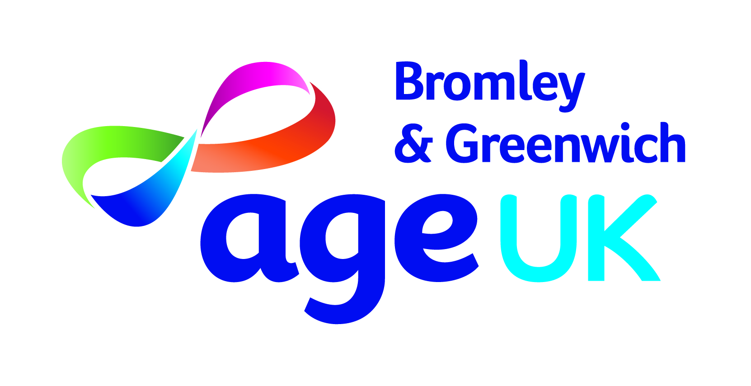
:
What’s on for over 50s in Greenwich
SEPTEMBER – OCTOBER 2026
As a local charity we welcome £1 donation for each of our physical activities, & groups
Booking is essential

Weekly activities for Over 50s in Greenwich, including social clubs, gentle seated movement & exercise, refreshments & guest speakers.

MONDAY | Venue
Yoga & Social Club  10.30am – 12 mid-day  Our weekly session is suitable for all fitness levels followed by social time, tea, coffee and guest speakers | Eltham Park Methodist Church, Westmount Road, Eltham, SE9 1XX
Over 50s Nepali Women’s Seated Yoga & Social Club  12:30pm – 3.30pm  नेपाली महिला क्लब (५०+) •बसेर गर्ने  योग भोजन • कुराकानी • अतिथि वक्ताहरू | Bostall Pavillion, Viola Avenue, Abbey Wood, SE2 0TQ
TUESDAY
Seated Yoga & Social Club  10.30am – 12 mid-day  Our weekly session is suitable for all fitness levels followed by social time, tea, coffee and guest speakers | Woolwich Common Community Centre, 17 Leslie Smith Square, London SE18 4DW
Senior Coffee Social Club  2.00pm – 3.30pm  Social time, tea, coffee and guest speakers. | Eltham Park Methodist Church, Westmount Road, Eltham, SE9 1XX
WEDNESDAY
Seated Pilates & Social Club  12.30pm – 3.00pm  Gentle seated exercise, social time, tea, coffee and guest speakers. | Bostall Pavillion, Viola Avenue, Abbey Wood, SE2 0TQ
THURSDAY
Over 50s Nepali Women’s Fun Dance & Social Club  12.00pm – 3.30pm  रमाइलो नृत्य• भोजन • कुराकानी • अतिथि वक्ताहरू | Slade Community Hall, Pendrell Street, Plumstead Common, SE18 2PQ
For more information or to book a place, please contact:

Greenwich Befriending: Andrea Redwood, 07398130796, Monday to Friday, or email hwbdgreenwich@ageukbandg.org.uk

Nepali Older Women’s Group: Amrit Gurung, 07931253052, Monday to Thursday, or email nepalesegroup@ageukbandg.org.uk

