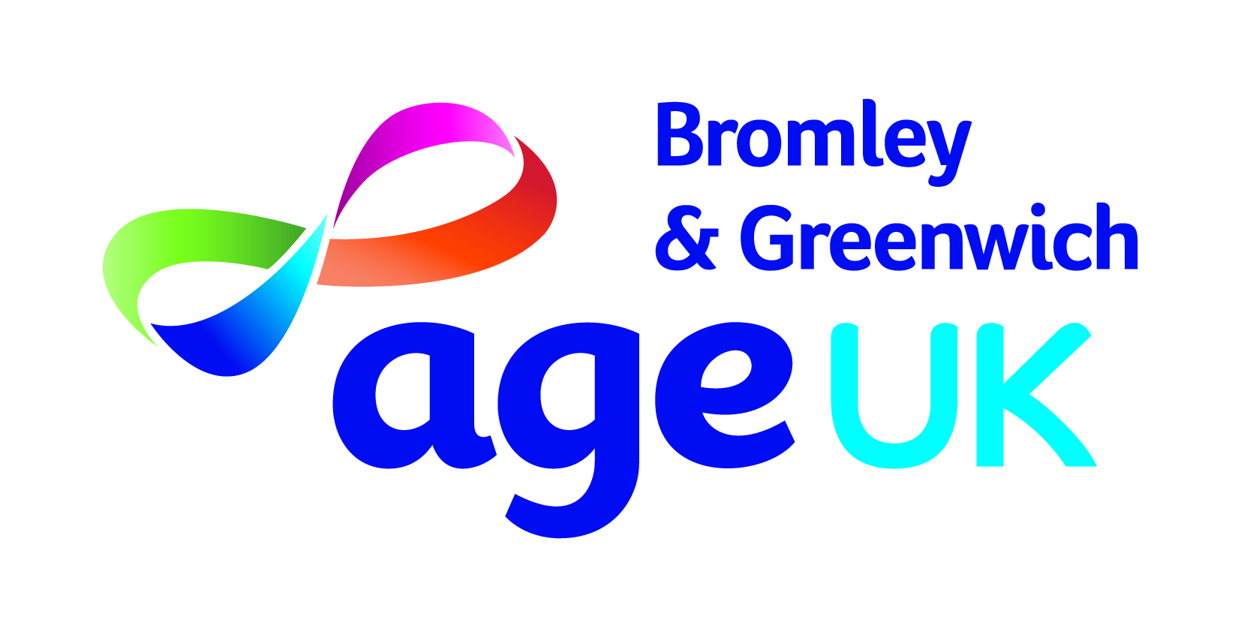

Job pack
Carers Support Advisor

April 2022

Dear Applicant

Re: Carers Support Advisor

Thank you for your enquiry in response to our advertisement for the above position. I have pleasure in enclosing the following:
- Job description and Person Specification
- Background information about Age UK Bromley & Greenwich
- Application form
- Equal opportunities monitoring form

I look forward to receiving your completed application form no later than midnight Monday 23 May 2022. If you have not heard from us by Thursday 26th May then you can assume that on this occasion you have not been successful.

Interviews will be held on week beginning Monday 30 May 2022. Candidates shortlisted for an interview will be contacted by email and or telephone so please include an email address and mobile telephone number or any other telephone number where you can be reached.

Thank you for your interest in this role.

Yours sincerely

Mark Ellison
Chief Executive

Job Description
Job Title: | Carers Support Advisors (Adults)  1 post at 18.75 hours per week
Reporting to: | Adult Carer Services Co-ordinator
Job purpose:
To provide emotional and practical support to Adult Carers in the London Borough of Bromley, aligned and working closely with the integrated care networks.
Key work areas and tasks:
- To offer emotional and practical support to build resilience for carers on a one-to-one basis.
- To provide support face to face, over the phone and in group settings.
- To develop and run local support groups.
- To actively target those carers facing multiple issues, most likely to fall into crisis
- To support carers to access and where appropriate complete Carer’s Assessments
- To build and maintain a network of contacts with local service providers
- To organise and participate in carers drop in and advice activities around the borough
- To organise and participate in training events for carers and professionals.
- To organise and participate in events for carers and or to raise awareness of carers needs, such as but not limited to Carers Week and Carers Rights Day.
- To run an active caseload within the KPI requirements of the PSIS contract.
- To input cases on to the Charity log system accurately
- To ensure that services are accessible to carers
- To participate in the provision of news and the production of the Carers newsletter
- To collaborate with other Bromley Well partners, including Mencap/MIND etc. to ensure effective appropriate referral pathways for quality service provision.
- To abide by and take part in the development and review of policy and procedures for the Carers pathway.
Other tasks and requirements
- At all times to maintain the professional integrity and reputation of the Charity and represent their main interests in any dealings with other bodies, groups and individuals.
- To attend monthly supervision meetings with the Services Manager.
- To undertake any other duties commensurate with the purpose and remit of the post.
This job description is intended as a summary of the main elements of the job described. They may be varied from time to time in consultation with the job holder without changing the general character of the duties or the level of responsibility entailed. Such variations are a common occurrence and cannot of themselves justify a reconsideration of the grading of the post.
Person Specification
Experience | Essential/Desirable
At least three years’ experience within a relevant role and or a minimum of a first level qualification in either social or health care | Essential
Willingness to train as required | Essential
Evidence of having succeeded in a results-orientated environment and with emphasis on high quality, customer focused working | Essential
Experience of working with carers | Desirable
Experience of facilitating groups | Desirable
Experience of Partnership working | Desirable
Abilities and competencies
Excellent verbal and written communication skills | Essential
Excellent listening skills and the ability to provide empathy and understanding of the needs of carers. | Essential
Ability to proficiently use Microsoft IT packages to a competent level | Essential
Ability to quickly and easily assimilate and understand information. | Essential
Able to promote the Age UK Bromley & Greenwich and Bromley Well in a professional manner to a variety of audiences | Essential
Able to work efficiently and effectively with a range of stakeholders forming productive and professional relationships | Essential
Ability to input accurate data to Charity Log CRM or similar | Essential
Other requirements
Empathy with carers, friendly warm disposition with an interest in helping carers meet their needs | Essential
Assertive and calm under pressure | Essential
Confident, clear, concise, and articulate use of language in presenting ideas verbally and in writing and speaking to groups | Essential
Prepared to adopt a flexible approach to line management arrangements resulting from organisational development and change | Essential
Ability to demonstrate an understanding and commitment to our values | Essential
To be committed to the principles of diversity | Essential
Full driving license and use of own car | Desirable

TERMS & CONDITIONS OF EMPLOYMENT
Salary | £12,659 pa
Pension | All eligible employees are automatically enrolled into our scheme with The Pensions Trust, contributions are in line with the government’s minimum standards (currently 5% employees and 3% employers).
Hours | 18.75 hours per week
Annual leave | 27 days per annum pro rata (2 days allocated over the Christmas period) plus public holidays.
Based at | The job is based primarily at Community House, South Street, Bromley but will require travelling to other parts of Bromley and working from home. There is no onsite car parking.
Uniform | You will be provided with an ID badge which should be worn at all times during working hours
Smoking | Age UK Bromley & Greenwich has a smokefree policy that applies to all premises and vehicles in keeping with legislation

Disclosure and Barring Service Check
This post is subject to the Rehabilitation of Offenders Act (Exceptions Order) 1975 and as such it will be necessary for a submission for Disclosure to be made to the Disclosure and Barring Service (formerly known as CRB) to check for any previous criminal convictions.
ABOUT AGE UK BROMLEY & GREENWICH
Age UK Bromley & Greenwich is the trading name of Age Concern Bromley a registered charity and company limited by guarantee. Age Concern Bromley was established in 1965 and Age Concern Greenwich merged with it on 30th November 2011.
Age UK Bromley & Greenwich has its main office in Bromley with offices located in Greenwich. It is a partner of the national network of independent Age UK charities each is responsible for their own governance and own income generation. Age UK is the national charity and partner, and all partners share common aims and values and work together for the benefit of all older people.
Age UK Bromley & Greenwich provides a wide variety of services to older people who are 50+ and resident in the London Boroughs of Bromley and Greenwich (direct service users are usually 60+). We provide practical help and advice to older people many of whom are frail or housebound, provide information on issues relating to older people their relatives and or carers such as money matters, housing, health and community care. Age UK Bromley & Greenwich campaigns locally on Age Discrimination and many other issues that impact the lives of older people.

Vision:
To make Bromley and Greenwich places were all can enjoy later life.

Mission:
We will provide quality services for older people in both boroughs
We will work with older people to enable, support and connect.
We will promote independence and well-being.

Values:
Equality: We value diversity and strive to give equality of opportunity. We believe that the organisation and society is enriched by its diversity.
Respect: We respect our staff, volunteers and clients. We believe in their potential and we will help to realise their ambitions.
Creativity: We encourage innovation in the solutions we adopt.

Strategic Aims
- To continue to provide quality services which meet the needs of older people.
- To maximise income and ensure value for money in the provision of services
- We will encourage and support independence and wellbeing for people in their later lives. We will increase access for all sections of the community who would benefit from our support.

Some of the services we provide are commissioned by local authorities and CCG and others by charitable Trusts and we also have paid services for self-funders, and people with personal budgets.
Our present and any future services will comply fully to our approach of how we work with and for older people:

- have a zero tolerance of all forms of abuse
- support people with the same respect and dignity you would want for yourself or a member of your family
- treat each person as an individual by offering personalised service
- enable people to maintain the maximum possible level of independence, choice and control
- listen and support people to express their needs and wants
- respect people’s right to privacy
- ensure people feel able to complain without fear of retribution
- engage with family members and carers as care partners
- assist people to maintain confidence and a positive self-esteem
- act to alleviate peoples’ loneliness and isolation

For further information visit our website:
www.ageukbromleyandgreenwich.org.uk

Age UK works in partnership to deliver Bromley Well, a service commissioned by Bromley Council and the local NHS to help people living in Bromley borough to improve and maintain their health and wellbeing.
Bromley Well launched in October 2017.
Bromley Well services are delivered by Bromley Third Sector Enterprise (BTSE) a charity which brings together leading local voluntary sector organisations with many years of expertise to provide a range of services for local people:
- Age UK Bromley & Greenwich
- Bromley, Lewisham and Greenwich Mind
- Bromley Mencap
- Citizens Advice Bromley.
As Carers Support Advisor you will be employed by and based at Age UK B&G but working closely with colleagues across the borough in the wider Bromley Well team.
You’ll be joining a large, diverse and skilled workforce of both professionals and volunteers working to provide holistic health and wellbeing services to local residents.
Bromley Well includes services which support: older people; young and adult carers; people with learning and physical disabilities; people with long term health conditions and people with mental health issues. We also provide an Information Legal Advice and Guidance Service and support people to find volunteering roles, training and paid employment. All Bromley Well services are available through a single point of access, which has a freephone telephone number and email address.
Please visit https://www.bromleywell.org.uk/ for further information.

