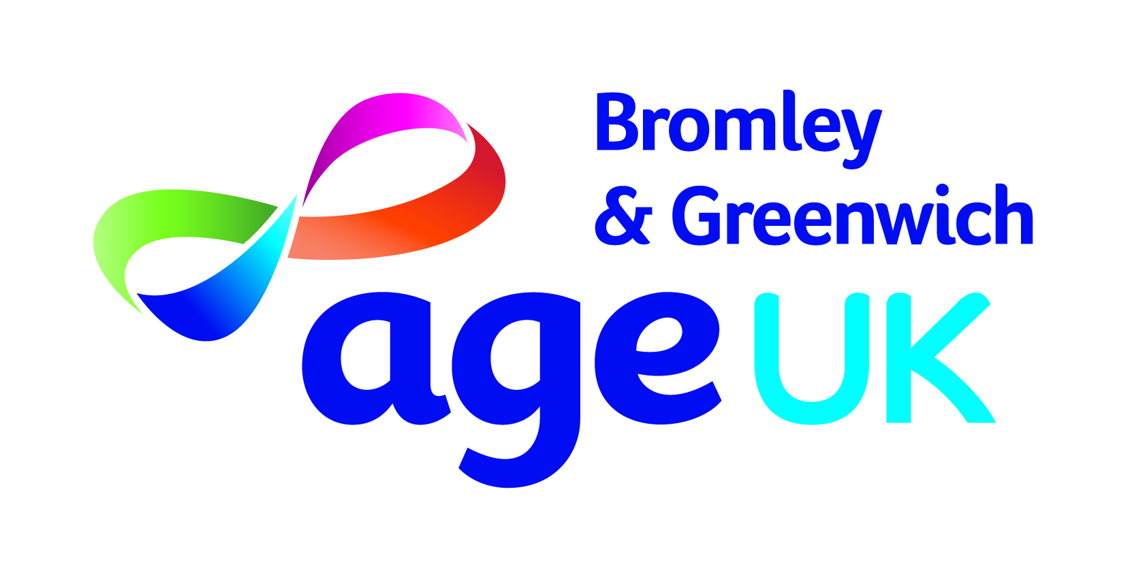

Health & Wellbeing Coordination Officer – Handyperson Service
At Age UK Bromley & Greenwich we are passionate about providing quality services to older people.
The charity is seeking to appoint a Health & Wellbeing Coordinator who will have operational responsibility for our Bromley Well Handyperson Service. The Handyperson Service supports older people in Bromley being discharged from hospital or those already in the community by installing equipment such as; key safes, grab rails and stair rails to promote independence and safety.
You will be able to demonstrate:
- Excellent customer care skills, understanding and empathy towards older people and the ability to deal with vulnerable callers
- Experience of handling a high volume of telephone calls in a customer-focused environment, providing information and guidance, preferably within an advice giving organisation
- Ability to organise and prioritise competing demands often with time pressures
- Excellent communication skills and the ability to problem solve
- Empathy towards older people, friendly warm disposition with an interest in helping older people meet their needs

Salary: £25,714 per annum
Hours: 37.5 per week
Role type: Hybrid
Closing Date: 10th August 2022
Interviews: Week commencing 15th August 2022

