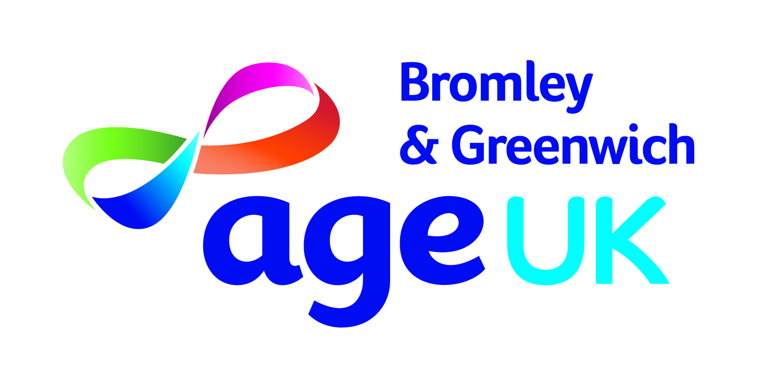
Job Pack
Senior Advisor
(Information & Advice)

August 2022

Dear Applicant

Senior Advisor - Information & Advice

Thank you for your enquiry in response to our advertisement for the above position. I have pleasure in enclosing the following:

- Job description and Person Specification
- Background to the post
- Background information about Age UK Bromley & Greenwich

Candidates shortlisted for an interview will be contacted by email and or telephone so please include an email address and mobile telephone number or any other telephone number where you can be reached.

We only contact applicants who are shortlisted for an interview. Therefore, if you have not heard from us by Wednesday 7th September you should presume that on this occasion your application has not been successful.

I look forward to receiving your completed application form no later than midday on Monday 5th September 2022. The interview will take in person week commencing 12th September 2022.

Thank you for your interest in this role.

Yours sincerely

Mark Ellison
Mark Ellison
Chief Executive

Job Description
Job Title: | Senior Advisor - Information & Advice
Role type | On site
Reporting to: | Information & Advice Manager
Responsible for: | Not applicable

Job Outline
To provide quality assured Information & Advice to older people. The service is primarily office-based (Bromley primarily but may be required on occasion in our office in Eltham) , but may also include outreach or home visits; to provide support to the volunteer I&A Advisors; to provide cover for the I&A Manager and support the I&A Manager in keeping our information resources up to date.

Main Duties and Responsibilities
- To provide information and advice to older people, their careers, relatives and friends. This advice may be in person or by phone, but will be confirmed in writing, by email or telephone. There may also be occasional home visits.
- To have an in-depth rights based knowledge of those issues likely to affect older people, for example but not limited to Lasting Power of Attorney, succession, health and care provision and housing as well as paying for care
- To respond promptly, proactively and effectively to a wide range of enquiries from the public
- To be responsible for the provision of up-to-date benefit information and undertaking of benefits checks supporting older people in benefits claims and appeals
- To undertake casework.
- To be responsible for the recording, collation and monitoring of all relevant information relating to clients accessing our services and the milestones, outcomes and outputs of the service
- To be responsible for inputting client records onto the organization’s case management system and running reports
- To arrange and participate in stakeholder and other events throughout the Borough
- To work closely with other members of the I&A team and partner agencies in respect to correspondence, telephone conversations and enquiries
- In the absence of the I&A Manager to provide support to the staff and volunteer I&A Advisors, ensuring they are briefed and updated before each of their sessions begins and that there is always someone available to take enquiries.
- To provide outreach information & advice at venues across the Borough as and when required
- To provide high quality information, ensuring that our policies and procedures are fully complied with, and that we meet the standards required by the Age UK Quality Advice Standard and other external accreditations
- To liaise with and refer clients to the external organisations and services, including the Pension Service and Tax Help for Older People advice sessions
- To undertake accurate case recording according to our policies and procedures
- To support the I&A Manager with the statistics and reports required across both the Boroughs
- To keep up to date with relevant laws, policies and procedures – locally and nationally and participate in training (internal and external)
- To promote the services provided by Age UK Bromley & Greenwich, including our charged-for services, to customers and professionals. This will include attending appropriate outreach events
- To uphold and protect the good reputation of the organisation

General
- To attend monthly supervision meetings with the Information & Advice Manager
- To participate in team and staff meetings as and when required
- To work within and fully comply with the policies and procedures of Age UK Bromley & Greenwich
- At all times to maintain the professional integrity and reputation of the Charity and represent their main interests in any dealings with other bodies, groups and individuals
- To undertake any other duties which may from time to time be required, and to participate in other events as requested by line manager
- To undertake any other duties commensurate with the purpose and remit of the post

All duties and responsibilities must be carried out in line with requirements of Data Protection Act, Equalities Act and with due regard to own and others’ health & safety.

This job description is intended as a summary of the main elements of the job described. They may be varied from time to time in consultation with the job holder without changing the general character of the duties or the level of responsibility entailed. Such variations cannot of themselves justify a reconsideration of the grading of the post.
Information and Advice Specialist Advisor
PERSON SPECIFICATION
Assessment will occur via application and interview

Note to candidates
Any criteria marked (A) will be used for short listing purposes.
You should attempt to describe how you meet these criteria in the ‘General Experience and Further Information’ section of the application form, giving examples where possible. Only candidates who can clearly demonstrate how they meet these criteria will be offered an interview.

 | Essential | Desirable
Experience
Experience of working in an advice setting providing generalist advice | X
Experience of providing advice to older people, their families and carers |  | X
Knowledge and experience of housing, health, social care and welfare benefits | X
Experience of working with and supporting volunteers |  | X
Experience of handling a high volume of telephone calls in a customer-focused environment | X
Skills, knowledge & abilities
In depth knowledge of issues relating to older people | X
Excellent administrative skills, well organised with good time management and a methodical approach to work | X
Ability to organise, prioritise and forward plan work and working under own initiative | X
Ability to provide accurate and appropriate advice in an understandable format | X
Ability to work accurately whilst under pressure | X
Line Management and Team Working
Self-motivated with the ability to work both independently and as part of a team | X
Communication Skills
Excellent oral and written communication skills and ability to communicate effectively with a wide range of people | X
Personal attributes
Empathy and understanding of older people and the issues that impact their lives | X
Commitment to the principles of Equality & Diversity and it’s practical implementation | X
Reliable with good time keeping | X
Information Management and Technology
Ability to proficiently use Microsoft IT packages and customer relationship databases | X
Excellent IT skills and experience using MS office software, databases and work processing applications | X
Travel
Ability to travel across Bromley and Greenwich boroughs | X
Full UK driving license |  | X

TERMS & CONDITIONS OF EMPLOYMENT
Salary | £25,000 - £28,000 per annum DOE
Pension | All eligible employees are automatically enrolled into our scheme with The Pensions Trust. Contributions are in line with the governments’ minimum standard (currently 5% employees and 3% employers).
Hours | 37.5 hours per week  Normal working week is Monday to Friday 9:00 until 17:30 with up to one hour unpaid lunch break.  The nature of the role is such that some flexibility and additional hours may be required from time to time, including some evening or weekend work. Time off in Lieu will be granted for extra hours worked in the evenings or weekends. Overtime payments are not normally made.
Annual leave | 27 days per annum (2 days allocated over the Christmas Period). + 8 public holidays
Based at | The post holder will be primarily based at Community House, Bromley. The post holder will be required to travel and work at other locations throughout both boroughs.
Smoking | Age UK Bromley & Greenwich has a smoke free policy that applies to all premises and vehicles in keeping with legislation

Disclosure and Barring Service Check
This post is subject to the Rehabilitation of Offenders Act (Exceptions Order) 1975 and as such it will be necessary for a submission for Disclosure to be made to the Disclosure and Barring Service (formerly known as CRB) to check for any previous criminal convictions.

BACKGROUND TO THE POST
PRIMARY AND SECONDARY INTERVENTION SERVICES (PSIS)
Age UK Bromley & Greenwich has been commissioned by London Borough of Bromley and Bromley Clinical Commissioning Group to deliver personalised support to Bromley’s older and adult residents.

This is an exciting opportunity to be part of a refreshingly new approach to supporting people who may have needs as a result of having long-term health conditions, age related frailty, learning disabilities, mental health and physical disabilities. This would also include support for carers including younger carers and assisting adults who may be experiencing barriers to employment and training. This innovative project delivers new choices for local people to help them maintain their health and wellbeing as well as their independence.

ABOUT BROMLEY WELL
Age UK works in partnership to deliver Bromley Well, a service commissioned by Bromley Council and the local NHS to help people living in Bromley borough to improve and maintain their health and wellbeing.
Bromley Well launched in October 2017.
Bromley Well services are delivered by Bromley Third Sector Enterprise (BTSE) a charity which brings together leading local voluntary sector organisations with many years of expertise to provide a range of services for local people:
- Age UK Bromley & Greenwich
- Bromley, Lewisham and Greenwich Mind
- Bromley Mencap
- Citizens Advice Bromley.
As a Senior Advisor you will be employed by and based at Age UK B&G but working closely with colleagues across the borough in the wider Bromley Well team.
You’ll be joining a large, diverse and skilled workforce of both professionals and volunteers working to provide holistic health and wellbeing services to local residents.
Bromley Well includes services which support: older people; young and adult carers; people with learning and physical disabilities; people with long term health conditions and people with mental health issues. We also provide an Information Legal Advice and Guidance Service and support people to find volunteering roles, training and paid employment. All Bromley Well services are available through a single point of access, which has a freephone telephone number and email address.
Please visit https://www.bromleywell.org.uk/ for further information.

ABOUT AGE UK BROMLEY & GREENWICH
Age UK Bromley & Greenwich is the trading name of Age Concern Bromley a registered charity and company limited by guarantee. Age Concern Bromley was established in 1965 and Age Concern Greenwich merged with it on 30th November 2011.

Age UK Bromley & Greenwich has its main office in Bromley with two offices located in Greenwich. It is a partner of the national network of independent Age UK charities each is responsible for their own governance and own income generation. Age UK is the national charity and partner and all partners share common aims and values and work together for the benefit of all older people.

Age UK Bromley & Greenwich provides a wide variety of services to older people who are 50+ and resident in the London Boroughs of Bromley and Greenwich (direct service users are usually 60+). We provide practical help and advice to older people many of whom are frail or housebound, provide information on issues relating to older people their relatives and or carers such as money matters, housing, health and community care. Age UK Bromley & Greenwich campaigns locally on Age Discrimination and many other issues that impact the lives of older people.

Vision and Values
Age UK Bromley & Greenwich aims to promote the wellbeing of all older people in the community. We value older people and believe that later life should be a fulfilling and enjoyable experience.

Vision:

To make Bromley and Greenwich places were all can enjoy later life.

Mission:

We will be the provider of choice of quality services for older people in both boroughs
We will work with older people to enable, support and connect.
We will promote independence and well-being.

Values:

Equality: We value diversity and strive to give equality of opportunity. We believe that the organisation and society is enriched by its diversity.

Respect: We respect the life histories of our staff, volunteers and clients. We believe in their potential and we will help to realise their ambitions.

Creativity: We encourage innovation in the solutions we adopt

Age UK Bromley & Greenwich services include:
- Advocacy and Representation – both boroughs
- Specialist Dementia Care / choir - Bromley
- Support Planning – Bromley
- Charity Shops – Orpington and Woolwich
- Care Navigation - Bromley
- Community helpers befriending and support service – both boroughs
- Community Services:
    - Clip It - Toe Nail Cutting – both boroughs
    - Exercise classes – both boroughs
    - Help at Home – Bromley
    - Hospital Aftercare - Bromley
- Day Opportunities – both boroughs
- Dementia Support Hub – Bromley
- Men in Sheds – both boroughs
- Computer & art classes – both boroughs
- Information and Advice – both boroughs: a single telephone number for all information and advice enquiries from people resident in both boroughs, letter and to personal callers, casework and welfare benefit checks. Home visits are made to older people who are frail and unable to visit our office.

For further information about Age UK Bromley & Greenwich visit our website:
www.ageukbromleyandgreenwich.org.uk

