**Teaming with Bromley Well – Here for you if needed!**

We’ve entered a new world since lockdown 2020 and, in an unexpected turn, much of the action takes place in the virtual land of Microsoft Teams!

Like many charities and businesses, Age UK Bromley & Greenwich had continuity plans in place in the event that disaster struck our offices in Community House. But with most of those concentrated along the lines of a fire or flood, the prospect of a global pandemic was barely on our radar.

Thanks to that forward planning, we did at least have a template to use when lockdown began on March 23rd 2020. And after the inevitable techie glitches involving laptops and diverting telephone lines, working from home was quickly established as the new norm for the majority of Age UK Bromley and Greenwich Staff.

This, of course, included the [Bromley Well Long Term Health Conditions](https://www.bromleywell.org.uk/our-services/adults-with-long-term-conditio/) Team. This team provides practical lifestyle support to help Bromley residents look after their own physical health and emotional wellbeing.

Staff then found themselves facing the challenge of how they could continue to support clients who usually attended their free face-to-face workshops and individual support sessions with theLifestyle Support Workers?

The answer that emerged was moving the workshops online using the Microsoft Teams communication platform. Instead of the one-to-one meetings at that time, new and existing clients were being supported by the Lifestyle Support Workersvia telephone calls.

The weekly team meetings have also moved over to Teams - as demonstrated by the photo.

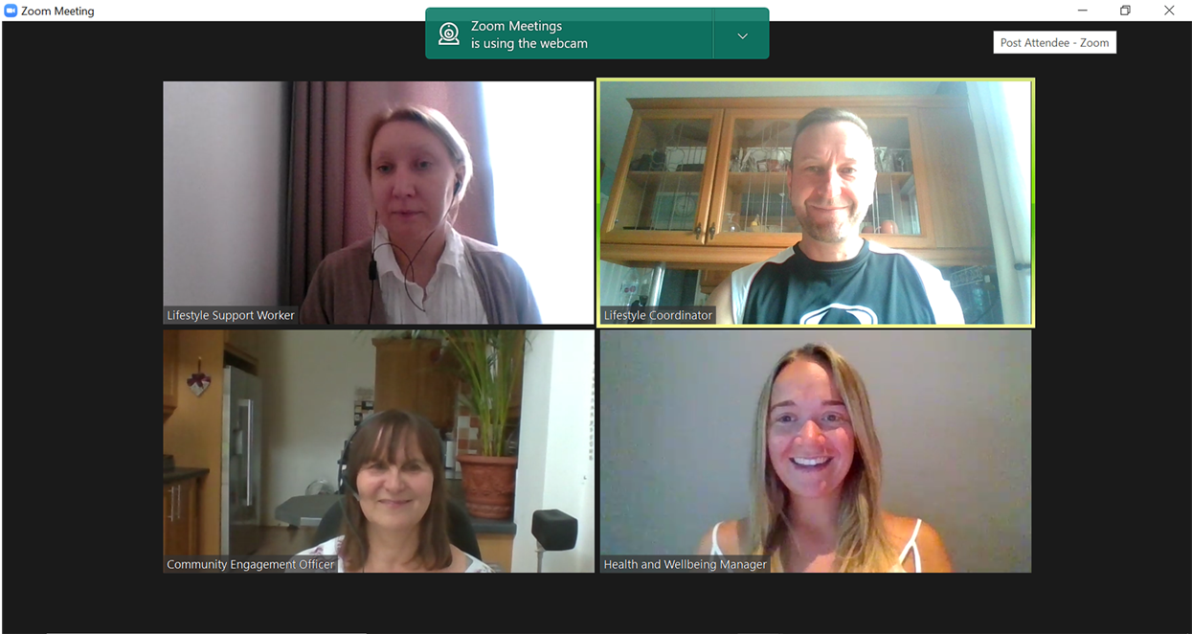

Our oldest new “Microsoft Team users” are in their Nineties, which proves that age need be no barrier to embracing new technology!

To use Microsoft Teams, you just need an email address and either a phone, tablet or computer. Get started by downloading the free Microsoft Teams application or utilising this via any web browser and join us or any of the other online Teams groups. Should you need some help to set up, we will provide you with Microsoft Teams support to help prior to the first workshops.

**We are still accepting new referrals so please call the single point of access on 0808 278 7898 / email** [**spa@bromleywell.org.uk**](mailto:spa@bromleywell.org.uk)

The popular series of Health and Wellbeing workshops for people living with a Long-Term Health Conditions are now also being held virtually as well as face to face, although you will need to register to secure your place:

In addition our Lifestyle Support Workers, facilitate a **Fibromyalgia Support Group** held fortnightly on a Friday 11.00 -12.30.

We feel that our participants are now able to enjoy the same positive engagement or interaction while using Microsoft Teams, which has taken our service into the next evolution using modern technology.

In addition to the above virtual meetings, all the upcoming workshops from the Bromley Well teams can be seen [here](https://www.bromleywell.org.uk/events/) .