**Zooming with Bromley Well – Here for you if needed!**

We’ve entered a new world since lockdown – and, in an unexpected turn, much of the action takes place in the virtual land of Zoom!

Like many charities and businesses, Age UK Bromley & Greenwich had continuity plans in place in the event that disaster struck our offices in Community House. But with most of those concentrated along the lines of a fire or flood, the prospect of a global pandemic was barely on our radar.

Thanks to that forward planning, we did at least have a template to use when lockdown began on March 23rd. And after the inevitable techie glitches involving laptops and diverting telephone lines, working from home was quickly established as the new norm for the majority of Age UK Bromley and Greenwich Staff.

This, of course, included the [Bromley Well Long Term Health Conditions](https://www.bromleywell.org.uk/our-services/adults-with-long-term-conditio/) Team. This team provides practical and emotional support to help Bromley residents look after their own physical and emotional wellbeing.

Staff then found themselves facing the challenge of how they could continue to support clients who usually attended their free face-to-face workshops and individual support sessions with theLifestyle Support Workers?

The answer that emerged was moving the workshops online using the Zoom communication platform. Instead of the one-to-one meetings, new and existing clients are being supported by the Lifestyle Support Workersvia telephone calls.

The weekly team meetings have also moved over to Zoom - as demonstrated by the photo.

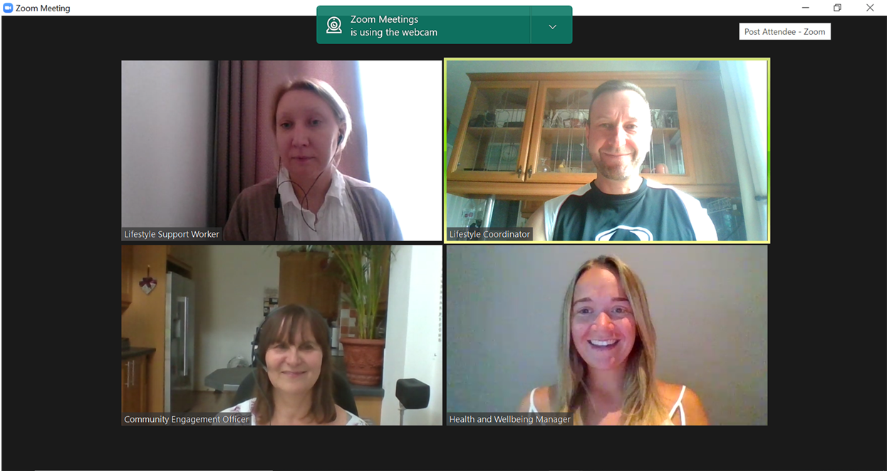

Our oldest new “Zoomers” are in their Nineties, which proves that age need be no barrier to embracing new technology!

To use Zoom, you just need an email address and either a phone, tablet or computer. Get started by downloading the free Zoom application and join us or any of the other online Zoom groups which are also emerging. Should you need some help to set up, we will provide you with a zoom guide to help prior to the first workshops.

**We are still accepting new referrals so please call the single point of access on 0300 3309 039 / email** [**spa@bromleywell.org.uk**](mailto:spa@bromleywell.org.uk)

Or to speak directly to our lifestyle support workers:

Kristina – 07985 444210 or [kristine.pzibilska@bromleywell.org.uk](mailto:kristine.pzibilska@bromleywell.org.uk)

Silvia – 07985 433045 or [silvia.richardson@bromleywell.org.uk](mailto:silvia.richardson@bromleywell.org.uk)

The popular series of Health and Wellbeing workshops for people living with a Long Term Health Conditions are now being held virtually, although you will need to register to sure your place:

[Ensuring Good Medical Care](https://www.bromleywell.org.uk/events/item/44338294) 28th July 11.00 -12.30

[Planning for the Future](https://www.bromleywell.org.uk/events/item/44338298) 4th August 11.00-12.30

Our Lifestyle Coordinator, Dean Baldwin, facilitates a **Fibromyalgia Support Group** held fortnightly on a Friday 11.00 -12.30 [24th July](https://www.bromleywell.org.uk/events/item/44364574) , [7th August](https://www.bromleywell.org.uk/events/item/44364578) and [21st August](https://www.bromleywell.org.uk/events/item/44364582).

Dean feels that our participants are now able to enjoy the same positive engagement or interaction while using Zoom, which has taken our service into the next evolution using modern technology.

In addition to the above virtual meetings, all the upcoming workshops from the Bromley Well teams can be seen [here](https://www.bromleywell.org.uk/events/) .