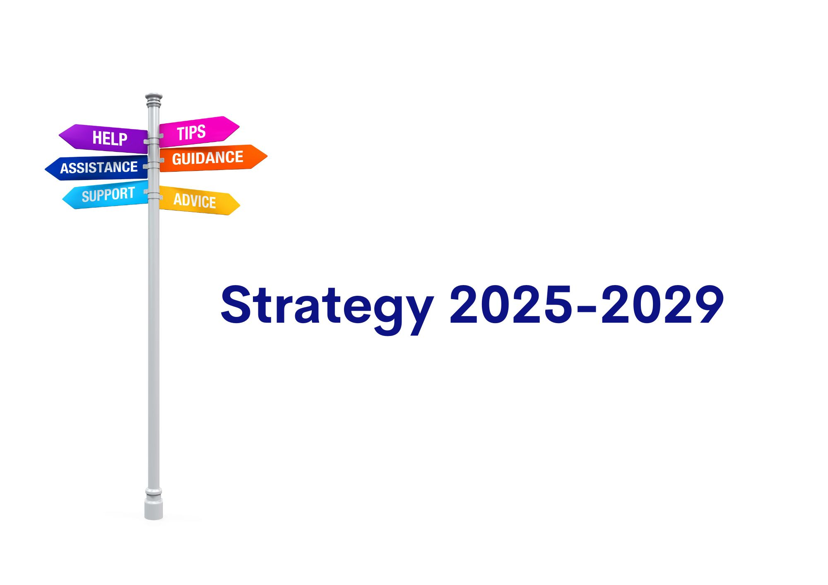

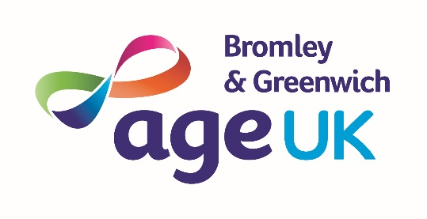

Executive Summery
As our previous strategy ends, the external environment for local charities remains difficult. As we start the new financial year, the increase in national Insurance liability, as well as above inflation increases in London Living wage, has required the organisation to reassess its financial commitments to loss making services; and as such we have had to take some difficult decisions to ensure the continuing financial stability of the organisation.
The funding situation for charities has worsened over the last three years, as local authorities struggle to balance budgets, the same is also true for local health authorities. As funding from these sources form most of the organisational income, this is of concern. We continue have constructive dialogue with funders on how the financial situation may impact our contracts in the medium term, as well as on renewal.

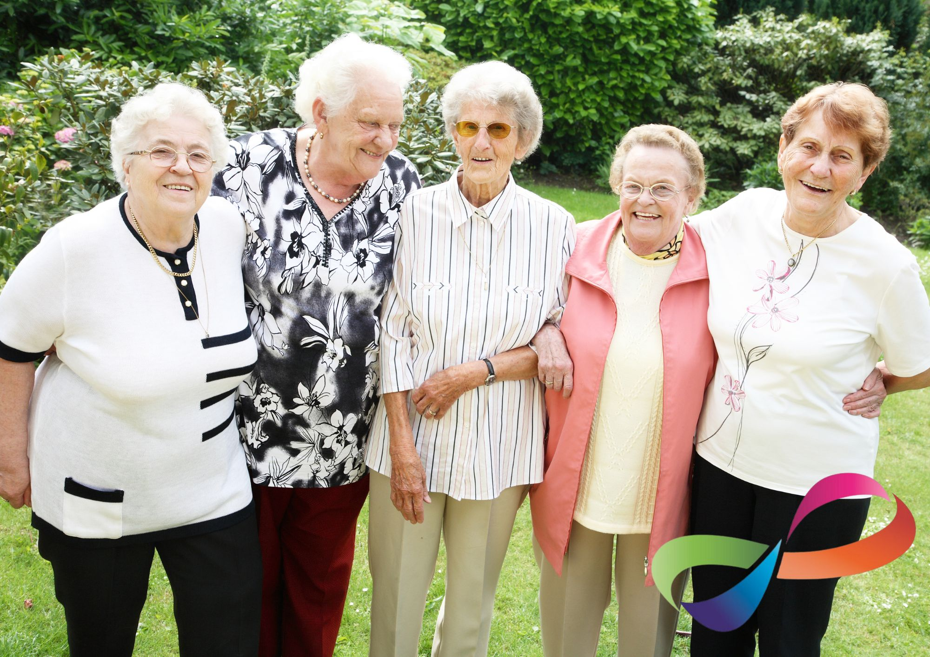

Strategic Review of the previous plan
Aim One of our previous strategy focused on the provision of quality services to older people in both Bromley and Greenwich. We successfully obtained and maintained the Age UK charity quality mark as well as the information and advice quality mark. We were able to increase our service provision in both boroughs with new contracts from local authorities and the Integrated Care Board.
We have further work to do on expanding our digital offer to older people and their families We will continue to work closely with both local authorities on issues relating to digital inclusion. The digital first agenda of both social and health services has profound consequences for older people, and we continue to advocate for a digital first but not a digital only agenda for services accessed by our clients.
Aim Two of our previous strategy was focused on maximising our income and the potential for social enterprise. We completed a review of all our service provision and made the difficult decision to stop funding loss making services from our reserves. As such we closed both our nail clipping service and our men in sheds services.
Limited progress was made on our fundraising strategy which will be brought forward to our new strategic plan.
Aim Three related to increasing voice and representation of older people in both boroughs.
We continue to represent older people on committees relating to health and social services. We have consulted with our users in relation to the service we provide and future provision. Further work is required on ongoing consultation and co-production.

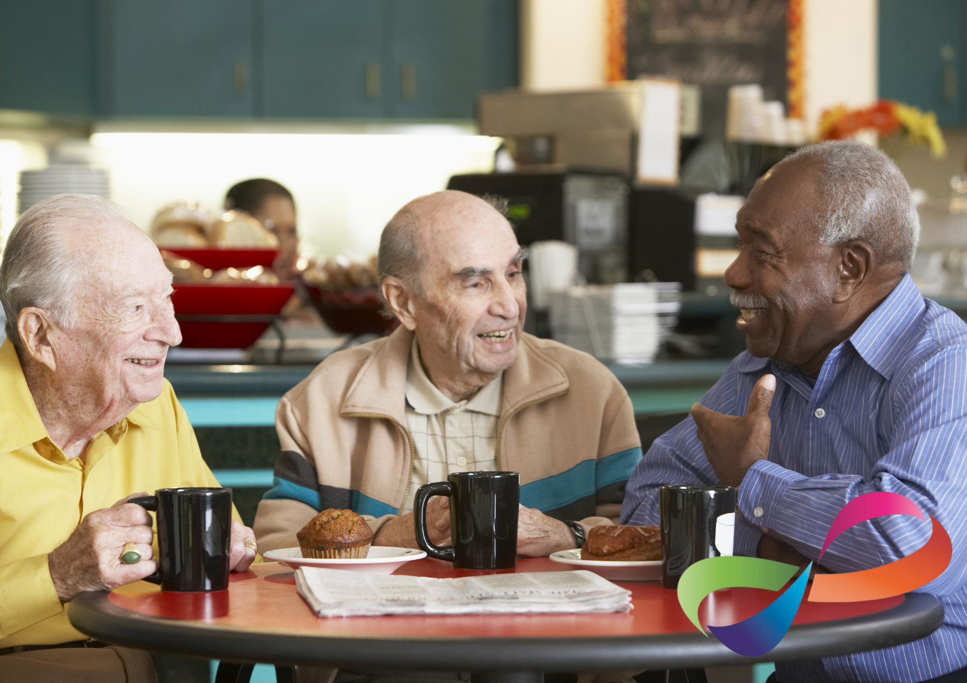

National Context
Over the past four years, the demographic profile of the United Kingdom has continued to reflect an aging population, a trend that has significant implications for the country’s economic, social, and healthcare systems. The Office for National Statistics (ONS) reported that in 2020, 18.5% of the UK population was aged 65 years or older, and this proportion has been steadily increasing.¹ Projections indicate that by 2041, over one in four people in the UK will be aged 65 or older, driven by longer life expectancy and declining birth rates.²
Recent Demographic Changes
Between 2019 and 2023, the proportion of individuals aged 85 and over has also risen significantly, reflecting an increase in longevity. In 2022, the ONS estimated that there were 1.7 million people aged 85 or older in the UK, compared to 1.6 million in 2019.³ This subgroup, often referred to as the "oldest old," is growing at a faster rate than any other age group. Factors such as advancements in healthcare, better living conditions, and healthier lifestyles have contributed to this demographic shift.
Conversely, the working-age population (those aged 16-64) has seen slower growth, and in some regions, a decline. In 2021, the ONS recorded that this group accounted for 62.5% of the population, down from 63.4% in 2011.⁴ This trend raises concerns about the ratio of working-age individuals to retirees, known as the dependency ratio. In 2023, there were approximately three people of working age for every person over 65, a figure projected to decline further in the coming decades.

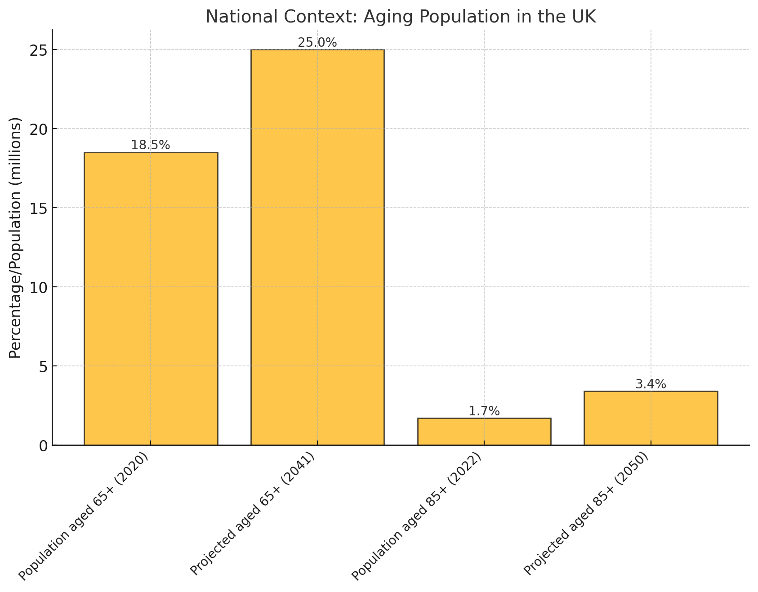

Future Projections
By 2050, it is expected that the number of people aged 85 and over will double to more than 3 million. This shift will result in a significant restructuring of societal demographics. While life expectancy continues to improve, regional disparities in health outcomes are likely to persist, with older individuals in certain areas experiencing higher levels of chronic illness and disability.
Additionally, international migration has had a modest impact on mitigating the aging trend. Migrants tend to be younger and of working age, temporarily boosting the workforce. However, migration alone cannot counterbalance the aging population’s long-term effects.
Implications for the UK
The aging population has profound implications for the UK's healthcare system. Demand for health and social care services is expected to increase substantially. The NHS faces mounting pressure to address age-related conditions such as dementia, arthritis, and cardiovascular diseases.
By 2040, healthcare expenditure related to older adults is projected to rise by 50%, according to the Health Foundation.
Economic challenges are also apparent. An aging workforce may result in labour shortages, reduced economic productivity, and increased public spending on pensions. The state pension age has already been raised to 67, with further increases under consideration to ensure fiscal sustainability.
Socially, the rise in single-person households among older adults could exacerbate loneliness and social isolation. Programms to foster community engagement and support networks will be critical in addressing these issues.



The demographic changes associated with an aging population in the UK present both challenges and opportunities. While the increasing proportion of older individuals underscores the success of advancements in healthcare and quality of life, it also necessitates significant policy adaptations in areas such as healthcare, pensions, and housing. Proactive measures are essential to ensure that the UK can meet the needs of its aging population while maintaining economic and social stability.

¹ Office for National Statistics (ONS), "Population Estimates for the UK, 2020."
² ONS, "Population Projections, 2019."
³ ONS, "Estimates of the Very Old (including Centenarians), UK: 2022."
⁴ ONS, "Labour Market Statistics, 2021."
5 House of Commons Library, "The UK Dependency Ratio, 2023."

London Borough of Bromley: Demographic Trends and Strategic Implications
Population Growth
The London Borough of Bromley has experienced steady population growth. Between 2011 and 2021, the population increased by 6.7%, from 309,400 to 330,000. Projections estimate that this growth will continue, reaching 345,350 by 2027.¹
Aging Population
Bromley has one of the oldest populations in London. In 2021, 17.7% of residents were aged 65 and over. This demographic is expected to grow further, with an estimated 67,400 residents aged 65 and over by 2030.² This increase necessitates strategic planning for age-related services and infrastructure.
Health Considerations
The aging population in Bromley presents significant health challenges. By 2030, it is projected that approximately 16,994 residents aged 65 and over will be living with a limiting long-term illness.³ This trend emphasizes the need for enhanced healthcare services and preventive health programs targeting older adults.
Social Isolation and Health Implications
Social isolation is a growing concern for older residents in Bromley. Prolonged isolation can lead to significant health issues, including depression, anxiety, and an increased risk of chronic illnesses such as cardiovascular disease.⁴ Ensuring that older adults remain socially connected is crucial for their mental and physical well-being.



Royal Borough of Greenwich: Demographic Trends and Strategic Implications
Population Growth
The Royal Borough of Greenwich has experienced rapid growth. Between 2011 and 2021, the population grew by 13.6%, from 254,557 to approximately 289,100. Projections indicate continued growth, with estimates of 305,658 by 2025 and 314,926 by 2030.¹
Aging Population
Greenwich’s population is aging significantly. By 2027, the population aged 75 and over is expected to increase by 25%, reaching approximately 16,200 individuals.²
Health Considerations
The aging population presents challenges in healthcare delivery. Projections suggest increased prevalence of age-related health conditions, requiring expanded healthcare capacity and specialized services for older adults.
Social Isolation and Health Implications
Social isolation is also a pressing issue in Greenwich. Older residents who are isolated are at higher risk of mental health conditions such as depression and anxiety. Social engagement programs can significantly improve health outcomes and quality of life for this demographic. ⁴

¹ Office for National Statistics, 2021
² Greater London Authority, 2023.
³ Age UK Bromley and Greenwich, 2023.
⁴ National Institute on Aging, 2022.

Vision
To make Bromley and Greenwich places where all can enjoy later life.

Mission
Age UK Bromley & Greenwich will listen to and collaborate with older people to ensure that they are fully represented in both boroughs. We will work with older people to enable, support, and connect. We will enable, promote, and respect older peoples' choices, independence, and well-being.

Values
Equality: We value diversity and strive to give equality of opportunity. We believe that the organisation, and society is enriched by its diversity.
Respect: We respect our staff, volunteers, and clients. We believe in their potential and will help them to realise their ambitions.
Creativity: We encourage innovation in the solutions we adopt.

Strategic Aim One
Service Provision: Age UK Bromley & Greenwich will provide services of the highest quality to the residents of the two broughs.
Age UK B&G are committed to providing appropriate, relevant and quality assured services for older people.
The quality of our services will be evidenced by external verification.
Our services are aimed at the over 50’s and whilst some services are open to the under 50’s our focus is on older people. Therefore, our services will:
Be focused on older people who are most in need. Whilst it is difficult to define “Most at need” it is likely to include some of the following demographics:
Older People over the age of 75
Older People with reduced income and people on benefits
Older People who are socially isolated
Older People from the global majority
Older People who have English as a second language
Older People from LGBT+ community
Older People with long term health conditions or who have a disability.

Service Design
In designing services senior managers and trustees will ensure that resources are used to create the biggest impact possible.

In deciding to allocate resources, trustees will need to be reassured that the charities resources are being used in such a way as to positively impact the highest number of beneficiaries as possible. Competing services may be measured against such a criterion in deciding which funding application will be successful.

In service design the organisation will harness all appropriate skills to ensure the longevity and cost effectiveness of services, this will include the development of paid for services.

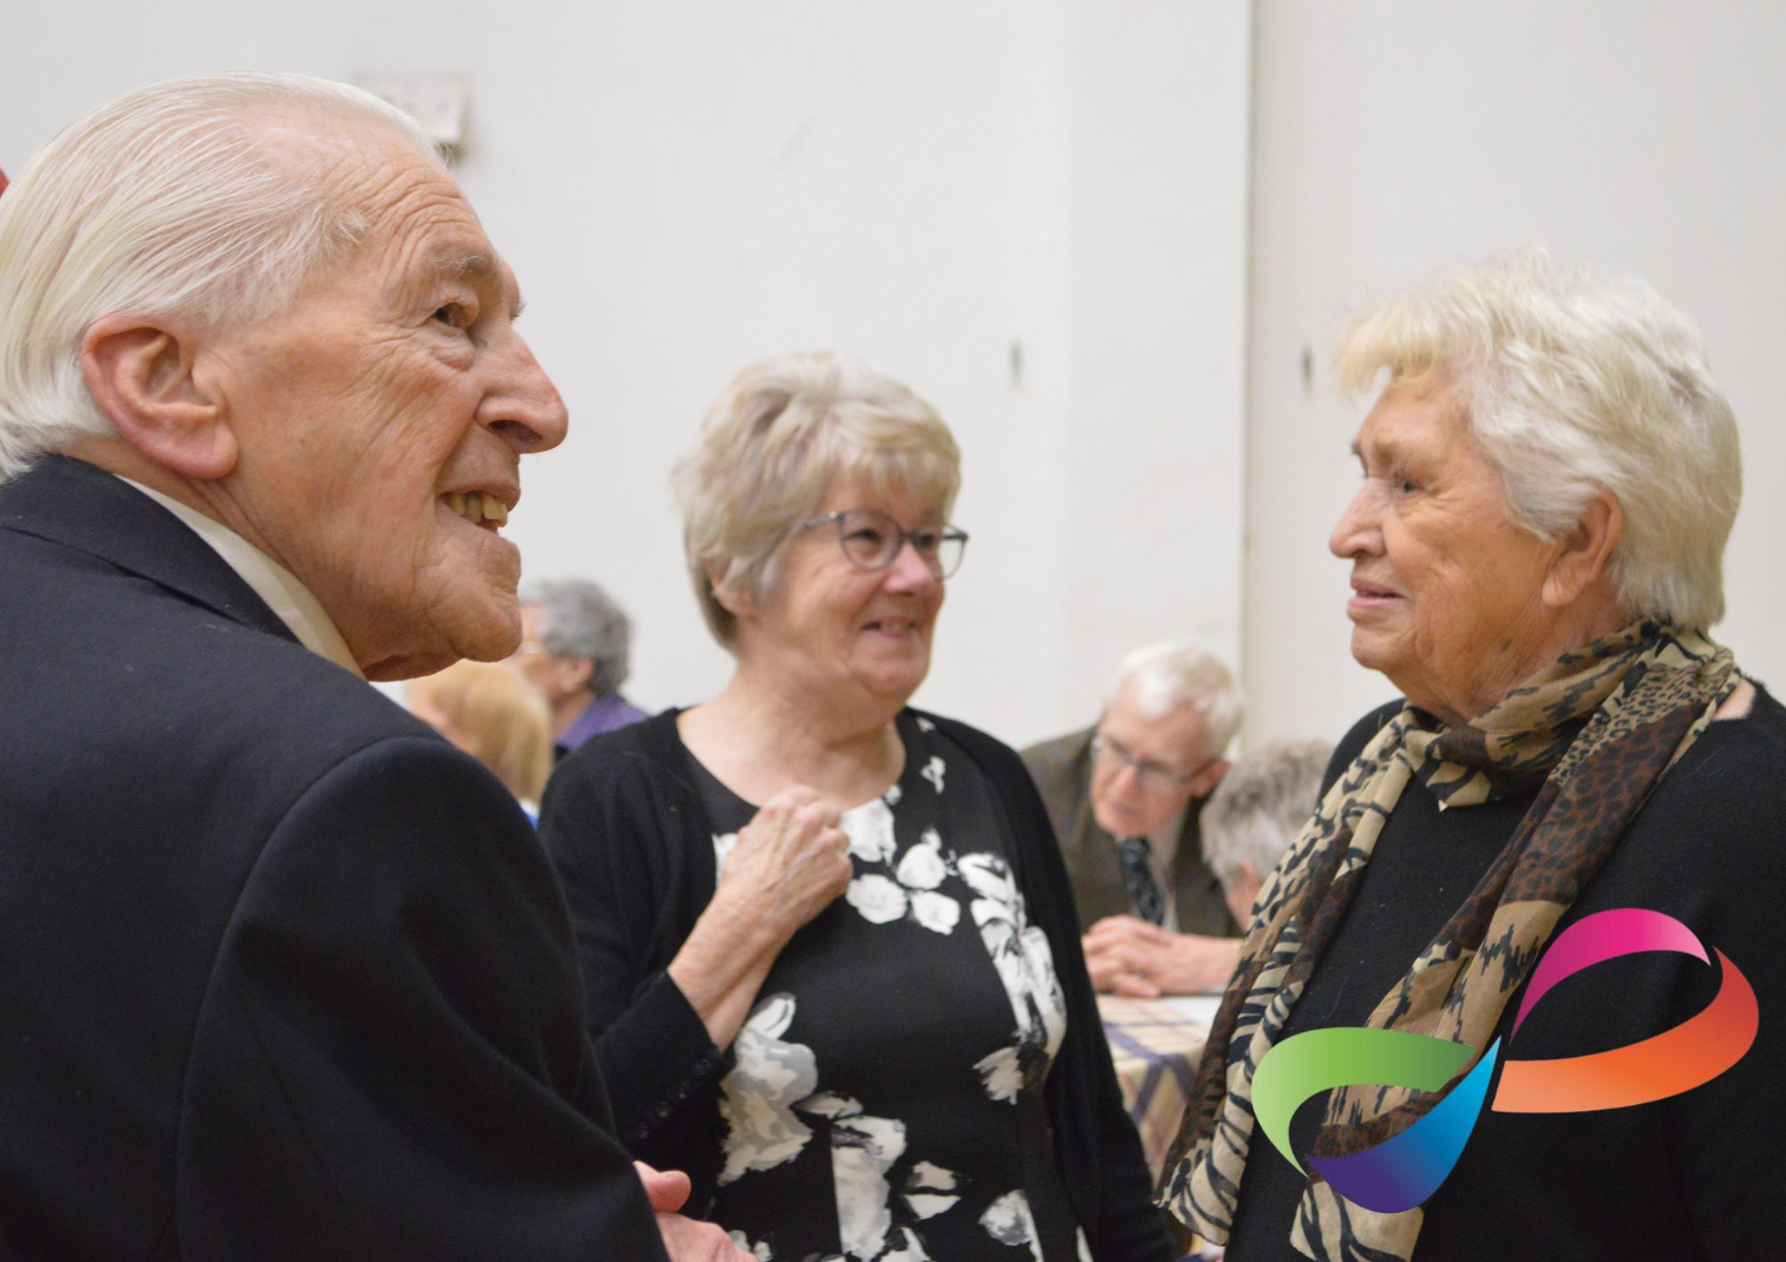

Strategic Aim Two
We will ensure that our income sources are as diverse as possible
We will develop a new fundraising strategy which will be overseen by a subcommittee of the trustee board. The committee will set measurable targets for voluntary income generation.
Legacies
As part of the fundraising strategy the organisation will look at ways to increase the number of legacies left to Age UK B&G. We will continue with promotion to local solicitors and through partnership with Octopus Legacies.

Branding
It is noted that the brand recognition has been impacted by the work undertaken under the Bromley Well contract, and as such we will look to increase the services provided solely by the organisation.
Consultation
We will continue to consult with our beneficiaries to identify the needs of the community.
We will promote the organisation through traditional and social media.
We will ensure that our beneficiaries are representative of the local population.

Costs
We will continue to ensure that costs are kept to a minimum and aim to have a balanced budget within the lifetime of this strategy.
We will continue to work to reduce the deficit in core funding by ensuring that grant and contract funded services are costed on a full cost recovery basis.

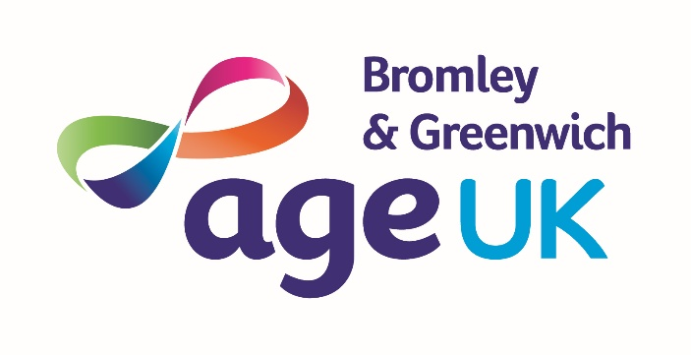

Age UK Bromley & Greenwich, Community House, South Street, Bromley, Kent, BR1 1RH T:020 8315 1850 Fx:020 8315 1851 www.ageukbromleyandgreenwich.org.uk
Age UK Bromley & Greenwich is a trading name of Age Concern Bromley, registered charity no 1060861 and company limited by guarantee registered in England and Wales no. 3304510

