WHAT’S ON FOR GREENWICH RESIDENTS 50 YEARS +
March and April 2026
As a local charity we welcome £1 donation for each of our physical activities, events & groups
Booking is essential

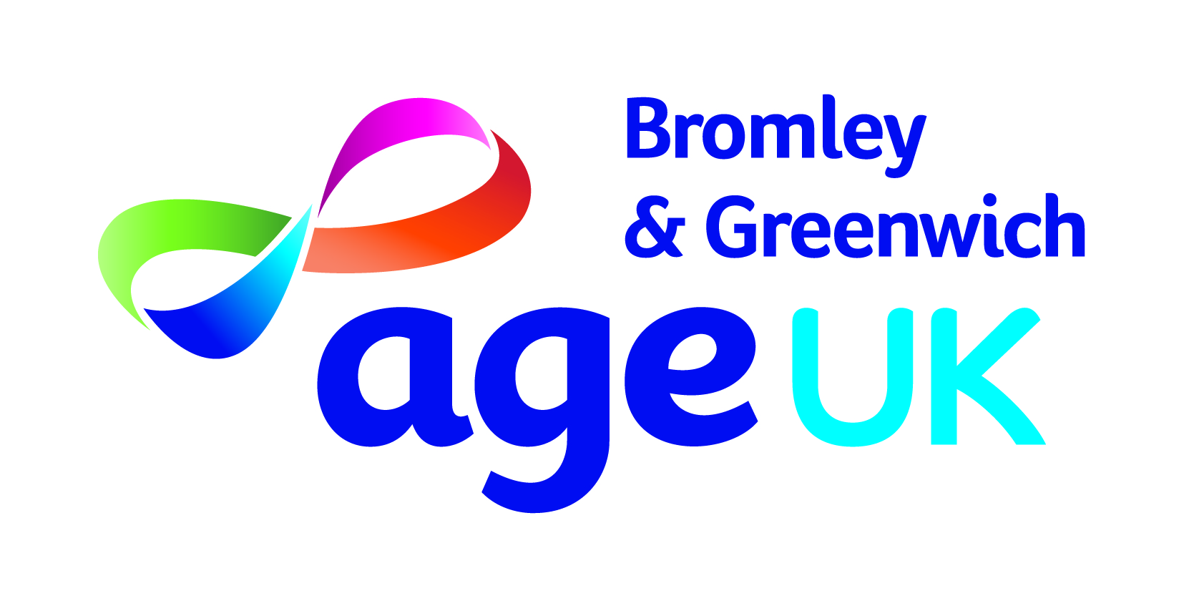
MONDAY
DANCE FOR WELLNESS  10 – 10.50am  Dance for Wellness sessions use dance movement to benefit people with mobility difficulties. | Eltham Park Methodist Church, Westmount Road, Eltham,  SE9 1XX
SENIOR YOGA  11.30am to 12.20pm  Our weekly session is suitable for all fitness levels and is part of our Greenwich Over 50s Feeling Good programme | Eltham Park Methodist Church, Westmount Road, Eltham,  SE9 1XX
MUSIC & MOVEMENT & SOCIAL CLUB  2 – 3.30pm  Chair based gentle exercises to music followed by wonderful company, bottomless tea & coffee,  & guest speakers. | Richard Neve House,  57 Plumstead High Street,  London SE18 1SS
TUESDAY
SENIOR YOGA & SENIOR SOCIAL CLUB  11am – 12.30pm  Our seated yoga is suitable for all fitness levels, it adapts traditional yoga postures to include the chair, offering stability and support. This is part of our Greenwich Over 50s Feeling Good programme  This is followed by our senior social club for wonderful company, bottomless tea & coffee, & guest speakers. | Woolwich Common Community Centre, 17 Leslie Smith Square, London SE18 4DW
SENIOR COFFEE AFTERNOON  2 – 3.30pm  You are invited to our senior coffee afternoon for wonderful company, bottomless tea & coffee, & guest speakers. | Eltham Park Methodist Church, Westmount Road, Eltham,  SE9 1XX
WEDNESDAY
YOGA & SENIOR SOCIAL CLUB  12.30 – 3pm  Our weekly yoga session is suitable for all fitness levels and is part of  our Greenwich Over 50s Feeling Good programme.  This is followed by our senior social club for wonderful company, bottomless tea & coffee, & guest speakers. | Bostall Pavillion, Viola Avenue, Abbey Wood, SE2 0TQ.
THURSDAY
OVER 50s NEPALESE YOGA & SOCIAL CLUB  12 mid-day to 2pm  Our weekly club for Nepalese Greenwich residents 50 years + for a weekly yoga session for all fitness levels, wonderful company, bottomless tea & coffee, & guest speakers. | Slade Community Hall, Pendrell Street, Plumstead Common, SE18 2PQ

In March and April 2026, we have several one-off events. These are open to our clients who regularly attend our weekly social groups and physical activities with priority given to clients who are new, lonely, isolated or from disadvantaged households.

For more information, or to find out how to register with us please contact
Andrea Redwood on 07398130796 Monday to Friday or email hwbdgreenwich@ageukbandg.org.uk

- Please note-
Our service will be closed for 1 week, week beginning 02 March 2026 due to staff leave and the Easter public holidays.

VOLUNTEER WITH US
We have several exciting volunteering opportunities in Greenwich.
These include one-to-one telephone and home visiting befriending, supporting our groups, events and trips out.
For more information, please call 020 83151883 / 07399 202314 or email volunteering@ageukbandg.org.uk

