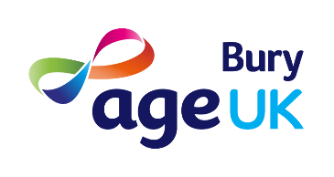
The Big Conversation:
Health and Care in Bury

We are working with partners across Greater Manchester to understand how we can improve health and wellbeing.
Your answers will help to develop the strategic plan for health and care across Greater Manchester.
We have four questions, plus some questions about you. The survey is open till Wednesday 2nd November 2022. Please return the survey to the reception at the Jubilee Centre or email to survey@ageukbury.org.uk
The feedback collated from the survey will help to shape the future vision of how we will work together in partnership.
WIN A £10 VOUCHER! We have ten £10 vouchers that you can spend at either the Jubilee Centre Café or in our Charity Shops at 91, The Rock or at Ramsbottom. Just include your name and contact telephone number below, fill in the questions overleaf and we will include you in the draw.

Please fill in these details if you wish to enter the draw. Your details will be kept by Age UK Bury for the purpose of this draw.
Name
Contact Telephone Number or email address

What would make the biggest difference to your life in relation to being healthier, happier and better?

What’s stopping this?

What would help this?

What’s the most important thing health and care services need to improve?

How old are you? (please circle) 0-17 18 to 49 50-66 67+
Do you experience a disability? Yes / No
Do you care for someone? Yes / No
Are you a veteran? Yes / No

