Age UK Calderdale & Kirklees is searching for new Trustees to join our Board.
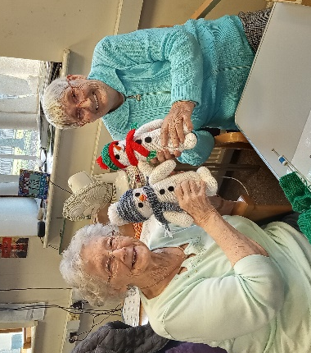
Age UK Calderdale & Kirklees is a registered charity that helps ‘change how we age’. Our aim is to improve the quality of life of older people by providing a variety of practical support services across Calderdale and Kirklees.

We are seeking new members for our Board of Trustees. With a proven track record, you will be a strategic thinker, with the time and skills to commit to this important role. The role is very much strategic, rather than operational.

We welcome applications from anyone with the empathy and inspiration to give their time to Age UK Calderdale & Kirklees and we are particularly keen to hear from candidates with the skills or experience in one or more of the following although this isn’t essential:

- PR and media
- Fundraising expertese
- Bid writing

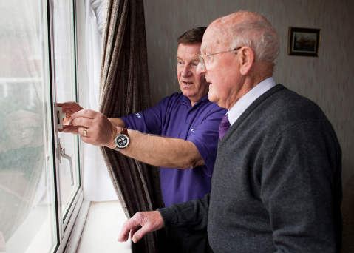
Trustee positions are unremunerated – reasonable travel and subsistence expenses can be reimbursed.

Time commitment is approximately 1-2 hours a month. We meet as a full Board, and in separate sub-committees, every three months. Some meetings are online and others in person. Engagement between meetings is generally by email.

- Do you have a passion and commitment to improving the quality of life of older people in your local community?
- Do you believe that listening to what older people want and need is a good way to improve services?
- Are you able to work as part of a team?
- Do you want to share and develop skills?

Then, we’d like to hear from you!
Applications are invited from people who live in, work in, or have another connection to Calderdale or Kirklees. We would also like to hear from applicants who reflect the diversity of the people who live in our communities.

We welcome applications from all suitably qualified persons regardless of their race, sex, disability, religion/belief, sexual orientation or age (18+).

Successful applicants will receive a structured induction, to learn more about Age UK and the Trustee role.

Application and Selection Process
Please read ALL the information on the dedicated webpage, or in the application pack, to help you make your application.

Contact Tony Morris, Chair of the Board of Trustees, to find out more about this opportunity by email enquiry@ageukck.org.uk

Applications are currently open.

To request an application pack in a different format or with larger print, please email: enquiry@ageukck.org.uk

Recruitment process:
Applications will be shortlisted and an interview with the Chair, Vice Chair and Chief Executive will be offered at a mutually convenient time.

References will be taken up before formally offering a place on the Age UK Calderdale & Kirklees Trustee Board.

Your application information will be dealt with as per our privacy policy. This can be found on our website www.ageukck.org.uk/calderdaleandkirklees

Thank you for your interest. We hope to hear from you soon.

