

MOBILITY SCOOTERS

*Hire & Servicing Information*

*April 2019*

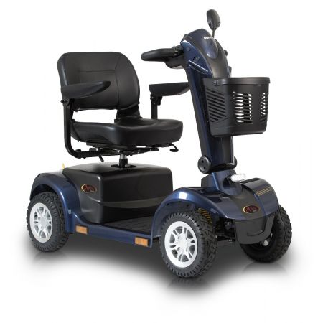







Hire of Shopmobility Aids

***Hire a scooter in Halifax Centre***

***for a minimum charge of £5.00 for up to 3 hours***

*(50p for each additional ½ hour)*

**Telephone: 01422 399830**

*We also supply scooters for holidays/long term hire.*

*Please contact Shopmobility for further details:*

***01422 399830***

Mobility living aids, stairlifts and walk-in

baths/showers are also available.

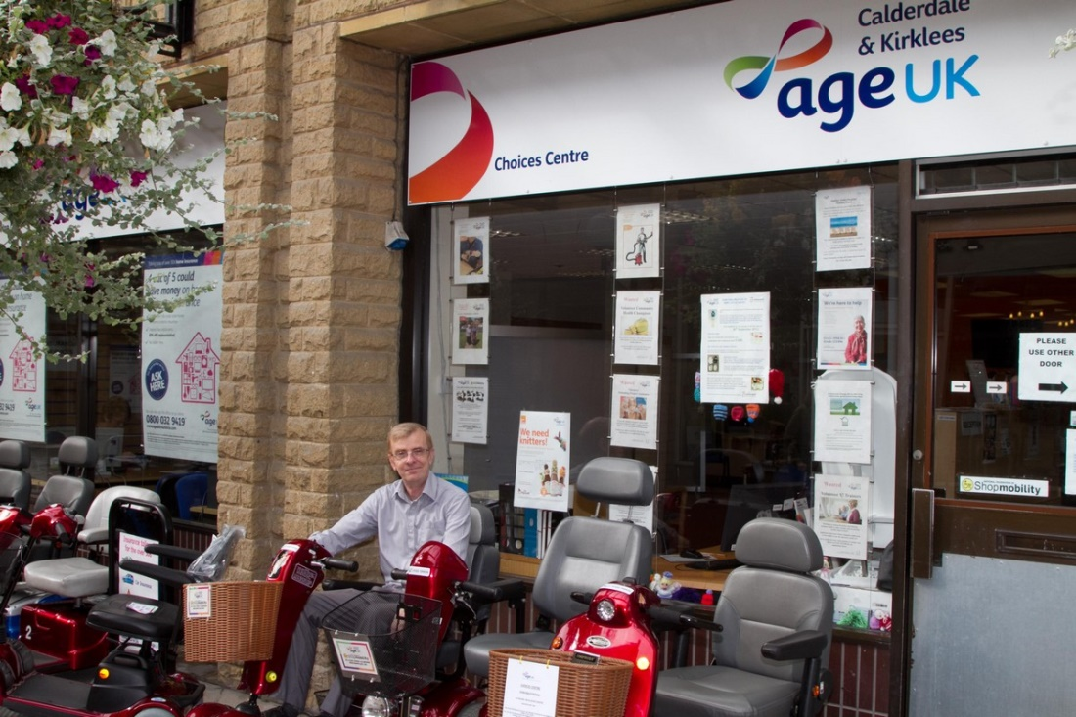

**Shopmobility**

**4-6 Square, Woolshops, Halifax HX1 1RJ**

**Opening Hours**

Monday to Friday 10am - 4pm

Saturday 10am-3pm

**Closed Sunday**

*Service Costs for Privately Owned Scooters*

|  |
| --- |
| Scooter brought in to shop for Service  £55 + parts |
|  |
| Home Service (Inc. transport to and from shop) £65 + parts |
|  |
| £15 off a Service if booked at  time of repair + parts |
|  |
| Breakdown & Service collected & returned within 20 miles £75 + parts |
|  |
| Breakdown call out £45 |
|  |
| Also available:  Wheelchair Service & Repair  £22 + parts |

***Shopmobility Hire Charges April 2019***

**Minimum Charges**

**Scooter Hire £5.00 up to 3 hours**

*(50p each additional ½ hour)*

**Wheelchair Hire £3.00 up to 3 hours**

*(50p each additional ½ hour)*

**Rollator & Walker Hire £3.00 up to 3 hours**

*(50p each additional ½ hour)*

***Long Term Hire***

***Scooters Wheelchairs***

*Deposit* ***£50*** *Deposit* ***£50***

*Hire per Night* ***£25*** *Hire per Night* ***£11*** *Weekend (Fri to Mon)* ***£35*** *Weekend (Fri to Mon)* ***£22***

*Weekly* ***£55*** *Weekly* ***£33***

*Fortnightly* ***£90*** *Fortnightly* ***£55***

*Monthly* ***£110*** *Monthly* ***£88***

***Additional days are charged at £15 per day***

***Longer term hire can be arranged - Please ask for details***

***Ramps & Walkers £10 per week***

***£30 per month***



Price List 2019

|  |  |  |
| --- | --- | --- |
| **TRAVEL SCOOTERS** |  |  |
| **Model description** | **MRP £:** | **AGE UK £:** |
| *Go Go Elite Traveller 3 Wheel 12 AH* | *£1,525.00* | **£800.00** |
| *Go Go Elite Traveller 3 Wheel 17 AH* | *£1,570.00* | **£890.00** |
| *Go Go Elite Traveller 4 Wheel 12 AH* | *£1,655.00* | **£905.00** |
| *Go Go Elite Traveller 4 Wheel 17 AH* | *£1,730.00* | **£935.00** |
| *Go Go Elite Traveller Lx 4 Wheel 12 AH* | *£1,710.00* | **£940.00** |
| *Go Go Elite Traveller Lx 4 Wheel 17 AH* | *£1,785.00* | **£995.00** |
| *Go Go Elite Traveller Plus 3 Wheel 17 AH* | *£1,815.00* | **£999.00** |
| *Go Go Elite Traveller Plus 4 Wheel 17 AH* | *£1,875.00* | **£1,030.00** |
| *Go Go Elite Traveller Sport 4 Wheel 20 AH* | *£1,950.00* | **£1,200.00** |
| *Apex Rapid 4 Wheel 18 AH* | *£1,875.00* | **£1,150.00** |
| *Pride Quest 4 Wheel Folding Lithium 11.5 AH* | *£2,500.00* | **£1,825.00** |
|  |  |  |
| ***Why not hire me for your holidays!*** | | |
| ***MID SIZE SCOOTERS (4 MPH SCOOTERS)*** |  |  |
| *Colt Twin* | *£3,100.00* | **£1,499.00** |
| ***MID SIZE SCOOTERS (6 MPH SCOOTERS)*** |  |  |
| *Colt Deluxe 40 AH* | *£3,750.00* | **£1,600.00** |
|  |  |  |
| ***LARGE SIZE SCOOTERS*** |  |  |
| *Colt Sport 8 mph 40 AH* | *£4,100.00* | **£1,799.00** |
| *Colt Pursuit 8 mph 50 AH* | *£4,350.00* | **£2,400.00** |
| *Colt Pursuit 8 mph 70 AH* | *£4,350.00* | **£2,500.00** |
| *Maxima 3 Wheel 4 mph 55AH (LED Display)* | *£4,440.00* | **£2,980.00** |
| *Colt Executive 8 mph 100 AH (LCD Display)* | *£4,995.00* | **£3,385.00** |
| *Maxima 4 Wheel 4 mph 55AH (LED Display)* | *£4,595.00* | **£3,980.00** |
|  |  |  |
|  | | |
|  |  |  |

***Please ask for our brochure or visit website:***

[***www.pride-mobility.co.uk***](http://www.pride-mobility.co.uk)

|  |  |  |
| --- | --- | --- |
| **POWER CHAIRS** |  |  |
| **Model description** | **MRP** | **AGE UK £:** |
| i-Go Plus | £2,495.00 | **£1,799.00** |
| Go-Chair | £2,495.00 | **£1,950.00** |
| Jazzy Air | £2,695.00 | **£2,223.00** |
| Jazzy Select | £1,890.00 | **£1,599.00** |
| Jazzy Select 6 | £2,100.00 | **£1,799.00** |
| Jazzy Select 600 ES | £2,695.00 | **£2,150.00** |
| Fusion | £2,895.00 | **£2,215.00** |
|  |  |  |
| **POWER LIFT RECLINER CHAIRS** |  |  |
| **Model description** | **MRP £:** | **AGE UK £:** |
| Camberley | £1,199.00 | **£695.00** |
| Essex | £1,299.00 | **£895.00** |
| Southwold | £1,199.00 | **£795.00** |
| Sussex | £1,399.00 | **£995.00** |
| C1 Petite | £945.00 | **£650.00** |
| LC101 | £725.00 | **£625.00** |
| LL 805 Wallhugger | £1,029.00 | **£565.00** |
| LC 107 Dual Motor | £1,049.00 | **£625.00** |
| 660 Mini Lounger Duet | £1,099.00 | **£665.00** |
| C:\Users\AMoney\Pictures\ll805_reading_mushroom_.jpg670 Chairbed | £1,199.00 | **£850.00** |



*All prices correct at time of printing. All prices in this brochure are subject to change.*



**Monday to Friday 10am to 4pm**

**Saturday 10am to 3pm**

**Sunday Closed**

Age UK Calderdale and Kirklees

4-6 Square, Woolshops, Halifax HX1 1RJ

Tel: 01422 399830

Website: [www.ageuk.org.uk/calderdaleandkirklees](http://www.ageuk.org.uk/calderdaleandkirklees)

E-mail: [enquiries@ageukck.org.uk](mailto:enquiries@acck.org.uk)

* **Fast friendly service**
* **Hire service available**
* **All work fully guaranteed**
* **Annual services carried out**
* **Repairs & services in-store or at your home**

Other related services:

* Domestic Services
* Handyman Service
* Companionship Centres
* Information & Advice



Charity No: 1102020

Company No: 5013745. A company limited by guarantee

S:SharedDocs/AUKLeaflets/ShopmobilityHalifax/V9