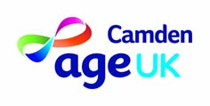

BACS PAYMENT

Charity no. 293446 – 102 Fitzjohn’s Avenue, London, NW3 6NS

To be paid by BACS please supply your bank details and email address for your remittance advice – confirmation of payment.

NB: This method of payment is OPTIONAL

Name of Bank: ………………………………………………….

Address: …………………………………………………………

Account Name: ………………………………………………….

Account Number: ………………………………………………..

Sort Code: ………………………………………………………..

Email address: …………………………………………………….

Sign & date: …………………………….. ……………………..

NB: If preferred you can email your details to: finance@ageukcamden.org.uk

