Internet Shopping Service External Referrals

Please note that due to GDPR we cannot seek credit card information over the phone – most of the information of these forms must be completed before we contact clients. This process will take a few days as we need consent from clients before signing them up for the service.

Thank you for making an enquiry about our Internet Shopping Service. Online shopping has been around for some time, but people without access to the Internet have so far been excluded from this convenient form of getting their groceries and household supplies. The service is also a great addition to any care package as it allows carers to support you at home rather than going out and doing shopping for you.

This document explains a little more about the service and includes an Application Form for you to complete, should you decide you want to register with us.

- Once registered with Age UK Camden, an account will be opened for you with your preferred supermarket.

- You will then receive a regular telephone call, at an agreed time, to take your shopping order. These calls are made on Wednesdays. We currently have an overflow of clients in the morning so afternoon times are better.

- The order is transmitted immediately to the supermarket, and a time and date agreed with you for delivery of your shopping.

- The supermarket then delivers your shopping the delivery driver will bring your purchases to your premises if you ask.

- In addition to the cost of your shopping, the supermarket will make a charge for delivery. This will vary depending on the day and time chosen for the delivery by you. This is added to the total bill, which is paid by debiting your bank or credit card, the details of which will have been registered as the payment method of choice for your shopping account. You do not pay the delivery driver.

- Age UK Camden charges for the service as we are not funded to deliver the service the fee is £5 per shop and is debited every other month you will receive an invoice to confirm payment.

- You can call our central reception desk if you have any questions between 9.30-5pm Monday – Friday Tel: 020 7 239 0400

Application Form

Please PRINT IN BLOCK CAPITALS

Name:

Address:

DOB:

Postcode:

Email:

Telephone Number:

Date of Birth:

Please give us the name of a relative or friend whom we can contact in case of need

Name:

Address:

Postcode:

Tel No:

Relationship to you:

Data Protection:

In order to place your order online, we need to have information about your bank account. As this information is classified by the Data Protection Act 1998 as personal or sensitive data, we need your permission to have this information and use it to set up your shopping account. Complete the attached forms if you are happy to provide this information. Your signature on the application form will allow us to use this information for the purposes of setting up an account for you with the supermarket and once entered into the supermarket’s system the information is destroyed.

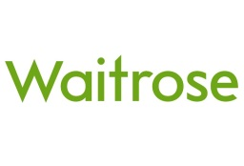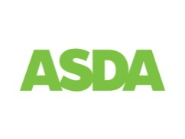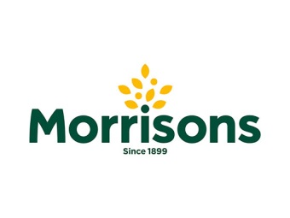

Preferred Supermarket (please tick):

Note: You can register with multiple supermarkets if you would like more choice.

- Waitrose - minimum order 60 but includes free delivery
- Asda – in certain parts of the borough only
- Tesco
- Morrisons
- Ocado
- Sainsburys

You can also order larger goods or household items via Argos / John Lewis etc. Please ask for more details if interested.

Please state your preferences for deliveries day and time:

Do you want us to call you at an arranged time?

Do you have a Loyalty (i.e. Nectar) Card? No

If yes, please give number/s…

Would you like to place a limit on the amount you spend each time? If so, please fill this in here and we will discuss with you when you are ordering.

£…

Payment: (see attached sheet)

Signature:

Date:

Payment Details:

Type of Card:

Visa MasterCard

Name on card:

Card Number:

(Note: this information is not retained by Age UK Camden)

Start month & year: __/__ Expiry month & year: __/__

CVS Card Security No: ___

(CVS Number is the last 3 digits on the back of the card)

All Payment detail information will be securely shredded once we have set up your online account with your chosen Super Market.

