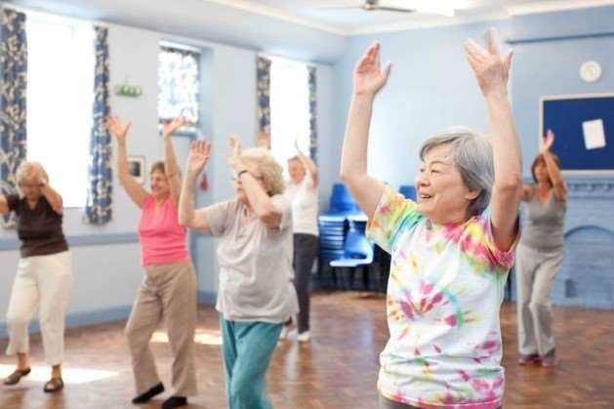

Welsh and Cardigan-area versions also available

2017/18

Independent Friendship groups
in the Aberystwyth area

vity Groups for 50+
Acti

Ceredigion Activity Groups for the 50+ (Aberystwyth Area)
These groups have been successfully launched under a Big Lottery funded project and are now fully independent. Please contact the group leaders directly for further information:

Group | Contact | Day / Time | Venue | Cost
Lunch Club: Aberystwyth | Angela Foot  01545 571165 | Wednesdays  Every 2nd Wed, 12-2pm | Marine Hotel, Aberystwyth | £8 lunch (2 courses)  £5 annual fee, Raffle
Lunch Club: Tregaron | Delyth Jones  01974 298593 | Wednesdays 12-2pm, monthly | Talbot Hotel, Tregaron | Lunch cost
Lunch Club: Tre’r Ddol | Joy Cook  01970 871649 | Tuesdays  Every 3rd Tues, 12–2pm | Wildfowler Inn, Tre’r Ddol | £8 lunch (2 courses)  Possible annual fee
Art and Craft Group | Michael Pooley  01970 820497 | Mondays  2-4pm, Weekly | Penrhyncoch Church Hall | Free
Seated Exercise to Music  (LIFT) | Fiona Hoare  01545 560234  07795 817572 | Wednesdays  10:30–11:30am, Weekly | Morlan Centre, Aberystwyth | £3.00
Reading group | Christine Pooley  01970 820497 | Wednesdays  Every 4th Wed, 2-4pm | Aberystwyth Library | Free
Knitting group | Christine Pooley  01970 820497 | Fridays  10.30am-12.30pm, Weekly | Belle Vue Royal Hotel, Aberystwyth | Free
The Silver Radio Show | Listen to Radio Bronglais 87.8 FM  and online | Tuesdays  4-5pm, Weekly | Enjoy themed music shows with  Denis and Molly | Free

