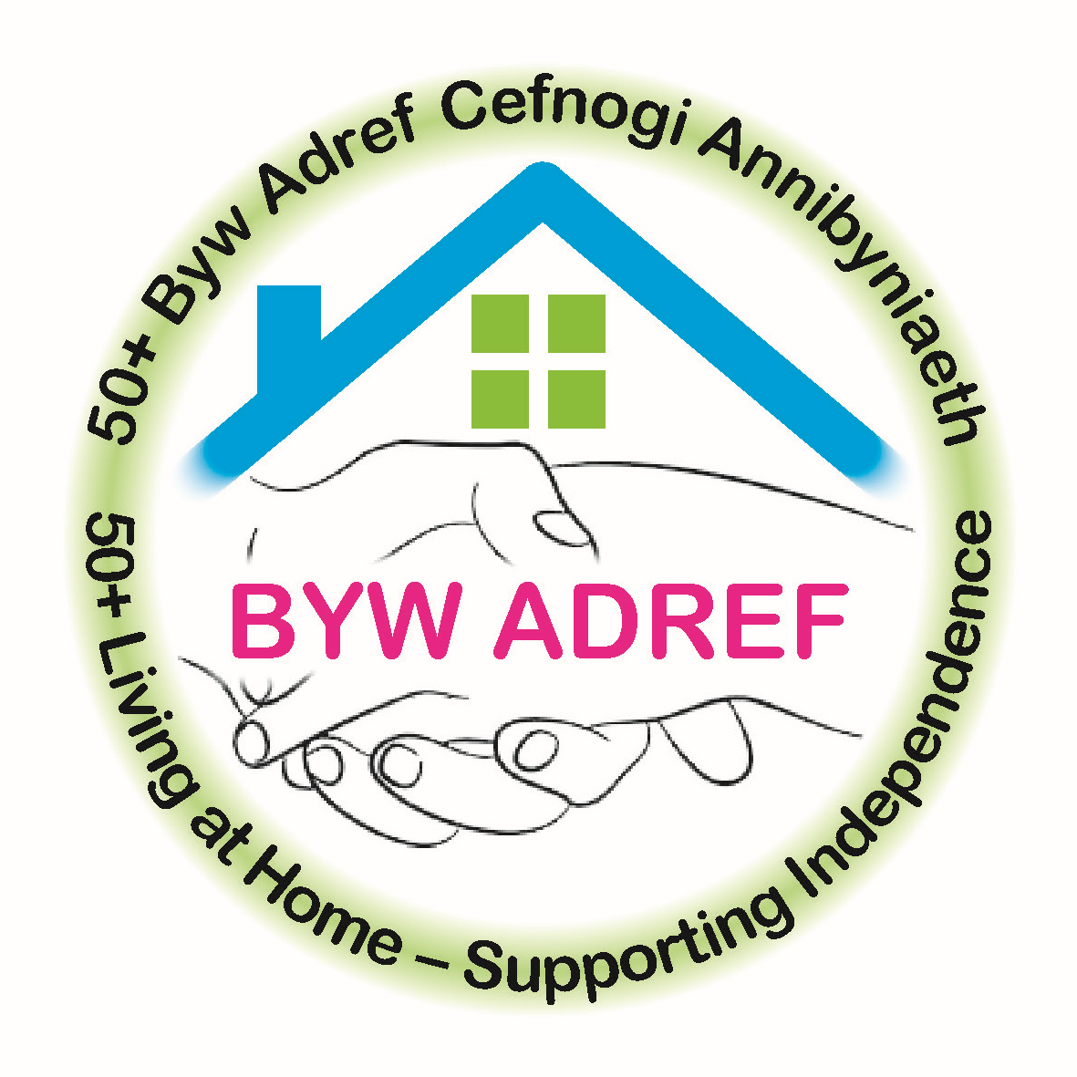

Byw Adref

JOB DESCRIPTION - HOME SUPPORT WORKER

Main Purpose of Job: To provide a home support service of high quality and
standard to clients aged 50+ living in Ceredigion

Responsible to: Age Cymru Ceredigion Byw Adref Manager

Hours of Work: Variable & Flexible, around employee’s availability

Rate of Pay: £8.00 per hour

Place of Work: Out in the Community (clients homes)

Age Cymru Ceredigion provides a support service to clients aged 50+ in their own homes when they are no longer able to maintain their home to the standards they would like. Provision of this service is delivered to meet the client’s needs and at an affordable cost.

MAIN DUTIES AND RESPONSIBILITIES

- To undertake domestic cleaning tasks as requested by and agreed with the client. These tasks will include general housework such as vacuuming, dusting and polishing, mopping floors, cleaning baths, showers and toilets, cleaning inside windows, spring cleaning.
- Laundry work to include changing and making beds, washing and ironing.
- Shopping duties if requested by the service user and agreed by the Byw Adref manager.
- An ability to provide patient, positive encouragement to maintain clients
independence where appropriate.
- Provide prompt, reliable, high quality service to clients.
- Show sensitivity and an interest in the well- being of vulnerable adults
- Ability to work independently and as an effective member of a team
- Report back to the Manager any concerns regarding clients and fill in monthly activity sheet
- Attend training and information sessions as decided by the Manager.
- Comply with all Safeguarding, Health & Safety and Fire Regulations.
- Accurately complete time sheets and return to office at approved time.
- Notify Manager immediately when unable to carry out services to clients.
- Provide medical certificate for illness lasting more than 3 days.

Salaries will be paid monthly, subject to satisfactory completion of time sheets.

Travelling expenses may be paid if employee has to travel over 5 miles from home to visit a client or between clients. Travelling will be paid at 40pence per mile for every excess mile over 10 miles, round trip. You must make the journey viable to warrant expenses being paid.

Elusen Cofrestredig 1155813 Registered Charity Number

CEFNOGI POBL HŶN YNG NGHEREDIGION/SUPPORTING OLDER PEOPLE IN CEREDIGION

