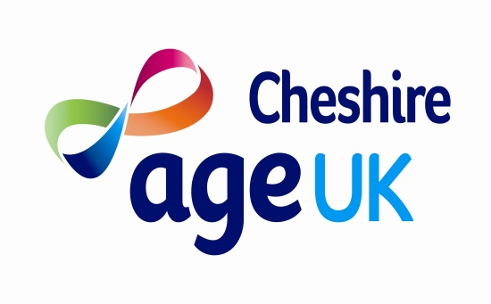
2018 Coach Trip Booking Terms & Conditions
Interested parties are able to register their interest in a particular trip, by providing passenger details and contact information to make an initial reservation. (Personal details are only taken for the purpose of contacting you and will not be shared outside of Age UK Cheshire. We will require a signature for consent of recording your personal details.) This serves to give Age UK Cheshire an indication of the level of interest but does not constitute a booking. In order to confirm a reservation, passengers will then need to contact the office on 01606 720430 to make payment in full 6 weeks before the trip in order to confirm their place.
Payment can be made by cash, cheque, and debit or credit card. Cash can be received at Castle Community Centre. Cheques should be made payable to Age UK Cheshire and sent to Castle Community Centre, Barbers Lane, Off Queensgate, Castle, Northwich, Cheshire CW8 1DT. Card payments can be made in person at Castle Community Centre or by telephone on 01606 720430.
Should passengers need to cancel their trip once paid, a coach fee refund may be due depending on the notice period as outlined below:
Notice period | Refund
More than 10 working days before the trip | 100%
5 - 10 working days before the trip | Transfer to a future Age UK Cheshire coach trip of equal or lower value
Less than 5 working days before the trip | No refund
Note: working days are Monday to Friday
In addition to the above it should be noted that where tickets have been purchased e.g. Theatre or entrance tickets, these are non-refundable. We are happy to transfer these to a passenger of your choice who may be able to go in your place.
Seat reservations are taken where there is a medical need. Age UK will endeavour to accommodate seat requests however unfortunately these cannot be guaranteed. Please ensure that it is made clear when booking of this need. (Mobility aids may be taken). Pets are not permitted on the coach with the exception of disability assistance dogs.
Whilst passengers may bring their own snacks and drinks on the trip, coach companies politely request that these are not consumed on the coach itself unless you have been advised differently by a member of Age UK Cheshire Staff.
Age UK Cheshire trips have a Representative on the coach and contact details of this person are given out should contact need to be made during the trip. Our Representative, however, does not extend to care and passengers are required to be independent on the trip or bring a friend/relative/carer with them. Some destinations may offer discount for carers as long as evidence is provided of the carer’s position. Age UK Cheshire may, at their discretion, refuse a reservation.
Prices are correct at time of printing but may be subject to change. In the event of unforeseen circumstances, Age UK Cheshire reserves the right to amend or cancel a trip. We will make every effort to keep these to a minimum.

