COACH TRIP TO THE TRAFFORD CENTRE FOR SHOPPING
Wednesday 10th January 2018
An opportunity to do some shopping in the January sales at the fabulous Trafford Centre.

All of the shops are under-cover so there is no need to worry about the January weather.

Many famous names like John Lewis, Debenhams as well as lots of smaller stores.
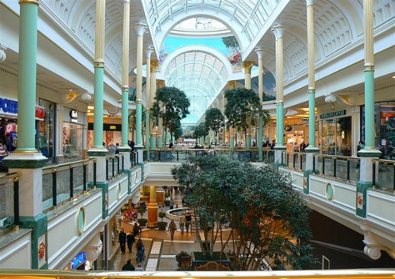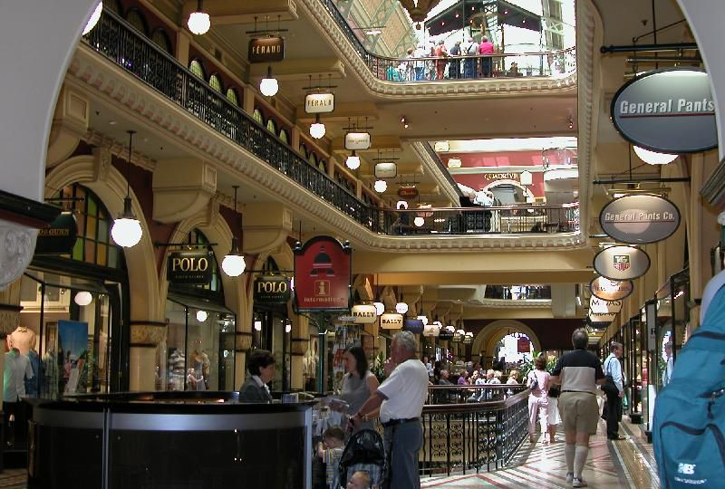
Coach groups will receive an exclusive book of treats and discounts, and a meet and greet with the lovely customer services team.
There are 60 places to eat, so definitely something for everyone.

£16 - payable by 29th November, please.
Pick-up points in Hartford, Northwich, Middlewich & Winsford
Departures 8.45 – 9.45 am. Return approx 5.00 – 5.45 pm.
To book please contact Helen or Mags on 01606 720430
Please refer to the Age UK Cheshire Coach Trip bookings Terms and Conditions
ccc@ageukcheshire.org.uk

