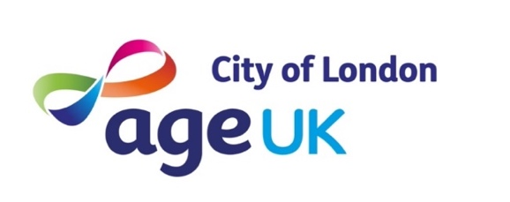
Weekly Activities Spring 24

Mondays 10.30-11.30am  Starts Mon 15/4 | Women only Zumba | Portsoken Community Centre,  Little Somerset St  E1 8AH | A free weekly Zumba class for women 50+
Mondays 2.15-4pm  No session 1/4 | Golden Social | Golden Lane Community Centre, Fann St EC1Y 0RD | Tea, coffee, chat, board games, crafts, films, visiting speakers
Tuesdays 10.30-11.30am | Very gentle health walk  (for Square Mile Health Walks see Walks Programme) | Meet outside Fusion Golden Lane leisure centre,  Fann St  EC1Y 0SH | A social walk to improve confidence, balance and stability. Tea & coffee to finish
Tuesdays 5.30-7pm | IT Support | Barbican Library,  Barbican Centre  EC2Y 8DS | Bring along your phone or tablet to get help with using it. For complete beginners and those needing a little extra help
Wednesdays  2-4pm | Textile Crafts/  Knit and Natter (alternate Wednesdays) | Artizan Library  Artizan St  E1 7AF | Textile-based crafts including knitting, crochet, weaving, felting and macrame
Fridays 10.30-11.15am | Yoga online | Zoom – contact Alice for details | A small friendly class for those new to yoga. Can be done either seated or standing
Fridays 2.15-3.15pm | Tai Chi | Golden Lane Community Centre | Contact Alice about joining.

For more info email Alice.Westlake@AgeUKCityofLondon.org.uk
or call 0203 488 6884 (Mon-Thurs)
www.ageukcityoflondon.org.uk
Calendar April 24:
When | What | Where | How
Mon 1st Apr  2 - 4pm | NO Golden Social – Easter Bank Holiday Monday | Golden Lane Community Centre | n/a
Sat 6th Apr  11am – 12 noon | Square Mile Health walk:  St Pauls circular | Meet at St Pauls tube, Café Nero | Just turn up
Sun 7th Apr  10am – 12 noon | Square Mile Health walk:  Royal Exchange circular | Meet at Royal Exchange | Just turn up
Mon 8th Apr  Session 1: 1pm- 2pm  Session 2: 2:30pm- 3:30pm | Gadget Clinic | Summit House,  12 Red Lion Square, London  WC1R 4HQ | Send an email to Finley with your preferred session:  Finley.Allott@ageukcamden.org.uk  Only 12 places per session
Wed 10th Apr  2 - 4pm | Knit and Natter | Artizan Library | Just turn up
Thu 11th Apr  3 - 5pm | Burtynsky exhibition | Saatchi Gallery | Contact Alice to book a place
Mon 15th Apr  12 - 2pm | “Eat Club” cookery course starts – 6 week course for City and Hackney residents | Golden Lane Community Centre | Contact Alice for info
Wed 17th Apr  2.30 - 4pm | The Glass Heart exhibition | Two Temple Place | Contact Alice to book a place
Fri 19th April  Time tbc | Kew Palace, including Guided tour of the Royal Kitchens  Coach trip from Barbican | Kew Palace/ Kew Gardens | Contact Alice to book.  Priority will be offered to City residents and those with limited mobility
Wed 24th Apr  2 – 4pm | Unravel exhibition  (There will be NO Knit and Natter at Artizan) | Barbican Art Gallery | Contact Alice to book a place  Limited availability
Thurs 25th Apr  2-4pm | Square Mile Health walk:  St Pauls circular | Meet at St Pauls, Cafe Nero | Just turn up
Mon 29th Apr  2 – 4pm | Golden Social: film – The Company of Strangers | Golden Lane Community Centre | Just turn up  Prompt 2pm start

For more info email Alice.Westlake@AgeUKCityofLondon.org.uk
or call 0203 488 6884 (Mon-Thurs)
www.ageukcityoflondon.org.uk

