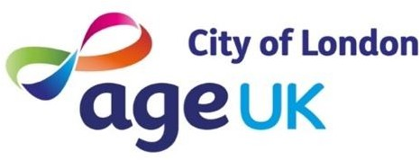

Weekly Activities Summer 26

Mondays 10.30-11.30am | Women only Zumba SUMMER BREAK,  resumes 27/7 | Portsoken Community Centre E1 8AH | Gentle Zumba class for women 55+
Mondays 2.15-4pm | Golden Social | Golden Lane Community Centre, Fann St EC1Y 0RD | Tea, coffee, chat, board games, crafts, films, visiting speakers
Tuesdays 10.30-11.30am | Stroll and chat  (for full details of all our walks see Walks Programme) | Meet by Giddy Up Coffee, Fortune Street Park EC1Y 0SB | A social walk to improve confidence, balance and stability. Tea & coffee to finish
Tuesdays 5.30-7pm | Digital Support  SUMMER BREAK  Last session 11/8,  resumes 1/9 | Barbican Library, Barbican Centre EC2Y 8DS | Bring along your phone, laptop or tablet to get help with using it
Wednesdays 2-4pm | Textile Crafts (fortnightly on Wednesdays starting  14th Jan) | Portsoken Community Centre | A group for knitters and stitchers to work on their own or joint projects
Wednesdays 4-5pm | Movement to Music SUMMER BREAK  Last session 22/7,  resumes 2/9 | Portsoken Community Centre | A fun, active fitness class for women 55+
Fridays 10-11am | Chair Yoga online class  SUMMER BREAK,  resumes 31/7 | Zoom | A friendly online class. Contact Alice for joining details
Fridays 2.15-3.15pm | Tai Chi | Golden Lane Community Centre | Tai Chi for people aged 55+

For details email: info@ageukcityoflondon.org.uk or call 0203 488 6884 (Mon-Thurs)
Web: www.ageukcityoflondon.org.uk

