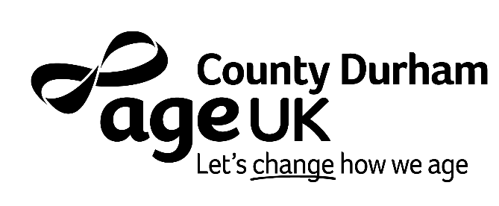

APPLICATION FORM (part c)

For Office Use Only
Reference number | 26.06 | Candidate reference number

Criminal Convictions
This post may require a Basic or Enhanced
Disclosure and Barring Service check

Therefore, you are required to provide details of all convictions, cautions, reprimands and final warnings other relevant non-conviction information, such as police enquiries and pending prosecutions should also be declared.

You should send this information marked as:
CONFIDENTIAL for the attention of and only to be opened by the Chief Executive Officer

You can send this information by post to Age UK County Durham, Houghton House, Belmont Business Park, Durham, DH1 1TW or by email to info@ageukcountydurham.org.uk

Have you any details to declare? | ☐ YES ☐ NO
If YES, have you enclosed the details as instructed? | ☐ YES ☐ NO  Independent Safeguarding Authority registration number (if you have been issued with one):
The information you have provided will be held by Age Concern Durham County (trading as Age UK County Durham) on computerised and/or manual files in accordance with the organisation’s retention schedule. Age UK County Durham is a registered Data Controller in accordance with UK GDPR and the Data Protection Act 2018. You have a right to correct the information we hold about you or to have it removed. To obtain a copy of the information we hold about you, please apply in writing to the Chief Executive Officer, Age UK County Durham, Houghton House, Belmont Business Park, Durham, DH1 1TW. To find out how we use your details, you can request a copy of our Privacy Notice by contacting us at the above address or emailing us at info@ageukcountydurham.org.uk. This information is also available by visiting our website at www.ageuk.org.uk/countydurham/about-us/our-privacy-notice/

© 2026 Age UK County Durham is a trading name of Age Concern Durham County, which is a registered charity (1122008) and company limited by guarantee. Registered in England and Wales, number 06431030. Registered office: Age UK County Durham, Houghton House, Belmont Business Park, Durham DH11TW. Reproduction or transmission of all or part of this work, whether by photocopying or storing in any medium by electronic means or otherwise, without the written permission of the copyright owner is prohibited.

