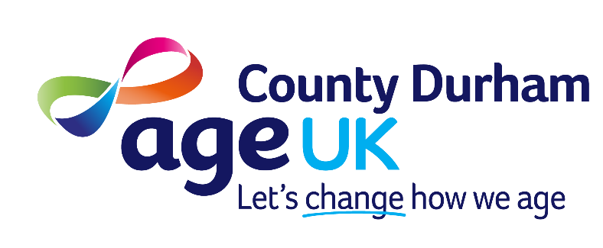

Age Concern Durham County trading as Age UK County Durham

JOB DESCRIPTION

Post Deputy Chief Executive Officer (26.09)

Responsible to Chief Executive Officer

Based at Houghton House, Belmont Business Park, Durham and the post holder will also be required to work at other locations if and when required.

Hours of work 37 hours per week.
Monday to Thursday 8.30am–4.30pm, Friday 8.30am–4.00pm.

Salary £50,000 plus up to 5% pension contribution to Organisation’s Pension Scheme.

Holiday Entitlement 38 days per annum including statutory holidays and Christmas closedown rising to 41 days after 15 years of service

Organisation Overview
Age UK County Durham is the ‘go to’ organisation for people aged 50 + across County Durham. Across the region we are recognised for our collaboration, financial strength and support for partners in our sector. Our key strength is our people; we have a strong Board of Directors who collectively bring a wealth of experience and knowledge from across the North East. We have a committed and experienced staff team and a valued network of volunteers.

Purpose of Role
Age UK County Durham has an exciting opportunity to join our dynamic team as Deputy Chief Executive Officer, responsible for strategic direction and operations. Age UK County Durham is looking for an individual who is passionate about the organisation’s cause and committed to supporting people aged 50+. We are keen to find an individual who will support the organisation to deliver the strategies to grow and develop the organisation. This opportunity would suit someone who has the natural ability to build relationships and possesses excellent organisational skills. You will have a positive can-do attitude and willingness to help with varied projects and challenges.

You will serve as the second most senior member of staff, deputising for the CEO. You will be responsible for the effective leadership and management of the organisation’s, IT, HR, Administration, premises functions in accordance with current legislation, relevant operational regulations and external quality standards. In collaboration with the CEO and senior management team you will contribute to securing funding and detailed reporting according to funder agreements and internal requirements
Key tasks

- Working with the Chief Executive Officer (CEO) and Board of Trustees to develop and implement the charity's strategy, ensuring high standards of governance and compliance with legal and regulatory requirements
- Responsible for the day-to-day operations and ensuring operational excellence across various functions such as finance, HR, IT, and service delivery. This will involve leading cross-organisational initiatives and change programs
- Contributing significantly to the financial sustainability of the organisation by contributing to the development and implementation of fundraising strategies, securing new income streams (grants, corporate partnerships, individual donors), and managing budgets and financial planning
- Acting as a key ambassador for the charity, collaborating, building and maintaining strong relationships with funders, partners, statutory bodies, and the media. This also involves representing the organisation at external events and meetings
- Leading, motivating, and managing senior staff and teams (both paid and volunteers) to foster a positive, high-performance culture aligned with the charity's values. This may include overseeing recruitment, training, and performance management
- Monitoring and Evaluation: Ensuring systems are in place to measure and report on the charity's impact and outcomes to the CEO, board, and funders
- Responsible for ensuring quality standards are met and maintained

General
There will be a requirement to travel therefore a current valid driving licence and daily access to a car is essential for this post. Mileage rates as agreed by our Board of Trustees will be paid for the use of a car for business use.

Age UK County Durham operates a no smoking policy in all of its premises.

Age UK County Durham is an equal opportunities employer.

The appointment will be made subject to the receipt of references and an Enhanced Data and Barring Service (DBS) check that meet the requirements of the organisation.

Person Specification

Essential
- Proven experience in a similar role, ideally within the not-for-profit sector
- Experience in managing and delivering programmes of work
- Experience in project and people management, supporting volunteers and senior management
- Experience in managing funder requirements, narrative and financial reporting (e.g. for Trusts and Foundations)
- Excellent stakeholder management and presentation skills
- Knowledge of HR processes, policy and legislation
- Financially literate and aware and understands and supports the finance team processes
- Enthusiastic, with an evident passion for the mission and vision of Age UK County Durham
- Excellent attention to detail, accuracy and organisational skills.
- Diplomatic approach and highly self-motivated with a positive and energetic attitude
- Focuses on what matters most, setting priorities and adapting them where required, with the right level of communication
- Develops successful relationships with colleagues and external stakeholders. Quickly builds rapport, builds trust, with a collaborative approach and strives to see issues from different perspectives
- Plans ahead, anticipates and reacts to change and project needs remaining flexible and adaptive in the face of change

Desirable
- Extensive knowledge of UK Political Institutions and how democratic systems work
- Experience working with people aged 50+
- Experience in working across a range of project types
- Excellent writing and IT skills
- Safeguarding experience (or desire and interest to attend training
- Able to manage confidential information and discretely resolve sensitive issues
- Experienced in leading highly effective teams through periods of change to achieve stretching goals

