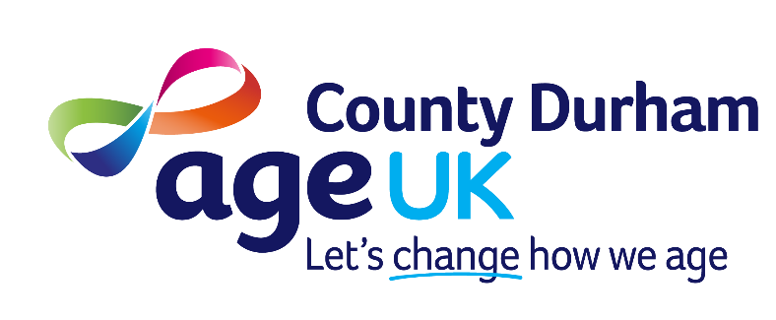

Age Concern Durham County trading as Age UK County Durham

JOB DESCRIPTION

Post Counsellor/Psychotherapist (26.10)
Older Person’s Mental Health and Wellbeing Service

Responsible to Chief Executive Officer

Based at Houghton House, Belmont Business Park, Durham and the post holder will also be required to work at other locations if and when required.

Hours of work Between 22.5 and 37 hours per week

Salary £34,592 (pro rata if part time) plus up to 5% pension contribution to Organisation’s Pension Scheme.

Holiday Entitlement 36 days per annum including statutory holidays and Christmas closedown rising to 41 days after 15 years of service

Purpose
To work within a small team delivering counselling and welfare support services, providing confidential support to older people across County Durham, identifying their needs and supporting them in achieving better mental health and wellbeing.

Key tasks

- Clinical Assessment and Treatment: Conducting specialist assessments and providing evidence-based therapies to address a wide range of issues, from anxiety and depression to historic trauma and suicidal ideation.
- Case Management: Managing a defined caseload, which includes planning, coordinating, and reviewing care plans in collaboration with the service user, their carers, and other involved agencies.
- Multidisciplinary Collaboration: Working as an integral part of a multidisciplinary team (MDT), internally and externally
- Community and Service Development: Contributing to the development and evaluation of service operational policies, working with community partners to address social inequities and enhance quality of life at a community level.
- Risk Management: Assessing, monitoring, and managing clinical risk to service users and others, and providing advice on aspects of risk management.
- Record Keeping and Reporting: Creating and updating confidential client records, writing reports, and contributing to data collection for audit and research purposes.
- Liaise and network with statutory, voluntary and independent providers and organisations within the area
- Be aware of and undertake appropriate training and professional development
- Work within the policies and procedures of Age UK County Durham
- To adhere to all Safeguarding policies and procedures in line with Age UK County Durham and wider older persons safeguarding bodies

General
There will be a requirement to travel therefore a current valid driving licence and daily access to a car is essential for this post. Mileage rates as agreed by our Board of Trustees will be paid for the use of a car for business use.

Age UK County Durham operates a no smoking policy in all of its premises.

Age UK County Durham is an equal opportunities employer.

The appointment will be made subject to the receipt of references and an Enhanced Data and Barring Service (DBS) check that meet the requirements of the organisation.

Person Specification

Qualifications
Essential
- Qualification in Counselling/Psychotherapy at diploma level (Level 4) or equivalent
- BACP or UKCP registration

Experience and Knowledge
Essential
- Experience of providing short-term, goal-oriented therapy
- Experience of conducting assessments, developing risk management plans
- Experience supporting older people through periods of loss, anxieties, trauma and low mental health.
Desirable
- Experience of working with people aged 50+
- Experience of group counselling

Technical Skills Competencies
Essential
- Excellent oral and written communication skills
- Ability to undertake client assessments and identify realistic short-term therapy goals
- Ability to set boundaries in terms of limits of expertise and time limitations
- Fully competent with data input and IT systems.

Personal Attributes
Essential
- Ability to use clinical supervision effectively with a well-developed capacity for self-reflection
- Ability to work autonomously and manage own caseload
- A developed sense of own self-care and management

