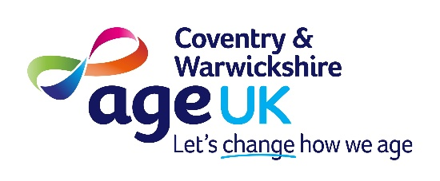

JOB DESCRIPTION

Post Title: Information & Advice Support Officer

Reporting Line: Services Manager

Summary of Post: To support clients in accurately completing application forms, with a particular focus on disability benefits. The postholder will work closely with clients to identify any additional needs and ensure they receive appropriate information, guidance, and signposting to relevant services.

The role also includes undertaking a range of administrative duties to support the effective delivery of the Information & Advice (I&A) service.

Client support will be delivered primarily by telephone, with home visits and appointments in community-based settings undertaken where necessary.

Hours of Work: 18 hours a week (over 3 days)
Job Scale: 20
Location: Coventry office (with periodic travel across Coventry and Warwickshire)

Duties and responsibilities:

- Support clients to accurately complete paper and online application forms, including those for the Department for Work and Pensions and Local Authorities, ensuring key dates are identified and acted upon to maximise a client’s outcome.

- Process referrals and enquiries into the I&A service, including completing disability benefit screening questionnaires to identify likely eligibility and gathering a client’s financial information to support Advisors complete benefit checks.

- Maintain up-to-date knowledge of relevant internal and external services to provide clients, their carers or families with clear, accurate and appropriate information and signposting across a range of local and national issues.

- Follow up on claims in a timely manner to confirm outcomes, accurately update relevant database fields and spreadsheets, as well as identify and escalate any actions to be completed by an Advisor.

- Work within the framework of Age UK quality standards, following established I&A policies and procedures.

- Maintain accurate and up-to-date client records on the customer database and ensure appropriate client consent is obtained.

- Manage own appointment schedule.

- Actively seek and record client feedback, to support service improvement, monitor satisfaction levels and complete case studies.

- Provide training, support and supervision where required for volunteers within the I&A department.

- Periodically represent Age UK at community information events across Coventry or Warwickshire.

- Provide general administrative support to the I&A team, including but not limited to, responding to emails, letter writing, photocopying, booking appointments and stationery ordering.

- To undertake appropriate training and personal development as required for the role and attend team and supervision meetings.

- Ensure all personal data is processed in accordance with the GDPR policy and procedure.

- To adhere to all Age UK Coventry & Warwickshire policies, with particular reference to staffing, health & safety, safeguarding and equality.

- To portray a positive image of the organisation, both internally and externally.

- To undertake such other duties as may be reasonably required, consistent with the nature and grade of the post.

All staff have an individual responsibility to comply with the organisation’s policies and practices.
A regular DBS check is a requirement of this role.
This job description will be reviewed annually in line with appraisals.

Employee Signature: ……………………………….…… Date: ………….……………….

Please print name: ……………………………………….

Person Specification: Information & Advice Support Officer

You must be able to demonstrate in your application that you have: | Essential | Desirable | Tested At
Qualifications
GCSE Grades A-C or equivalent in English and Maths |  | ✓ | A/I
Knowledge and Experience
Experience of completing documentation where attention to detail is essential. | ✓ |  | A/I
Experience working directly with the public, such as in health/social care, finance, local authority or information provision settings. | ✓ |  | A/I
A good understanding of the needs and issues affecting older people &/or people with physical disabilities. |  | ✓ | A/I
Skills and Abilities
Communicate effectively both written and verbally, including active listen skills & the ability to adapt communication style. | ✓ |  | A/I
Good IT skills, including experience with CRM systems and Microsoft packages including Word, Outlook, and Excel. | ✓ |  | A/I
Full driving licence with access to own transport and ability to across Coventry & Warwickshire. | ✓ |  | A
Personal Qualities & Attributes
Commitment to equality of opportunity. | ✓ |  | A/I
Ability to work flexibly within a team or on own initiative. | ✓ |  | A/I
Strong organisational skills including ability to prioritise workload. | ✓ |  | A/I
Empathetic & non-judgemental. | ✓ |  | A/I
Key: A = Application Form I = Interview Process

