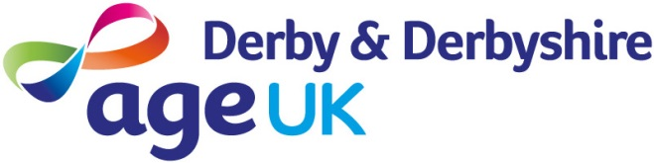
Form E

Equal Opportunities Monitoring Form

The Equal Opportunities Policy of Age UK Derby & Derbyshire states we will not unjustifiably discriminate against candidates for jobs on the grounds of age, race, colour, nationality, religion, gender, disability, sexual orientation and marital status. In order that we can measure the impact of this policy, and continue to develop relevant personnel policies, could you please tick the appropriate boxes. The information on this page will be used for monitoring purposes only and will not be taken into account in short-listing or interviewing.

Post Applied for:.................................................................................................................

Female................................Male...............................Transgender…………………………

What is your ethnic origin?

Black British |  | Asian British |  | Dual Heritage |  | Filipino
Black African |  | Indian |  | Irish |  | Gypsy/Roma
Black Caribbean |  | Pakistani |  | Other Non European |  | Traveller of Irish Heritage
Black Other |  | Bangladeshi |  | Other European |  | Other
Chinese |  | Asian Other |  | White British |  | Declined to answer/unknown

Do you have a disability: YES/NO

Date of Birth:......................................................

Age last Birthday.....................

How did you find out about this post? Please state the source of any advertisement

......................................................................................................................................

