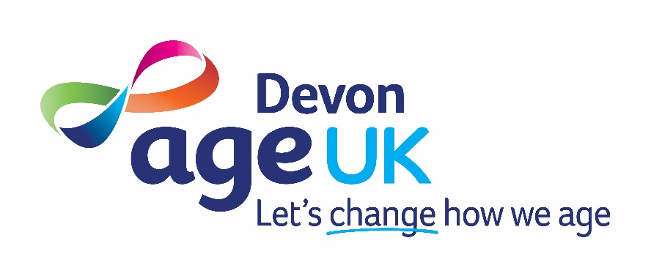

Complaints Policy
Version 10

1. INTRODUCTION

Age UK Devon aims to provide high quality services and to be responsive to the needs of service users.

Service users, their families, carers and advocates and those who have requested or been referred for a service have the right to raise concerns, objections or make complaints about the services and responses they receive from Age UK Devon. All concerns and complaints from service users, or others, will be taken seriously, listened to carefully, investigated fully where necessary, and responded to with respect and courtesy, and within the time scales as detailed within this policy.

2. PURPOSE

The purpose of this policy is to:

- Enable people who use our services to comment on dissatisfaction and to let us know when things have gone wrong or cause concern.

- Assure people who use our services that we take their views seriously and follow up any issues raised.

- Protect the interests of individual clients and prevent future complaints from occurring.

- Enable service users, potential users and carers to challenge decisions.

- Protect employees and volunteers and enable Managers to deal with complaints fairly, efficiently and effectively.

- Improve the quality of services by acting on the views of those affected by the services to inform future planning and development.

A complaint can be a written or oral expression of dissatisfaction, or a concern relating to the everyday operations of the services and activities provided by Age UK Devon. This dissatisfaction may include the actions of the Charity’s employees and volunteers, their failure to act, or delay in acting, which requires the Charity to account for its conduct.

Whilst we understand that making a complaint can be distressing or frustrating, Age UK Devon will not tolerate unacceptable behaviour towards our employees or volunteers. This includes aggressive, abusive or discriminatory language, intimidation, harassment, or unreasonable or excessive demands. Where such behaviour occurs, we may limit or restrict contact. Correspondence that is offensive or abusive will not receive a response, and the complainant will be advised to resubmit their concerns appropriately if they wish them to be considered.

Age UK Devon is committed to protecting the privacy and personal data of all individuals who raise a concern or make a complaint. Any information provided as part of the complaints process will be handled in accordance with the UK General Data Protection Regulation (UK GDPR) and the Data Protection Act 2018.

We will:
- Collect only the information necessary to investigate and respond to the complaint.
- Store complaint records securely and restrict access to staff who need this information to carry out their duties.
- Use complaint information only for legitimate purposes, including investigation, responding to the complainant, monitoring service quality, and fulfilling regulatory or safeguarding requirements.
- Retain complaint records for a set period in line with our Data Retention Schedule, after which they will be securely deleted or destroyed.
- Share information only where necessary and lawful, such as with regulatory bodies or safeguarding agencies, or when required by law.
- Respect the confidentiality of all parties involved throughout the complaints process.

Individuals have the right to:
- Request access to the personal data we hold about them (Subject Access Request).
- Request rectification of inaccurate information.
- Request erasure, restriction, or objection to processing (where legally applicable).
- Complain to the Information Commissioner’s Office (ICO) if they are dissatisfied with how their data has been handled.

Any data protection queries relating to complaints can be directed to the Chief Executive, who is Age UK Devon’s Data Protection Lead.

3. THE COMPLAINTS PROCEDURE

There are three distinct stages to the procedure:
Step 1 – The Informal Approach
Step 2 – The Formal Approach
Step 3 – The Review

Step 1 - The Informal Approach
In the first instance, some comments, concerns or complaints will, by their nature, be easy to resolve immediately, to everyone’s satisfaction. The complaint or concern should be raised directly with the manager of the service concerned. Most issues will usually be resolved in this way via telephone, email, or letter.

Step 2 - The Formal Approach
If the informal procedure fails to resolve the problem, it should be put in writing and sent to the Chief Executive of Age UK Devon. The complainant should set out what the issue is about and what action they would like to see as a result of their complaint. An acknowledgement will be made in writing within three working days. An investigation will be undertaken, and, in most circumstances, a formal written response will be made within 10 working days of receipt. If there is any variation to this time frame this will be discussed with the complainant, and a new response time will be agreed. Written records will be kept about each complaint received.

Step 3 - The Review
If the complainant remains dissatisfied after receiving the formal written response, they may request a review by writing to the Chair of the Board of Trustees within thirty (30) working days of the response.

Upon receipt, the Chair of Trustees will appoint a Complaints Review Panel, normally consisting of the Chair and one other independent Trustee who has not previously been involved in the matter. The panel may request to meet with the complainant if this would support the review. The complainant may be accompanied or represented by a person of their choice.

The Review Panel will consider:
- Whether the complaint was handled fairly, thoroughly, and in line with this policy
- Whether the outcome was reasonable based on the information available
- Whether any additional evidence or relevant information has since come to light
- The Panel will aim to issue a written decision within 10 working days. If more time is needed due to complexity or external factors, the complainant will be informed and a revised timescale agreed.

Final Appeal (if applicable)
If the complainant believes that:
- the review procedure was not followed correctly, or
- significant new evidence has become available that was not considered
- they may request a final appeal. This request must be made in writing within 10 working days of receiving the Review Panel’s decision.
The Chair of Trustees will then appoint a new Appeal Panel, consisting of two Trustees who have not previously been involved in the complaint at any stage. The Appeal Panel may consider written submissions only or may invite the complainant to attend a meeting if appropriate.

The Appeal Panel will review the procedural concerns or new evidence and will issue a final written decision within 10 working days (or notify the complainant if an extension is required).

The decision of the Appeal Panel is final, and the complaints process will then be concluded.

4. REVISION HISTORY

Revision Date | Summary of Changes | Other Comments
March 2018 | Section 3 updated accordingly.  Revision History added. | Version 6
03/01/2020 | No changes required. | Version 7
31/01/2020 | Reference to Age UK Enterprises’ Complaints Procedure removed following closure of Trading on 31/01/20. | Version 8
10/01/2022 | No changes required. | Version 9
27/02/2024 | No changes required. | Version 9
12/03/2026 | Logo updated.  Section 2: Purpose  - The paragraph on behaviour standards has been rewritten.  - Information on data protection and UK GDPR has been added.  Section 3 - Step 3 The Review: Has been rewritten to:  - Remove the confusing “appeal after an appeal” ambiguity.  - Explain who appoints each panel.  - Separate the Review Stage from the Final Appeal Stage clearly.  - State clearly when the process ends.  - Protect Trustees by setting clear, reasonable expectations.  - Maintain complainant rights without creating infinite loops. | Version 10  Revised policy added to Teams channel.  Trustees advised of Policy Review via email on 13/03/26.

