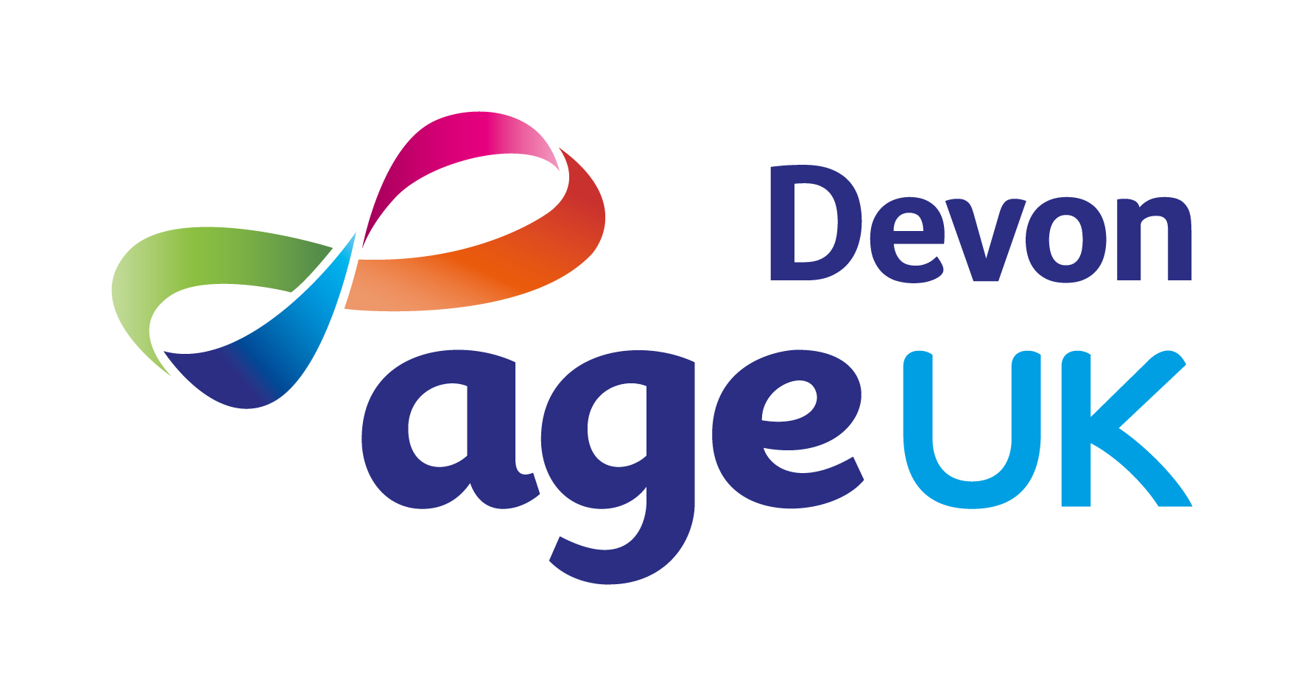
-

JOB DESCRIPTION

Role

Job Title: | Home Support Assistant
Accountable To: | Enabling & Home Support Manager

Job Purpose

Deliver the Enabling & Home Support Service, ensuring a high-quality professional service is provided to clients.

Key Responsibilities

Service Delivery

- Carry out household tasks for clients e.g., vacuuming, dusting, cleaning bathrooms, kitchens, laundry, ironing, washing floors and other surfaces and spring cleaning.

- Support clients to organise and attend appointments or social activities.

- Undertake light shopping for, or with, clients.

- Assist clients with household administrative tasks, e.g., filing paperwork.

- Plan and prepare light meals for clients.

- Report any concerns relating to the well-being of the clients to the Enabling & Home Support Manager.

- Manage allocated work via the Field Service App on the Age UK Devon smartphone provided.

Quality and Monitoring

- Always wear the provided Age UK Devon branded clothing (polo shirt & hoodie) and photo ID name badge during allocated work.

- Encourage the views of clients to inform current and future service provision.

Other

- Ensure that all work is carried out in accordance with Age UK Devon’s policies and procedures.

- Liaise with other Age UK Devon staff to ensure clients receive all other necessary services and support.

- Undertake any other reasonable and relevant duties appropriate to the role.

Personal Development

- Complete the mandatory employment induction including Communicating with Older People and Recognising Self Neglect training.

- Complete the mandatory e-learning modules during the probationary period and annually thereafter.

- Participate in one-to-one support sessions with the Enabling & Home Support Manager.

Age UK Devon’s Values

We want to be known for:
- Improving the lives of older people in Devon.
- Providing expert, clear, confidential advice and information to empower informed choices.
- Listening to needs and valuing contributions.
- Promoting and enabling active and fulfilling later lives.
- Promoting independence and wellbeing.

Additional Information

Age UK Devon is an Equal Opportunities employer and positively encourages applications from suitably qualified and eligible candidates, regardless of age, sex, race, disability, sexual orientation, gender reassignment, religion or belief, marital/civil partnership status, or pregnancy and maternity.

Age UK Devon is committed to safeguarding adults at risk from abuse and neglect. We expect everyone who works with us to share this commitment.

This job description is a guide to the general duties required of the post holder. The duties and responsibilities may vary from time to time and the job description may be changed at any time with the agreement of the postholder. Such variations are a common occurrence and would not justify the re-evaluation of a post.

PERSON SPECIFICATION

Education & Qualifications | Essential | Desirable
5 GCSEs including Maths & English at grade c or above (or equivalent). | ✓
Experience
Undertaking household tasks. | ✓
Working with older people who need support. | ✓
Working in other people’s homes. |  | ✓
Working for a charity. |  | ✓
Knowledge & Skills
Understanding of the health & social issues affecting older people. | ✓
Awareness of Age UK Devon’s services. |  | ✓
Knowledge of Devon’s voluntary and statutory sector organisations. |  | ✓
Excellent interpersonal, networking and communication skills. | ✓
Highly organised and able to plan and prioritise workload at each visit. | ✓
Sound judgement with good problem-solving abilities. | ✓
Ability to use a smartphone to operate a digital app and send/receive emails. | ✓
Other Requirements
The legal right to work in the UK. | ✓
A valid driving licence and use of a motor vehicle insured for business use. | ✓
Willingness to continue professional training and development. | ✓

