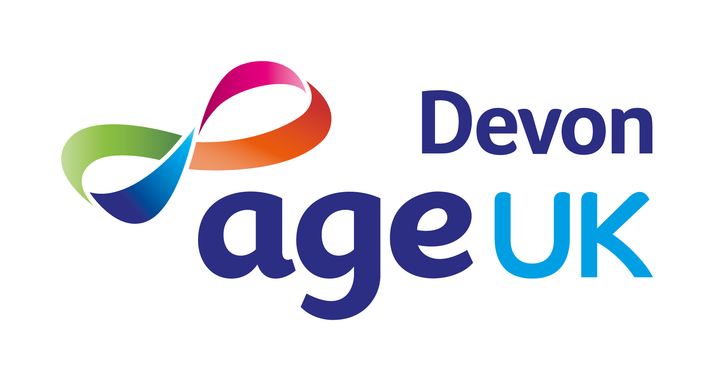

JOB DESCRIPTION

The Digital Champion programme will primarily address digital skills support, and provision of relevant technology and connectivity. Age UK Devon has received grant funding to deliver an 18-month programme (June 2022 until November 2023).

We aim to deliver a programme to tackle digital exclusion by embedding Digital Champions into frontline services, by providing ongoing support for older people to increase and improve their digital skills, and through the provision of loan technology to those older people without access.

Role

Job Title: | Digital Outreach Worker
Accountable To: | Digital Project Coordinator
Responsible For: | NA

Terms & Conditions

Grade: | Operations/Business Support 1.
FTE Salary: | £19,500 - £22,750 depending on skills and experience.
Hours: | 22.5 per week.  Some evening and week-end work may be required for which Time Off In Lieu can be taken.
Place of Work: | Age UK Devon, 1 Manaton Court, Matford Business Park, Exeter, EX2 8PF (Hybrid Working).
Contract Type: | Fixed term until 30 November 2023.  An extension may be possible if further funding is secured.
Annual Leave: | 20 days holiday (pro-rata) plus bank holidays with 1 extra day for each full year of service, up to a maximum of 24 days holiday plus bank holidays.
Pension: | An Auto-Enrolment Pension Scheme is in place with a 3% contribution from the employer, provided it is matched by a 5% contribution from the employee.

Job Purpose

- Facilitate outreach visits to promote digital awareness and generate referrals for on-going digital skills support sessions.

- Enable participation of older people who are unable to attend outreach sessions through the delivery of 1:1 digital support sessions in their homes, or remotely via Teams/Zoom.

Key Responsibilities

Service Delivery

- Work with the Digital Project Coordinator to initiate, develop and maintain relationships with key partners to promote the Digital Champion Programme for older people.

- Visit external organisations and community groups offering a mix of group or 1:1 digital awareness sessions and on-going digital support.

- Deliver digital awareness sessions and on-going digital support from community venues or remotely via Teams/Zoom.

- Liaise with the Digital Project Coordinator (and volunteers) to identify older people who are unable, or unwilling, to attend community venues, but who could benefit from and are interested in 1: 1 digital skills support.

- Visit older people in their homes to deliver 1:1 digital skills support sessions. If home visits are not possible sessions can be delivered remotely via Teams/Zoom etc.

- Support participants to make payments for sessions via BACs, Worldpay or SumUp.

Quality and Monitoring

- Ensure Learning Records are completed for all participants.

- Work with the Digital Project Coordinator to complete all monitoring requirements as defined within the grant agreement.

- Work with the Digital Project Coordinator to evaluate operational delivery to ensure the Charity Quality Services (CQS) standards are consistently applied.

- Encourage the views of older people to inform current and future service provision.

- Use quantitative and qualitative data to produce reports and statistics for the Chief Executive and Board of Trustees.

Other

- Ensure that all work is carried out in accordance with Age UK Devon’s policies and procedures.

- Liaise with other Age UK Devon staff to ensure clients receive all other necessary services and support.

- Attend staff meetings.

- Attend Board and Committee Meetings, as requested by the Trustees and/or Chief Executive.

- Represent Age UK Devon at meetings, conferences and events.

- Ensure that Age UK Devon works with Age UK, other members of the Age UK network, other national, regional and local voluntary, public and private sector organisations to promote the needs of older people and develop appropriate services.

- Undertake any other reasonable duties as requested by the Trustees, Chief Executive, or senior managers.

- Undertake any other reasonable and relevant duties appropriate to the role.

Personal Performance and Development

- Complete the mandatory employment induction including Communicating with Older People and Recognising Self Neglect training.

- Complete the mandatory e-learning modules during probationary period and annually thereafter.

- Actively participate in Age UK Devon’s Performance Management process.

- Maintain a commitment to professional development through a combination of formal and informal learning methods.

Age UK Devon’s Values

We want to be known for:
- Improving the lives of older people in Devon.
- Providing expert, clear, confidential advice and information to empower informed choices.
- Listening to needs and valuing contributions.
- Promoting and enabling active and fulfilling later lives.
- Promoting independence and wellbeing.

Additional Information

Age UK Devon is an Equal Opportunities employer and positively encourages applications from suitably qualified and eligible candidates, regardless of age, sex, race, disability, sexual orientation, gender reassignment, religion or belief, marital/civil partnership status, or pregnancy and maternity. We guarantee an interview to all candidates who meet the minimum criteria.

Age UK Devon is committed to safeguarding adults at risk from abuse and neglect. We expect everyone who works with us to share this commitment.

This job description is a guide to the general duties required of the post holder. The duties and responsibilities may vary from time to time and the job description may be changed at any time with the agreement of the post holder. Such variations are a common occurrence and would not justify the re-evaluation of a post.
PERSON SPECIFICATION

Experience | Essential | Desirable
Developing and delivering digital inclusion projects/sessions.
Working with older people, or other vulnerable groups, who need support. | ü
Working for a charity. |  | ü
Using a CRM database. |  | ü
Working from multiple bases e.g., home and office. |  | ü
Knowledge & Skills
Understanding and appreciation of how digital exclusion affects older people. | ü
Ability to explain the benefits of technology/digital inclusion in a clear and simple way. | ü
Excellent interpersonal, networking and communication skills. | ü
Confidence delivering group and 1:1 activities with older people. | ü
Ability to create impactful session plans based on the needs of the participant/s who may have different levels of knowledge and skill. | ü
Excellent IT skills (Microsoft Office Suite, Zoom, WhatsApp etc) and confidence in using different devices, including smart phones and tablets (Apple and Android), laptops, and smart speakers. | ü
Highly organised, able to plan and prioritise work, meet deadlines and use initiative. | ü
Proactive and able to work both individually and as part of a team. | ü
Sound judgement with good problem-solving abilities. | ü
Awareness of Age UK Devon services. |  | ü
Knowledge of Devon’s voluntary and statutory sector organisations. |  | ü
Other
The legal right to work in the UK. | ü
Use of a vehicle, a valid driving licence and insurance for business use. | ü
Willingness to continue professional training and development. | ü
Honest and reliable. | ü
Patient and understanding. | ü

