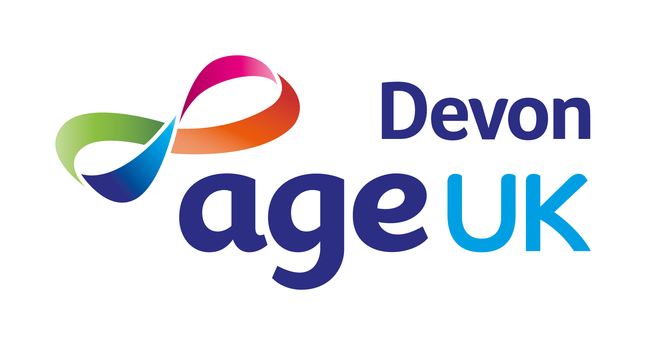

JOB DESCRIPTION

Role

Job Title: | Information & Advise Advisor
Accountable To: | Advice & Wellbeing Manager
Responsible For: | NA

Terms & Conditions

Grade: | Operations/Business Support 2
Salary Range: | £21,000 - £24,500 depending on skills and experience
Hours: | 30 per week
Place of Work: | Age UK Devon, 1 Manaton Court, Matford Business Park, Exeter, EX2 8PF (Hybrid Working)
Contract Type: | Permanent
Annual Leave: | 20 days holiday (pro-rata) plus bank holidays with 1 extra day for each full year of service, up to a maximum of 24 days holiday plus bank holidays.
Pension: | An Auto-Enrolment Pension Scheme is in place with a 3% contribution from the employer, provided it is matched by a 5% contribution from the employee.

Job Purpose
- Be the first point of contact, for clients and professionals, contacting Age UK Devon.

- Provide clear and accurate information and advice to clients on a variety of issues, including health and social care, welfare benefits and local services.

- Conduct telephone welfare benefit entitlement checks and complete benefit forms, e.g., Attendance Allowance, Pension Credit.

- Assist the Advice & Wellbeing Manager with supporting the I&A volunteers and allocating home visits.

Key Responsibilities

Service Delivery

- Answer the telephone in accordance with Age UK Devon’s Customer Service Standards.

- Actively listen and identify clients’ requirements ensuring that calls are dealt with or transferred to the appropriate member of staff.

- Provide information and advice to clients using Age UK’s literature and independent research.

- Identify situations when clients would benefit from more expert/in-depth advice from the Advice & Wellbeing Manager, or the Better Later Lives Coordinators.

- Conduct telephone welfare benefit entitlement checks for clients, and to support the completion of benefit forms, via telephone or face-to-face.

- Use Age UK Devon’s CRM system (CharityLog) to ensure that all client contacts and further actions required are recorded.

- Report any trends or concerns to the Advice & Wellbeing Manager.

- Maintain stocks of Age UK I&A literature.

- Ensure client confidentiality and data protection legislation is adhered to.

- Assist in allocating home visits to I&A volunteers and send confirmation information to clients.

- Be respectful and non-judgemental of older people's lifestyles, and to encourage them in choices and actions that are both acceptable and achievable to them.

Financial Management

- Ensure that work is delivered in a cost-effective manner, and in line with agreed budgets.

Quality and Monitoring

- Work alongside colleagues to ensure full compliance with required quality standards e.g., Charity Quality Services (CQS), Information & Advice Quality Programme (IAPQ) and Advice Quality Standards (AQS).

- Work closely with the Advice & Wellbeing Manager, to ensure that monitoring and reporting requirements are met for current projects.

- Encourage the views of older people to inform current and future service provision.

Other

- Ensure that all work is carried out in accordance with Age UK Devon’s policies and procedures.

- Liaise with other Age UK Devon staff to ensure clients receive all other necessary services and support.

- Attend staff meetings.

- Attend Board and Committee Meetings, as requested by the Trustees and/or Chief Executive.

- Represent Age UK Devon at meetings, conferences and events.

- Ensure that Age UK Devon works with Age UK, other members of the Age UK network, other national, regional and local voluntary, public and private sector organisations to promote the needs of older people and develop appropriate services.

- Undertake any other reasonable duties as requested by the Trustees, Chief Executive, or senior managers.

- Undertake any other reasonable and relevant duties appropriate to the role.

Personal Performance and Development

- Complete the mandatory employment induction including Communicating with Older People and Recognising Self Neglect training.

- Complete the mandatory e-learning modules during probationary period and annually thereafter.

- Complete I&A mandatory training during probationary period and ongoing thereafter.

- Actively participate in Age UK Devon’s Performance Management process.

- Maintain a commitment to professional development through a combination of formal and informal learning methods.

Age UK Devon’s Values

We want to be known for:
- Improving the lives of older people in Devon.
- Providing expert, clear, confidential advice and information to empower informed choices.
- Listening to needs and valuing contributions.
- Promoting and enabling active and fulfilling later lives.
- Promoting independence and wellbeing.

Additional Information

Age UK Devon is an Equal Opportunities employer and positively encourages applications from suitably qualified and eligible candidates, regardless of age, sex, race, disability, sexual orientation, gender reassignment, religion or belief, marital/civil partnership status, or pregnancy and maternity. We guarantee an interview to all candidates who meet the minimum criteria.

Age UK Devon is committed to safeguarding adults at risk from abuse and neglect. We expect everyone who works with us to share this commitment.

This job description is a guide to the general duties required of the post holder. The duties and responsibilities may vary from time to time and the job description may be changed at any time with the agreement of the post holder. Such variations are a common occurrence and would not justify the re-evaluation of a post.
PERSON SPECIFICATION

Education & Qualifications | Essential | Desirable
5 GCSEs including Maths & English at grade c or above (or equivalent) | ü
Experience
Provision of information and advice.
Working with older people who need support. | ü
Working for a charity. |  | ü
Using a CRM database. |  | ü
Working from multiple bases e.g., home and office. |  | ü
Knowledge & Skills
Understanding of Welfare Benefits applicable to older people.
Excellent customer services skills.
Understanding of the health & social issues affecting older people. | ü
Awareness of Age UK Devon services. | ü
Knowledge of Devon’s voluntary and statutory sector organisations. | ü
Excellent interpersonal, networking and communication skills. | ü
Highly organised, able to plan and prioritise work, meet deadlines and use initiative. | ü
Excellent IT skills - Microsoft Office Suite. | ü
Proactive and able to work both individually and as a team. | ü
Attention to detail. | ü
Sound judgement with good problem-solving abilities. | ü
Other
The legal right to work in the UK. | ü
Use of a vehicle, a valid driving licence and insurance for business use. |  | ü
Willingness to continue professional training and development. | ü

