19 July 2022

Dear applicant

Re: Application for Employment – Digital Outreach Worker

Thank you for expressing an interest in the above post at Age UK Devon.

Please refer to the online application pack which includes a job description/person specification, an application form and a Diversity and Equality monitoring questionnaire.

Your completed application form and monitoring form should be returned by the closing date, 12 August 2022 (midnight) by email to s.littlewood@ageukdevon.co.uk

All short-listed applicants will be notified by email, therefore if you have not heard from us by 16 August, please accept that your application has been unsuccessful. Interviews are scheduled to take place for short listed candidates on 19 August 2022 at our office.

Thank you for your interest and we look forward to receiving your completed application form.

Yours sincerely,

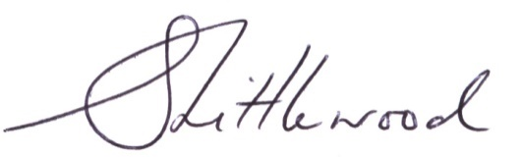
Sophie Littlewood
Chief Executive
Email: s.littlewood@ageukdevon.co.uk

