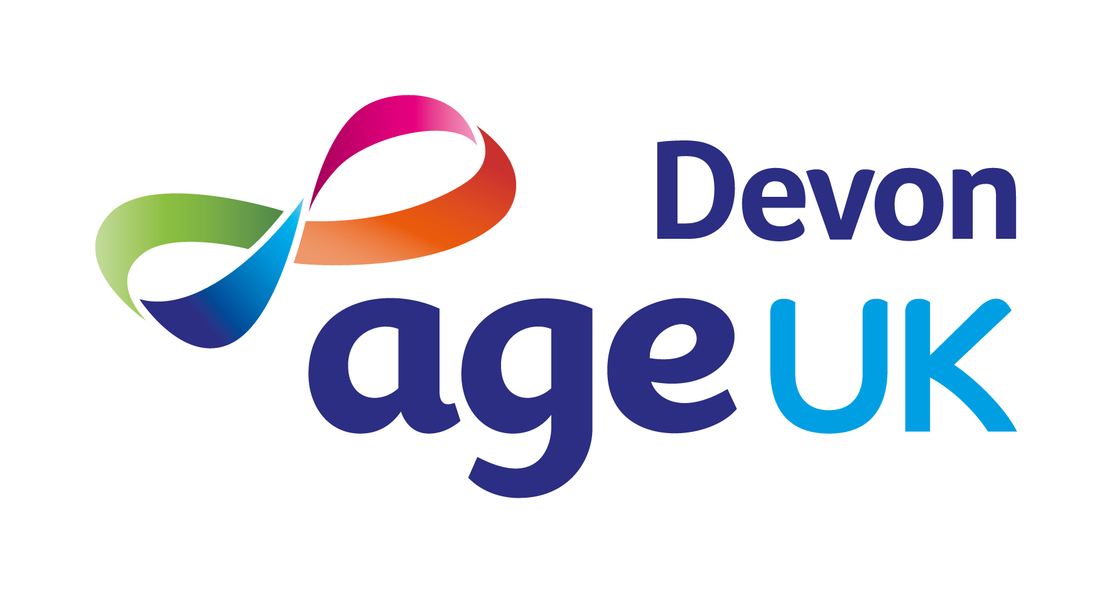

JOB DESCRIPTION

Role

Job Title: | Marketing Officer
Accountable To: | Chief Executive

Terms & Conditions

Grade: | Professional & Specialist 1
FTE Salary: | FTE of £27,791 per annum, increasing to FTE of £28,405 per annum on successful completion of probationary period.
Hours: | 30-37 hours per week
Place of Work: | Age UK Devon, 1 Manaton Court, Matford Business Park, Exeter, EX2 8PF  With some home working due to Hybrid Policy in operation
Contract Type: | 1-year fixed term contract  (potential for permanent extension thereafter)
Annual Leave: | During first year of employment: 28 days (20 days holiday + 8 bank holidays)  Over 2 years’ service: 29 days (21 days holiday + 8 bank holidays)  Over 3 years’ service: 30 days (22 days holiday + 8 bank holidays)  Over 4 years’ service: 31 days (23 days holiday + 8 bank holidays)  Over 5 years’ service: 32 days (24 days holiday + 8 bank holidays)
Pension: | An Auto-Enrolment Pension Scheme is in place with a 3% contribution from the employer, provided it is matched by a 5% contribution from the employee.
Benefits: | BUPA Employee Assistance Programme  The Blue Light Discount Card  Age UK Discounts Portal provided by Aon  Tickets for Good

Job Purpose

- Support the implementation of Age UK Devon’s annual Marketing and Communications Plan in line with strategic objectives.

- Ensure brand compliance by applying Age UK’s Brand Guidelines.

- Assist in designing and maintaining branded content across print, digital, and social platforms to promote the charity’s work.

Key Responsibilities

Marketing and Communications

- Support the relevant teams in delivering, and reviewing, the annual Marketing and Communications Plan aligned with organisational priorities.

Support marketing initiatives that enhance service delivery, brand visibility, and stakeholder engagement.

- Assist in creating compelling content across digital, print, and media channels to promote services and enhance the charity’s profile.

- Support national Age UK campaigns and maintain alignment with network-wide marketing efforts.

- Assist with designing and producing branded marketing materials using tools like Adobe Suite and Canva.

- Work with Managers to draft and distribute agreed press releases; build and maintain media and partner relationships.

- Maintain and update website content, social media strategy, and digital engagement using tools like Google Analytics and Facebook Insights.

- Support Managers with tracking and coordinating marketing-related expenditures.

- Distribute branded materials across teams.

Quality and Monitoring

- Assist in monitoring marketing effectiveness.

- Ensure brand consistency by adhering to Age UK guidelines and support internal brand awareness.

- Produce data-driven reports for leadership, trustees, and funders.

Other

- Ensure compliance with Age UK Devon’s policies and procedures.

- Participate in staff, board, and committee meetings as required.

- Represent the charity at events and in external partnerships.

- Collaborate with Age UK and sector partners to support older people.

- Perform other duties aligned with the role and organisational goals.

Personal Performance and Development

- Complete mandatory induction and annual e-learning requirements.

- Engage in the Performance Management process.

- Commit to ongoing professional development through formal and informal learning.

Age UK Devon’s Values

Our values underpin how we work and help us achieve our mission.

- We support older people in Devon to take positive action to improve their lives, independence and wellbeing.

- We provide clear expert quality assured information, advice and support to help older people make informed choices about their lives.

- We embrace the diversity of our clients, staff and volunteers; and we listen to and value all contributions.

- We promote and enable active and fulfilling later lives.

- We encourage meaningful social connections to tackle loneliness and isolation.

Additional Information

This role works under supervision or as part of a team. Decisions are made in consultation with senior staff or within defined parameters.

Age UK Devon is committed to safeguarding adults at risk from abuse and neglect. We expect everyone who works with us to share this commitment.

This job description is a guide to the general duties required of the post holder. The duties and responsibilities may vary from time to time and the job description may be changed at any time with the agreement of the post holder. Such variations are a common occurrence and would not justify the re-evaluation of a post.
PERSON SPECIFICATION

Education & Qualifications | Essential | Desirable
5 GCSEs including Maths & English at grade c or above (or equivalent)
Degree, postgraduate or professional qualification in marketing or related field.
Experience
Min 1 years’ experience in a marketing or communications role.
Supporting website and social media platform management.
Working with older people who need support.
Working for a charity.
Working from multiple bases e.g., home and office. |  | ü
Knowledge & Skills
Knowledge of marketing techniques and principles.
Understanding of social media and website analytics e.g., Facebook Insights, Google Analytics.
Understanding of the health & social issues affecting older people.
Awareness of Age UK Devon services.
Knowledge of Devon’s voluntary and statutory sector organisations.
Excellent interpersonal, networking and communication skills.
Highly organised, able to plan and prioritise work, meet deadlines and use initiative.
Excellent IT skills: Microsoft Office365, Adobe Design Suite, Adobe Acrobat, Canva.
Creativity and commercial awareness.
Proactive and able to work both individually and as a team.
Attention to detail.
Sound judgement with good problem-solving abilities.
Other
The legal right to work in the UK.
Use of a vehicle, a valid driving licence and insurance for business use.
Willingness to continue professional training and development.

