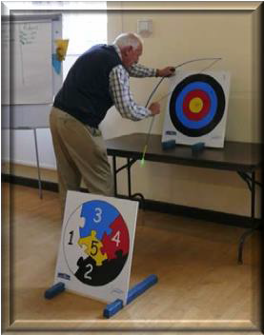
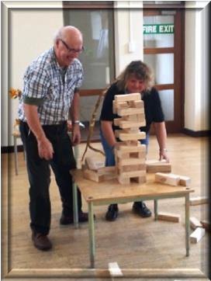
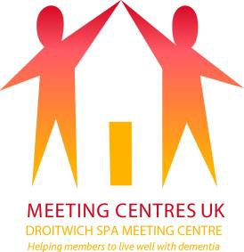

Droitwich Spa Meeting Centre
- helping members to live well with dementia

Interim arrangements from Wednesday 6th September

Unfortunately, it has not been possible to arrange for the Meeting Centre to stay open in its current form but from Wednesday 6th September we have arranged the following:

Staff: A member of staff from Age UK (H&W) will host a 3 hour session from 1pm to 4pm on a Wednesday, Thursday and Friday, which will include an activity, plus tea/coffee/cake.

Title: Meeting Centre Friends Together Club

What: This will be an opportunity for people to get together, chat, support each other, engage in an activity and have some fun while we work towards getting the full Meeting Centre programme operational again.

Who: As this will be a reduced service, run by just one member of staff, if the member with dementia needs supervision it will be the responsibility of the family member/carer to ensure this is appropriately covered. During this interim period we will not be recruiting/taking in new members.

Where: Droitwich Spa Rugby Club, Hanbury Road Droitwich, Worcestershire, WR9 7DU

When: Every Wednesday, Thursday and Friday

Time: 1pm - 4.00pm

Cost: £12 per session for current Meeting Centre members and their family member/carer (one payment to cover both) from week commencing 17th September. Taster sessions are free until that date.

Longer term arrangements
We will continue to explore the options for re-opening a fully functioning Meeting Centre and getting a full 3 day programme operational again. This is expected to take around 3 months. We will keep you informed about this. When it does re-open we anticipate that we will be asking members to make a contribution of £25 a day (to include lunch) if they attend for the full day or £12 for a morning or afternoon session (excluding lunch).
More information:
If you would like more information or to discuss what is proposed please get in touch will me by calling 07971220671 – leave a message if I don’t answer or by emailing alanhumphries1917@outlook.com.

Councillor Alan Humphries
Chair – Droitwich Meeting Centre CIO

DROITWICH SPA MEETING CENTRE
Registered Charity Number 1172997

