St Andrew’s Church Community Café, Highbridge Road, Netherton, DY2 0NW  Want to have some cracking conversation. Make new friends or renew old friendships.  Chat, play dominoes, card games or knit.  Tea, coffee and biscuits.  £1 donation.  Takes place last Thursday of each month from 10.00am - 12.00pm  Contact: Sue Ridley  Tel: 07711 049310  Photography Group  St James House, Trinity Road,  Dudley, DY1 1JB  Join us every Monday and Wednesday 9.30am - 12.30pm  Contact: Robert Couldrey  Tel: 01384 894672  Email: thepics2014@gmail.com  International Old People’s Day  Civic Hall, Brierley Hill, DY5  1 October 2018  From 10.30am - 2.30pm  Event includes gentle chair exercise  Smoothie demonstration  Relaxation and reminiscence  FREE ENTRY  For further information contact Reception on 01384 354508 or email receptionhq@ageukdudley.org.uk  New Zumba Gold Class  Age UK Community Café  Ettymore Road, Sedgley, DY3 3SG  Low impact modified dance fitness  Small class suitable for nervous beginners and returners to exercise  Monday 10.00 - 10.45am  £3.50  Contact Age UK Sedgley to book your place  Tel: 01902 883847 | Knit & Natter  Brierley Hop House, Brierley Hill,  DY5 1XD  Get involved in the Age UK Big Knit  Starts Tuesday 25 September 2018  Then every Tuesday 2.00 - 3.00pm  Contact: Sue Buckingham/Maggie Brookes  Tel: 07866 492108/01384 343535  Email: maggie.brookes@ageukdudley.org.uk  Dominoes and Darts Club  Pensnett Community Centre, High Street, DY5 4JQ  Come along for a game of dominoes and darts every Monday from  12.30 - 2.30 pm  Refreshments provided  £2 per week  Contact: Elaine Blakeway  Tel: 01384 79521  www.communitycentrepensnett.co.uk  Get Moving to Music  Jack Newell Court, Jevon Street,  Coseley, WV14 9LW  Suitable for people returning to exercise and any nervous beginners  Wednesday 2.00 - 2.45pm  £3.00  Contact: 01384 816998  Coffee Morning  Jack Newell Court, Jevon Street,  Coseley, WV14 9LW  Meet new people, make new friends Wednesday 10.30am - 12.00pm  Contact: 01384 816998  Family History  Dudley Wood Neighbourhood Learning Centre, Pavillion Gardens,  Dudley, DY2 0DB  Who do you think you are?  Chase your ancestors  Monday 10.00 am – 12.00 pm  Contact: Sue Bengough  Tel: 01384 255640 | Newsletter September/ October 2018  - These events are endorsed by  - Age UK Dudley  Hi everyone,  - Just to let you know what activities  are taking place in the Dudley Borough during September and October  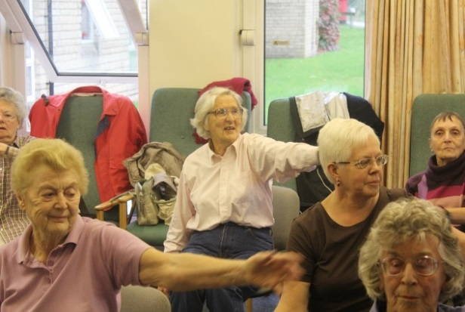  Craft and Chat  Cradley Library, Colley Lane, Cradley  Takes place first Thursday of every month from 10.30am - 12.30pm  Contact: Barbara Meredith  Tel: 01384 636533  Friends & Family Coffee Morning  Ashgrove Care Home  Dudley Wood, Netherton, DY2 0DA  Meet new people, make new friends.  Join us every Wednesday  from 10.30am -12.00pm  Contact: Alison  Tel: 01384 413913  Knit & Natter  Age UK Community Café  Ettymore Road, Sedgley, DY3 3SG  Starts Tuesday 9 October 2018  Then every Tuesday  Contact: Age UK Sedgley on 01902 883847  for further information

