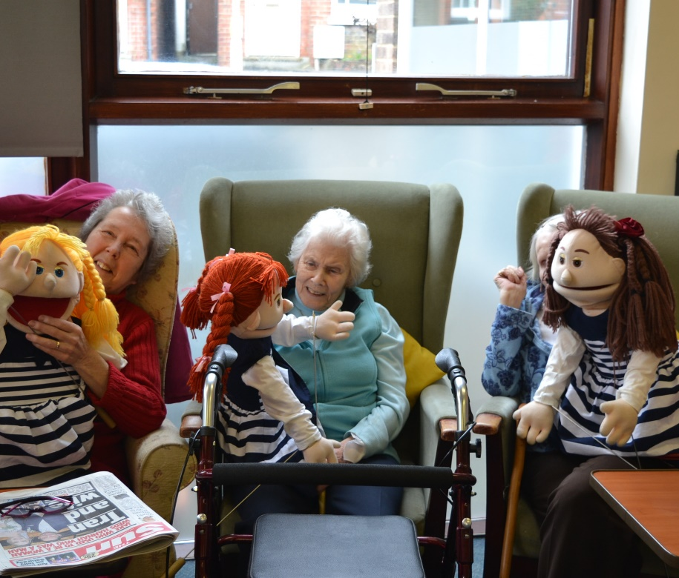

Recruitment Pack

Activity Coordinator
June 2021

Table of Contents

About Age UK East Grinstead & District

What we do across East Grinstead and the local area.

Role

Job description
Person specification

How to apply and interview arrangements/cookery test

Application Form
Equality & Diversity form (please return separately)
There will be a formal interview by a panel together with a short 15-minute practical interaction exercise (which you need to prepare for) with our members on the day of the interview.

Closing date for applications

Friday 18th June 2021

Interviews will take place during weekending.

Friday 25th June 2021

What we do across East Grinstead and the local area

Activity Centre
Our Activity Centre is based at Glen Vue it is the hub of our operations. Our office staff are there and nearly all our services are delivered from there including the lunches served, Monday through to Friday. We have regular Talks, Entertainers and presenters, Card and board games, Bingo, Computer and tablet classes. Musical Fridays or for those that want to, a friendly place to chat with likeminded souls.
Rainbow Hot Meals
During 2020, we set up a home delivery service of hot lunch time meals delivered to vulnerable older people’s homes by a dedicated team of our volunteer drivers and members of the East Grinstead Lions.
Trips, Outings and Holidays
Each year we arrange many day trips, outings to places of special interest, and a group holiday.
Day breaks for Carers
Our carers respite service was established in 2003 by Age UK East Grinstead, the County Council and the Alzheimer’s Society. It was initially designed to support carers or family members of those living with dementia or memory loss but now also caters for the elderly and frail. This operates every 1st and 3rd Saturday of each month and with the growing need for this type of service we are looking to operate this through the weekdays as well.

Activity Coordinator

JOB DESCRIPTION

Introduction

The object of Age UK East Grinstead & District is to support older people and Carers in East Grinstead and the surrounding areas. Based at Glen Vue in Railway Approach, East Grinstead, we provide a ‘home from home’ environment where we offer a variety of activities and services for older people with a wide range of needs and abilities. In addition, we run Trips, Outings and Holidays, as well as a range of other projects in the Community including the “Rainbow Hot Meals” service. Respite for carers service run the 1st and 3rd Saturday of each month.

Salary: £ 8,580 per annum (for a 15-hour week) plus additional monies and hours for covering Community Centre Manager’s holidays and absences.

Accountable to: Community Centre Manager

Location: Glen Vue Centre, Railway Approach, East Grinstead, RH19 1BS

Hours: 15 hours per week

Job summary:

- The post holder will act as Coordinator for the management of a service facilitating social, cultural and leisure activities for older people at the Glen Vue Centre. Also covering any holidays or absences of the Community Centre Manager (normally planned and agreed in advance).

- The post holder will have a significant role in reducing social isolation through developing activities and events, including volunteering opportunities and promoting these to older people.

- The post holder will be responsible for liaising with Volunteers and other personnel to recruit and train suitable volunteers to assist in the administration and delivery of the service.

- The post holder will liaise with professionals from statutory and voluntary sector within the district to promote the service and develop opportunities for joint activities.

MAIN RESPONSIBILITIES

- To facilitate collaborative working with all agencies in health, Social Services and the voluntary sector to promote the service and create opportunities to reduce social isolation.

- To act as coordinator for the management of a service facilitating social, cultural and leisure activities for older people across the East Grinstead district to promote health and well-being.

- To identify opportunities to develop the service in liaison with the Community Centre Manager and other colleagues.

- To research social, cultural and leisure activities available, identify gaps and create further opportunities through working with other organisations, commercial settings and other providers.

- To take responsibility for managing all bookings for events and regular activities promoted by the service.

- To ensure that the Charity meets all necessary requirements on its external afternoon trips when supervising.

- To carry out risk assessments for all activities and events, with regard to venues, accessibility, transport options, procedures for payment and members’ own health and disabilities.

- Where handling of money is required, to comply with the Charity’s policy as stated in Employee Handbook and with procedures agreed with the Board of Trustees.

- To produce a monthly calendar of events and opportunities to promote to members, assisted by volunteers where necessary.

- To ensure the members all receive information about forthcoming activities and events, including the monthly calendar, using a variety of media to contact them, assisted by volunteers where necessary.

- To provide all members with information about transport and accessibility arrangements and options, and, where necessary, assisting members to make arrangements, assisted by volunteers.

- To facilitate regular activities such as coffee mornings, social and leisure groups and outings and trips, assisted by volunteers.

- To help volunteers and members establish ground rules (confidentiality, sharing of contact details etc)

- To support volunteers in welcoming and including new members as well as ascertaining members’ interests in order to develop new activities and events.

- To widen the membership through promotional activity and liaison with other service providers, in addition to other colleagues within the Charity.

- To register members, obtaining contact details and other essential information and ensuring the information is recorded on Charitylog.

- To recruit and provide training for volunteers, in line with our Volunteer Policy, and to work to ensure the development of appropriate skills and competencies for volunteers.

- To work with the Community Centre Manager to ensure sufficient numbers of volunteers are recruited and trained in order to maintain and further develop the service.

- To arrange regular supervision and support for volunteers

- To record, maintain and provide monthly and quarterly statistical and qualitative data for the monitoring, evaluation and development of the service.

- To obtain regular feedback from members about activities and events to ensure quality is maintained with regard to venues, facilities, activities, transport etc.

- To produce or arrange for promotional material for special events or activities and organise, attend and present at publicity events to raise awareness of the service with the general public.

- To comply with all the Charity’s policies and procedures with particular regard to Equal Opportunities, Health and Safety and Confidentiality.

- Attend training courses and other meetings as required.

- Attend regular supervision and annual appraisals.

- To be committed to the Charity’s policy and procedures on keeping adults safe from abuse, ensuring that all abuse is reported to the Community Centre Manager and that safeguarding is embedded in all decisions and actions.

- To undertake any other duties as may be reasonably required by the line manager.

This job description may be subject to change in consultation with the post holder. The post holder will be required to work flexibly in accordance with service and organisation needs.

ACTIVITIES CO-ORDINATOR

PERSON SPECIFICATION

Job title:
Activity Coordinator

Criteria: -  E= Essential D = Desirable | E or  D
Ability to initiate, develop and support volunteer projects including:  Recruitment, selection and initial training of volunteers  Liaise with existing management staff to ensure on-going volunteer supervision, management and training.  Understanding of the needs of older people including those who are particularly isolated and vulnerable.  Ability to write reports, maintain records and communicate effectively (in writing and verbally)  To demonstrate an open minded and friendly approach to individuals avoiding stereotyping and pre-judgement and at all times adopting a professional approach to work, service users and volunteers, actual and potential.  Ability to promote the work of the Charity and the service by liaising and networking with other agencies and local older people’s groups.  Ability to publicise the work of Charity and the service both verbally and in the production and provision of publicity/promotional materials.  Well-developed organisational skills, including management of volunteers, researching and establishing new activities, managing bookings and a calendar of events  Able to cover any holidays or absences of the Community Centre Manager,  Capacity to build positive rapport with volunteers, members, colleagues and other professionals  Excellent communication skills, with the ability to communicate effectively and creatively, both verbally and in writing  Ability to work with the minimum of supervision and to demonstrate imagination and initiative as well as being proactive. To work as part of a team and seek and offer/receive appropriate support to/from other staff.  Excellent interpersonal and team working skills with abilities to support and motivate volunteers.  Computer literate, able to use Microsoft packages, email, the internet, web searches and databases  Understanding of quality systems and abilities to ensure collection of electronic data efficiently in order to provide statistical evidence for analysis.  Knowledge of local services and support available to older people; problem solving abilities to support client to achieve independence  To be aware of, and comply with, the Charity’s policies with particular regard to Equal Opportunities, Health and Safety, Confidentiality and Safeguarding vulnerable adults.  Demonstrate an understanding of Health & Safety, and Risk assessment policies and practice especially when supervising afternoon trips.  This post is subject to a check through the disclosure and barring service | E  E  E  E  E  E  D  E  E  E  E  E  E  E  D  D  E  E  E

How to Apply
Application forms only, please no CV’s together with a completed Equal Opportunities form seperately to the Chief Operations Manager

If you wish to enquire more about this opportunity, please call the Community Centre Manager on 01342 327046

Please email your completed application to:

community@ageukeastgrinstead.org.uk

Or post it to:
Community Centre Manager
Age UK East Grinstead & District
Glen Vue Centre
Railway Approach
East Grinstead
RH19 1BS

Please email your completed Equal Opportunities form to:

operations@ageukeastgrinstead.org.uk

Or post it to:
Chief Operations Manager
Age UK East Grinstead & District
Glen Vue Centre
Railway Approach
East Grinstead
RH19 1BS

Please complete this form in
BLACK INK & CAPITALS and return to:

Community Centre Manager
Age UK East Grinstead & District
Glen Vue Centre
Railway Approach
East Grinstead
RH19 1BS

Alternatively email to community@ageukeastgrinstead.org.uk

STAFF APPLICATION FORM

Only information submitted on this form will be considered when assessing your application.

CVs will not be accepted.

Post Applied for: Activity Coordinator

Surname:

First Name(s):

Address:

Telephone No:

Mobile No:

Email:

What is the best method to contact you? Telephone / Mobile / Email

EDUCATION/ACADEMIC QUALIFICATIONS
Please start at the top with your most recent education/academic history.

School/Further Education | Dates Attended from/To  (Month & Year) | Qualifications Gained | Grade(s)  Achieved
Specific Training Relevant to this Position | Date  (Month & Year) | Qualification  (if relevant) | Grade  (if relevant)

EMPLOYMENT HISTORY

From/To
(Month & Year)
Employer’s Name & Address
Position Held/ Reporting To/Brief Summary of Work
Reason for Leaving.

Final/Current Salary

EMPLOYMENT HISTORY (continued)

From/To
(Month & Year)
Employer’s Name & Address
Position Held/ Reporting To/Brief Summary of Work
Reason for Leaving.

Final/Current Salary

From/To
(Month & Year)
Employer’s Name & Address
Position Held/ Reporting To/Brief Summary of Work
Reason for Leaving.

Final/Current Salary

From/To
(Month & Year)
Employer’s Name & Address
Position Held/ Reporting To/Brief Summary of Work
Reason for Leaving.

Final/Current Salary

Why do you want to work for us?
Summarise why you would like this job and why you think you are a good candidate. Please relate your skills, knowledge and experience to the Job Description and the criteria in the Person Specification. Please use headings and extra pages if you wish.

Personal Contacts
Please detail any personal contacts or relatives working within Age UK East Grinstead & District on either an employed or voluntary basis:

_________________________________________________________________________

_________________________________________________________________________
References

Please give the names and addresses of two referees, one of whom should be your current or most recent employer (if you have worked for your current employer for less than 5 years, we may also need to contact previous employers). The other referee should have known you for at least two years and MUST NOT be a family member. If your circumstances mean that you are unable to provide current references, we will be happy to discuss this further with you.

Please give contact details for two referees who meet the above criteria:

Current/Most Recent Employer

Name:

Company Name:

Position in Company:

Address:

Telephone No:

Email Address:

Relationship to You?

Can we approach this referee before interview?

Additional Referee

Name:

Address:

Telephone No:
Email Address:

How Known to You?

Time Known to You?

Can we approach this referee before interview?

Next of Kin/Emergency Contact:
Please give details of your Next of Kin or someone to be contacted in the event of an emergency involving yourself:

Name:

Address:

Telephone No:

Mobile No:

Relationship to You:

Illness
How many days have you been absent from work in the last three years due to illness?

________________________________________________________________________

On how many occasions have these absences occurred? ___________________________

Disclosure of Criminal Convictions

Do you have any convictions, cautions, reprimands or final warnings that are not “protected” as defined by the Rehabilitation of Offenders Act 1974 (Exceptions) Order 1975 (as amended in 2013)?

YES NO

The amendments to the Exceptions Order 1975 (2013) provide that certain spent convictions and cautions are “protected” and are not subject to disclosure to employers and cannot be taken into account.

Guidance and criteria on the filtering of these cautions and convictions can be found on the Disclosure and Barring Service website.

If you have ticked yes, please summarise details below.

________________________________________________________________________
________________________________________________________________________

________________________________________________________________________

Previous convictions will not prevent full consideration of your application to work with Age UK East Grinstead & District. Failure to disclose a criminal conviction whilst securing a post could result in the end of the staff member’s employment. A Disclosure and Barring Service (DBS) Enhanced check will be requested for all staff and volunteers undertaking specific roles.

Are you happy for the organisation to submit your name for a DBS (Disclosure and Barring Service) check:

Yes No – please indicate why __________________________________

How We Use Your Personal Information on this Form

The information you have provided on this form will be processed in line with the General Data Protection Regulations of April 2018. We will keep your personal details safe and will not share them with other organisations.

I understand that my personal details will be kept securely and will be entered onto the Age UK East Grinstead & District database system. I agree to Age UK East Grinstead & District processing and retaining the personal information contained on this form for any purposes connected to my application.

DECLARATION:

I confirm that the information given in this application is accurate and complete and that it may form the basis of a Contract of Employment with Age UK East Grinstead & District.

I understand that any false statement will be sufficient cause for rejection or, if employed, dismissal.

Signed: __________________________________________ Date: _______________

Printed: __________________________________________
EQUAL OPPORTUNITIES MONITORING FORM –
STAFF, TRUSTEES & VOLUNTEERS

Age UK East Grinstead & District aims to treat everyone fairly and according to their needs, to ensure that services are free from discrimination and prejudice. We also want to make sure that we can support as many people as possible with different needs and from different backgrounds and cultures. To help us do this we would be grateful if you would answer the questions below. Providing this information enables us to monitor our approach to equalities and all information given will be treated in strictest confidence and stored securely.

The form will not be used at any stage in the selection process. A disability or health problem does not preclude consideration for the job and applications from suitable people with disabilities are welcome. Please tick boxes as applicable.

Date of Birth ____________________

Your Gender Male Female Prefer not to say
Your Ethnic Origin:

White | British
 | Irish
 | Any other White background – please specify ......................
Mixed | White & Black Caribbean
 | White & Black African
 | White & Asian
 | Any other Mixed background – please specify ......................
Asian or Asian British | Indian
 | Pakistani
 | Bangladeshi
Any other Asian or Asian British background – please specify.

...............................................
Black or Black British | African
 | Caribbean
Any other Black or Black British background – please specify.

...............................................
Other | Chinese
 | Romany Gypsy/Irish Traveller
 | Any other ethnic background – please specify ......................
No Response | Prefer not to say

Your Sexual Orientation Your Religion/Belief

Heterosexual |  | Christian
Bisexual |  | Buddhist
Homosexual/Gay/Lesbian |  | Hindu
Transgender |  | Jewish
Other |  | Muslim
Prefer not to say |  | Sikh
 |  | Other – please specify .........................
 |  | None
 |  | Prefer not to say

Do you consider yourself to have a disability or long-term illness?

Yes please specify.

- And do you need require any reasonable adjustments to assist you with the application and interview process.

..........................................................................................................................................................................................................................................................................................................................................................................................

No | Prefer not to say

Thank you for taking the time to complete this form.

Please return to:

Chief Operations Manager
Age UK East Grinstead & District
Glen Vue Centre
Railway Approach
East Grinstead
West Sussex
RH19 1BS
E-mail: operations@ageukeastgrinstead.org.uk

