To make a one-off donation to Age UK East Sussex, please fill in the form and return it to: Fundraising Team, Age UK East Sussex, 54 Cliffe High Street, Lewes, East Sussex, BN7 2AN. Alternatively you can phone 01273 476704 and give your instructions over the phone.
Your details
Title | First Name |  | Surname
Address
 |  |  | Postcode
Home Phone |  | Mobile
Email Address

We would like to let you know about the vital work we do for the older people, our fundraising appeals and opportunities to support us, as well as our services. We will never sell your data and we promise to keep your details safe and secure.

I would like Age UK East Sussex to contact me in the following ways:
☐ None ☐ Email ☐ Telephone ☐ Post ☐ SMS

You can change your mind at any time by phoning 01273 476704 or writing to our Fundraising Team at the address given above or emailing fundraising@ageukeastsussex.org.uk. If you want to know more about how your data is used and stored please visit our website www.ageukeastsussex.org.uk.

Your gift
I enclose a cheque made payable to Age UK East Sussex
I would like to make a gift of £_______________________
☐ I do not need a thank you/receipt for this donation.

If you wish to make a gift using Card Payment please call 01273 476704 or email fundraising@ageukeastsussex.org.uk

Gift Aid Declaration

Please add to your donation through Gift Aid.
If you are a UK tax payer, we can reclaim 25p for every £1 you donate

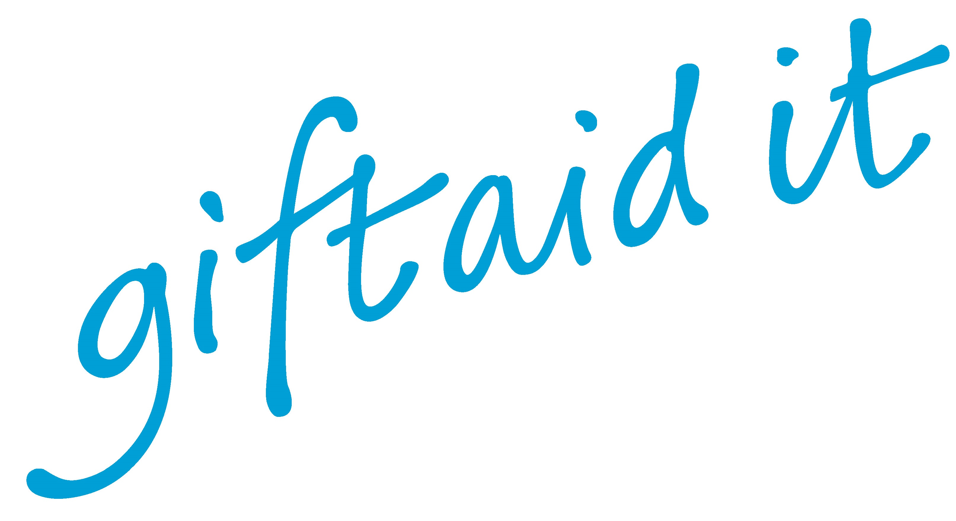
☐ Yes, I want Age UK East Sussex to treat all donations I have made for the four years prior to this year, and all donations I make from the date of this declaration until I notify you otherwise, as Gift Aid donations. I am a UK tax payer and understand that if I pay less income tax and/or capital gains tax than the amount of Gift Aid claimed on all my donations in that tax year it is my responsibility to pay any difference.
Today’s Date_____/_____/_____

Please let us know if you wish to cancel your declaration, or if your tax status, name or address changes.
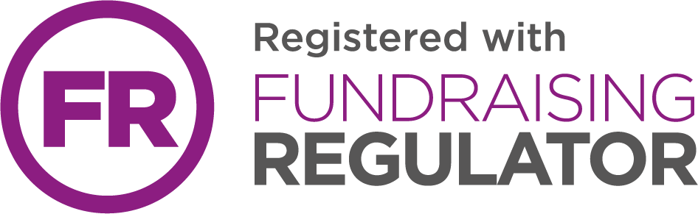
Thank you

