**Falls Prevention** 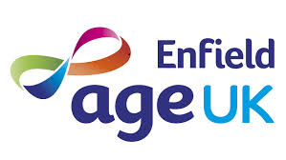

**free training in Enfield**

**Do you want to help prevent Falls in Enfield?**

Age UK London (in conjunction with Age UK Enfield and Enfield CCG) is providing **practical, free training in Enfield on preventing Falls** including:

* Risk factors for Falls and Frailty including diet, medications, footwear, bone health, reduced vision, mobility, hazards and many others
* Falls Risk Assessment using recognised tools.
* Enfield ‘Falls Services’- how to access these services
* Importance of exercise and self- care in Falls Prevention
* A free comprehensive, Falls Prevention Resource pack with handy tips, guides and useful contacts

**Training Sessions**

Each session will take place in the Dugdale Centre, Enfield, commencing 9:30am and finishing 12:45am, with a refreshment break (teas and coffee). Partcipants can choose **one** of the following training sessions – content is the same for every session

***(All 2018) – 27 April, 22 May, 28 June, 20 July or 27 September***



***Places are limited so book early to avoid disappointment!***

To book a place email [general@ageuklondon.org.uk](mailto:general@ageuklondon.org.uk) and indicate which session you are interested in. Age UK London will try and accommodate you but may request you attend an alternative date if your chosen session is full.