A guide on how to complete Attendance Allowance forms
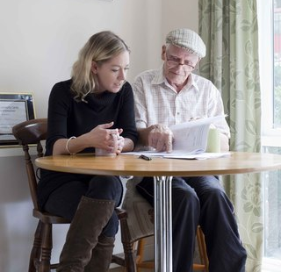

Help and advice on applying for this benefit for yourself or someone else
Attendance Allowance is extra money from the government for older people who have a longer-term disability or health condition which affects their ability to look after their personal care or keep themselves safe.
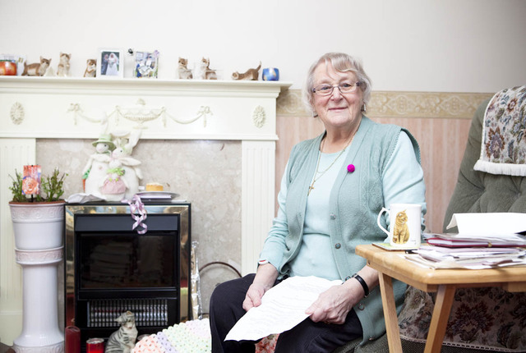
Attendance Allowance is not means-tested. You won't be asked about your income or savings when applying and it is also tax-free. If it is awarded, you’ll have full control over it and can spend it as you like. It can help with the extra costs of having a disability or health issue.
If you are 65+, you can apply for Attendance Allowance. There are 2 rates: a lower rate if you have care or supervision needs during the day or night and a higher rate if you have care or supervision needs during the day and night.
To request an application form call the Department for Work and Pensions (DWP) Attendance Allowance unit on 0800 731 0122. You can also complete the form online: https://www.gov.uk/attendance-allowance/how-to-claim. The form can be a bit daunting at first sight but please don’t be put off by it!
There could be more money you’re entitled to
Being awarded Attendance Allowance may mean you, or someone that cares for you, could become eligible for extra money like Pension Credit, Carer’s Allowance, Council Tax reduction or a discount, Housing Benefit and Warm Home Discount. If could increase your existing entitlement or mean you become entitled for the first time. Why not ask us for a full benefits check?
If you're finding it difficult to complete the form yourself, please call us on (insert contact details) and we’ll try to help further.
Remember to think about the help that you need and not just the help that you get; you do not have to be physically receiving any care to qualify.
You will need to state how you manage different tasks within your daily routine so you should think in terms of what difficulties you have. Describe ‘what help you need’ as well as any help that you get. If you live alone you may not get any help but this does not mean that you would not benefit from help - so think about the help you ideally need and put this in the form.
A person called a ‘decision maker’ at the DWP’s Attendance Allowance unit in Wolverhampton will assess your claim. They will look at your form to see how you cope with daily and weekly tasks which they term ‘bodily functions’ (by this, they mean anything to do with your body and how it works). This includes: washing, bathing, dressing, moving around indoors, managing medication, getting in/out of bed etc. They also look at whether you need prompting, supervising or motivating to complete these.
You’ll need to explain why you have difficulties and which illnesses or disabilities affect you in completing the task. Some tasks may not be a problem in themselves, but your level of mobility may prevent you from completing them quickly, repeatedly or easily. If you can only do certain tasks with pain or difficulty, or if someone must remind you to do them, say so.
It is important to remember that for an award to be granted, the 'decision maker’ will be looking at the effects on your ‘bodily functions’ mentioned earlier. They are not very concerned with any difficulties you have with domestic tasks like housework, gardening or shopping. (However, if you do get Attendance Allowance there is nothing to stop you spending it on help with these tasks.)
Do not worry about repeating the difficulties you face on different questions on the form. This helps to show how often these things affect you and will be taken into account by the ‘decision maker’.
You may find it helpful to keep a diary; write in it whether you find certain tasks difficult and how long it takes you to complete them. Try and consider the bigger picture when answering questions on the form. Don’t just look at whether you can complete a task, look at how you complete it, the process from start to finish and how long it takes.
You may perform some tasks differently to how you used to do them. Write how you have adapted the way you perform the tasks so you are able to cope. Write about whether you need help from people or need to use aids or equipment to do certain things.
Sections of the Form
Details of your illnesses and disabilities
You will need to list your conditions/health issues on the form- make sure you include them all! Say how long you have had these conditions; approximate length of time is ok. The 'decision maker’ is mainly interested in issues you have had for 6+ months as you need to have had your problems for at least 6 months in order to meet the eligibility criteria. Attaching a recent prescription list to the form will save you having to write down all your medications.
Medical Professionals (other than your GP)
You can give details of any medical professionals (such as hospital doctors, consultants, district nurse, occupational therapist) that you have seen in the past 12 months. If you have seen more than one then you can put their details in the Extra Information section at the end of the form. It would be a good idea to include copies of any letters you have received from these people. You can sign to give consent for the DWP to contact these people; they may be able to provide information to support your application.
Medical reports, tests and other supporting evidence
There is space to write in any recent health-related tests you've had. Even if you haven’t had the results yet, or the result was simply ‘ongoing monitoring of my condition’ you can still include it.
It’s helpful to send in supporting documents from medical professionals, or other people involved in your care, with your application. These could be a discharge summary or a consultant’s report or a care plan. If it is likely to take extra time obtaining these supporting letters, explain on the form that you will forward them when you get them. Your GP may provide you with copies of letters if you tell them you are applying for Attendance Allowance.
A carer, friend or relative could complete the section at the end of the form ‘Statement from someone who knows you’ to show another perspective and reinforce the difficulties you have explained in the form.
If you include any extra documents you should make a note of them in the section at the end of the form, to ensure they are not overlooked!
Aids, equipment and adaptations
If you use any equipment to help you look after yourself then make sure you include these in the form, even if they are small. Examples could include: walking stick, grab rails, perch stool, magnifying glass, hearing aid, dosette box, lifeline, chair risers, stairlift, bath hoist. If you have any difficulty using the equipment make this clear. For instance, you could say “my stick helps keeps me steady but walking is still painful” or “the extra bannister helps me up and down stairs but I struggle to grip it and still worry about falls”.
Filling in the rest of the form
You will sign the form to say it is a true reflection of your circumstances so all your answers should be in the first person i.e. “I have difficulty…”. If someone else needs to sign the form for you, for instance if you do not have mental capacity due to dementia, then the answers can be in the third person i.e. “My mum struggles to…” or “Mr Smith has difficulty with…”.
When you write your answers you should include some, or all of the following:
- What difficulty you are having with a particular activity
- What condition is causing the difficulty
- The help that you need
- How long the activity takes you to complete
- How often you have the difficulty or need the help
- An example of your difficulty in completing the activity
The 'decision maker’ makes their decision based mainly on what is written on the form and any medical documents that you provide. It is key to put in as much detail as possible. Use extra paper if there is not enough space and ensure you write your name and National Insurance number on any loose pages. Clearly spell out your difficulties and do not assume the decision maker will be able to read between the lines.
Here are some examples of answers that could be put in an Attendance Allowance form:
Getting in and out of bed

- Due to my angina, I have to sit on the edge of my bed for a few minutes in order to steady myself and catch my breath before I can get to my feet.

- I have to use my walking frame for support in order to get to my feet due to the arthritis in my legs.

- Because my balance is poor, I can’t stretch out if my bedclothes fall off as I fear I may fall out of bed.

- Due to the arthritis in my arms and legs I struggle to sit up in bed because this is very painful.

- I am depressed and not motivated to do anything and I need a lot of encouragement to get out of bed each day.

- Because my legs are weak, I need to have something to help lever myself to my feet.

- My mobility is very poor and I need someone to help me off the bed and onto my feet.
Help with toilet needs

- The water retention in my feet means I can only walk very slowly and 3-4 times a week I do not reach the toilet on time.

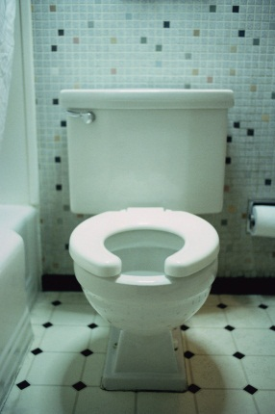
- My arthritis makes it difficult to undress myself in order to use the toilet, push the flush handle or turn the taps to wash my hands. I always need help with these tasks.

- Because I can’t see, someone needs to check whether I have washed and cleaned my hands properly after using the toilet.

- After using the toilet/commode, I need help to put my clothes back on.

Washing and bathing

- My arthritis means I need help to shave, wash my hair and check my appearance. Without help these activities are slow and painful; it can take me up to an hour and I am exhausted afterwards.

- My bad back means I cannot step into, or out of, the bath or shower unassisted.

- Most days I feel too depressed to bother with washing unless someone encourages me and checks that I have done it.

- My mobility and balance are poor and I need to sit while washing my face or brushing my teeth.
Getting dressed or undressed

- The pain in my back and legs means I have difficulty bending to get clothes out of cupboards and drawers. Someone has to help me.

- Chronic asthma means I become very breathless and therefore have to rest between putting on or removing each item of clothing. It can take me half an hour or longer.

- My severe rheumatism means I need help to fasten buttons, zips and laces as it is too painful to do it myself.

- My hands are contorted due to arthritis and therefore I can’t grip fastenings to do them up.

- A few times a week I am in too much pain to want to get dressed unless someone encourages me to.

- Due to confusion they don’t wear the appropriate clothing (for example, not enough clothing on cold days or too many layers on a warm day).

Moving about indoors

- I have very weak legs and can only climb the stairs by putting both feet on each step rather than on alternate steps.

- My arthritis means I can get very stiff sitting in a chair and need to rock to gain the momentum to get to my feet.
- I am very unsteady on my feet and need to hold onto the walls and furniture otherwise I will fall.
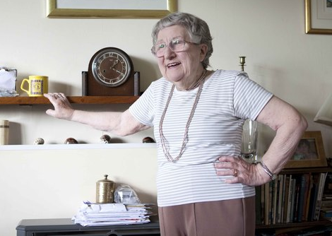
- I suffer from chronic arthritis and also get extremely breathless. When I climb the stairs, I need to take a break half way and sit on them.

- I suffer from dizzy spells and experience them when getting to my feet or trying to go upstairs.

- I get very depressed and often don’t want to do anything. I need encouragement to get up or move around.
Falls and Stumbles
- I have to walk very slowly and hold onto things. I tend to shuffle when I walk. This causes me to stumble frequently.

- I have poor circulation which often results in numbness in my legs causing me to fall.

- I suffer from high blood pressure, which causes dizzy spells resulting in falls.

- My deteriorating eyesight means I knock into things and this also affects my balance causing me to stumble or fall.

- When I fall, I don’t have enough strength to pick myself up and need to call for help.
Mealtimes
- The trembling in my hands, due to Parkinson’s, makes it difficult to eat and drink without spilling.

- Due to my blindness, I need someone to check I am clean after meals.

- Since my stroke, I am unable to use my left side and need someone else to pre-cut my meals.

- The rheumatoid arthritis in my hands makes it difficult to grip cutlery, cut food, open packaging and hold cups for drinking.

- Due to my depression, I have no motivation to eat and need to be encouraged daily to have regular meals.

- Due to their short-term memory loss they forget whether they have eaten and need supervision.
Taking medication
- Due to my deteriorating sight I am unable to read the labels and need someone to set out the correct medication for me.
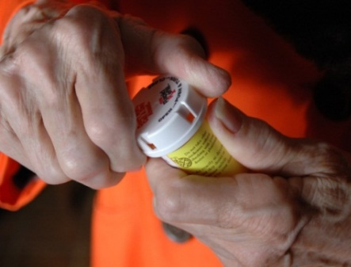
- My short-term memory loss means I need to be reminded several times a day to take my medication.

- My fingers are deformed due to arthritis and I have trouble opening medicine bottles or blister packs.
Communicating with other people
- I cannot see to read, answer letters or fill in forms. Someone must read them for me and write the reply.

- I can’t hear and rely on sign language to communicate so I cannot use the phone or hear the doorbell.

- My speech is slurred due to a stroke and I have difficulty being understood when talking to anyone who does not know me well.

- My deafness means I have problems trying to communicate with unfamiliar people and therefore often have problems asking for help when needed.

- As a result of short term memory loss, they find it difficult to hold a conversation because they forget the topic of conversation and start talking about something else.

- Due to mental illness, they would find it difficult to cope in unfamiliar surroundings and with unfamiliar people.
Help at night
- I sleep on four pillows to keep upright in bed as this helps ease the breathing problems caused by my asthma.

- I sometimes get very confused and forget things. I don’t always realise when the bedclothes fall off the bed, and therefore do not pull them back on. I need someone to do this for me.

- Due to my mobility and balance problems I have a commode by my bed at night. I am not able to empty or clean this myself because of my arthritis.
Supervision to keep me safe
- I get confused and don’t always know what time of day or night it is. About 5 times a week I will make seemingly random phone calls to my family at unusual hours if someone isn’t with me to provide reassurance.

- I have problems with my blood pressure which makes me light headed when I stand up. Sometimes I get dizzy and fall so I need someone to keep an eye on me.

- I forget to eat regularly; sometimes I forget to drink. I need someone to prompt me to do these things.

- I hear voices which upsets me. I need to have someone I know tell me everything is ok.

- Each night I need to get up to go to the toilet. My wife has to listen out to make sure I get there and back to bed safely.

What happens next?
Once your claim has been received by the DWP it will be assessed and processed. This can take 6-8wks or more. The decision is based mainly on the application form and supporting documents you submit. Sometimes the DWP will contact your GP or other professional named in the form for further information. Face-to-face assessments are extremely rare. Once a decision has been made you will receive a letter from the DWP confirming your entitlement. This will also explain how you can challenge the decision if you are unhappy with it.
For further information, contact Age UK Wiltshire on (insert details) or visit (insert your website details)

