About Age UK Exeter
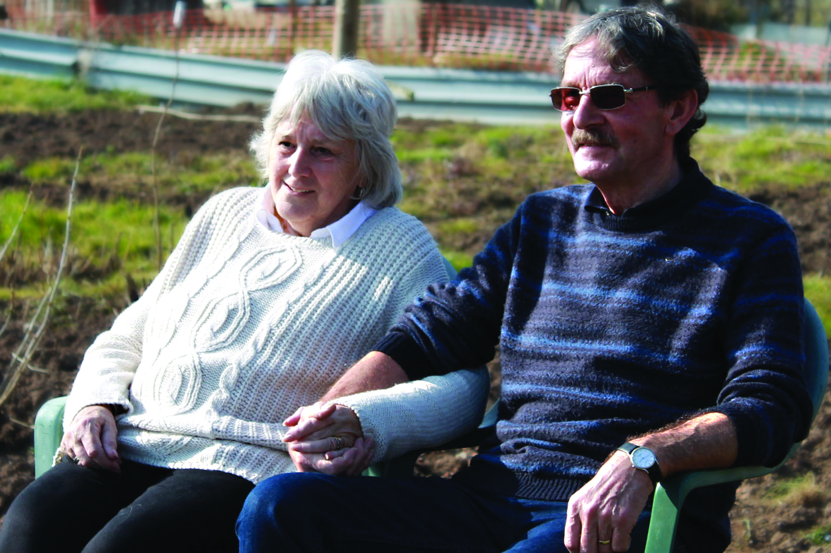
Established in 1987, Age UK Exeter is an independent charity with its own locally elected board of trustees and part of the Age UK network. The charity makes a positive contribution to the lives of over 1,000 older people in Exeter every week. Based at its main centre in Cowick Street, Age UK Exeter actively designs services that meet the wants and needs of local older people and their families by:

- tackling loneliness and isolation
- promoting health, wellbeing and independence
- supporting families and carers
- helping people access services and financial benefit entitlements
- enabling people to get the most out of life.

The charity’s services include:
- day services for older people who are physically frail or have a dementia both at
St Thomas and Mount Pleasant
- information and advice on all issues of relevance to older people plus help to claim the benefits to which people may be entitled
- befriending, telephone support, social groups and activities that build friendships and social networks
- health promotion activities and support for people to manage their long-term health conditions
- one-to-one support to help people stay independent at home and access local shops and services
- providing time off to carers of older people
- working as part of a multi-disciplinary team on the acute medical unit of the RD&E hospital to support people being discharged home
- a ‘Men in Sheds’ project providing meaningful activity for older men with a range of needs.
Age UK Exeter employs a team of over 120 paid staff and its work is supported by approximately 270 wonderful volunteers. The culture of the organisation is one that puts people first and the charity enjoys high staff morale and good staff retention. Age UK Exeter has a strong board of trustees who, as well as providing good governance, work closely with the senior management team on matters of strategy and direction.

Age UK Exeter works to improve later life for everyone in Exeter by providing life-enhancing services and vital support.

