|  |
| --- |
| AGE UK EXETER |
| Controlled Document  Document Name: Handling Clients’ Money and Assisting in the Management of their Financial Affairs  Document Reference Number: POL1  Document Version Number 10  Agreed by Standards Committee on: 5 March 2018  Approved by Board of Trustees on: 13 March 2018  Review Schedule Every two years  Next review due March 2020  Owner (Responsibility) Services Manager  Pass amendments to: QA & Systems Manager  Revision History See appendix  Document Location Idrive/Resources/ Policies/Pol1 |
|  |
| Document Description  This document outlines the policies and procedures which should be followed by staff when handling clients’ money or assisting them to manage their financial affairs. |
|  |
| Implementation and Quality Assurance  Implementation is immediate and this Policy shall stay in force until any alterations are formally agreed.  The Policy will be reviewed every two years by the Board of Trustees, sooner if legislation, best practice or other circumstances indicate this is necessary.  All aspects of this Policy shall be open to review at any time. If you have any comments or suggestions on the content of this policy please contact Sue Martyr, [s.martyr@ageukexeter.org.uk](mailto:s.martyr@ageukexeter.org.uk) or at Age UK Exeter, 138 Cowick Street, Exeter,  EX4 1HS, 01392 455600 |

**Policy for Handling Clients’ Money and   
Assisting in the Management   
of their Financial Affairs**

**Policy Statement**

Age UK Exeter aims to promote and maintain the independence of its clients in all aspects of their lives, including where appropriate to provide support to them in managing their finances. This support is normally provided as part of our Enabling Service.

Where such support is needed and is identified within the clients’ Care Plan, it is essential that good practice is implemented and observed, in order to promote trust and avoid disputes, misunderstanding or suspicion.

Other staff, may occasionally be involved in handling clients’ money and will refer to the relevant sections of this policy.

In delivering all its services, Age UK Exeter understands that it has a responsibility to protect its clients from financial abuse and also to ensure that our staff are clear about the correct procedures and requirements for dealing with individuals’ financial affairs.

The policy and procedures are designed to protect both the people who use our services, and our staff. Any failure on the part of Age UK Exeter staff to observe this policy in full may result in disciplinary action.

**Financial Affairs**

The Client Information Sheet (CIS) (see appendix 1) is developed as part of the Enabling Service’s assessment with him/her and also reflects the outcomes identified in their My Plan. It will clearly record the level of support the client requires in dealing with their financial affairs, if any. The CIS is subject to regular reviews.

Where support is required to manage financial affairs, handle cash or collect pensions, a financial permissions form (Gen 33) will be completed, signed and uploaded to the client record.

**Handling cash**

When cash changes hands the member of staff will count it in front of the client and complete a receipt immediately, which will be signed by the client and the worker and handed over. Change will be noted and initialled on the same receipt. Cash will be taken from or given into the client’s hands wherever possible, especially if the client has poor sight. If cash does need to be taken from a purse etc. then this should be done in conjunction with the client.

The client’s money will always be kept separately from the worker’s own money and from that of any other client. Staff are responsible for keeping clients’ money safe whilst it is in their possession and may be required to reimburse any unexplained losses. Age UK Exeter receipts are used for every transaction involving a client’s own money or bank/building society/pension cards with the top copy being left with the client, the blue copy being returned to Age UK Exeter’s office and the pink copy being retained by the worker. Shop, cashpoint, post office or bank receipts will also be provided to the client. Please also refer to the Enablers’ Handbook and guidelines.

**Collecting pension/benefits**

Wherever possible, the member of staff will support the client to undertake these activities themselves. If this is not possible, we recognise that this involves staff being given access to highly confidential information such as account names, balances, PIN numbers etc. Staff will follow Age UK Exeter’s procedures in order to protect themselves and the organisation from any potential allegation of wrongdoing and to ensure the client’s trust in the service.

Staff will undertake pension or benefits collection, or any other financial transaction such as paying bills only where there is a current and signed financial permissions form (see Appendix 2) in place (see above). However, where a client requests one-off support, (for example if they are unwell and unable to go with the member of staff to collect their pension), the staff member will use their receipt pad to record permission to take the card and pin number, and will call into the office to report this within three working days. A financial permission form will then be completed to cover any such future activities.

**Shopping and paying bills**

When taking a client shopping forms part of the service, staff will observe the following:

* Where a choice of shop is available, it is the responsibility of the client to make that choice and in no circumstances will staff direct them to any particular shop/outlet without their agreement*.*
* Where a particular shop/outlet is used on a regular basis it makes sense to take advantage of any loyalty cards, bonuses or promotions that may be on offer. Assistance should be given to clients in taking advantage of such offers, although staff will ensure that all advantages fall to the client.
* Where special offers exist such as ‘Buy one get one free’ or ‘extra points’ the member of staff will ensure that as with all other shopping opportunities, the benefits fall only to the client if they wish to take up such offers. .
* In circumstances, for example, where the client indicates that the member of staff may benefit from any special offer or promotion, then such an offer will be respectfully declined.

If shopping on behalf of the client without them being present, the member of staff will agree a shopping list with the client in advance. Staff will never:

* overspend and ask the client to reimburse them
* withdraw more money than the client specifically authorised
* present their own store reward cards when paying with the client’s money.

An Age UK Exeter receipt will be used to log cash given to the member of staff, and change returned. Shop and till receipts will also be provided for all purchases.

**Paying bills**

If paying a bill on behalf of a client who is not present, an Age UK Exeter receipt will be signed by the client indicating the amount of cash provided to the worker to do so. On their return a separate receipt will be provided by the worker from the shop or organisation that received the money in settlement of the bill.

If staff are asked to ‘top up’ gas, electric, mobile or other cards on behalf of a client who is not present, the same applies as above. Staff will only take those cards with them that are required, they will not take whole wallets or card holders.

If the client provides a member of staff with cash or a cheque to pay an Age UK Exeter invoice, an Age UK Exeter receipt will be completed with the white copy going to the client (ideally stapled to the client’s part of the invoice), the blue copy to be placed into one of the envelopes provided, along with the cash or cheque and remittance advice, in front of the client. The envelope should then be handed in to reception at Age UK Exeter’s offices in Cowick Street, unopened.  The receptionist will initial the pink copy to confirm receipt which should then be kept by the member of staff for their records.

**Money, valuables and property**

Where a member of staff is concerned about cash or valuables being stored in the house (for example large amounts of cash left out in view), they will suggest to the client that they may wish to take some precautions. They will also notify the Service Co-ordinator who will record the concern and, if appropriate, take the matter up with the client or their representative.

Age UK Exeter’s staff will never take charge or look after any item of property or money even if the client wishes it. Such requests will be drawn to the attention of the Service Co-ordinator.

**Providing support for the client to manage their finances**

Where specified in the Care Plan, and ensuring that a financial permissions form has been signed and uploaded, staff will support clients to manage their financial affairs. This is an enabling role, and will **only be undertaken alongside the client, and with their direction**. The client must have the capacity to do this. In no circumstances whatsoever will a member of staff act as if they have Power of Attorney. Staff will let the Service Co-ordinator know if they have been asked to undertake any financial task that would require them to act independently of the client, and the Service Co-ordinator will clarify this with the client and/or their representatives.

Staff will not remove paperwork from the client’s house although there may be limited circumstances (for example to seek advice from our I&A manager, or to make a call that wasn’t possible during the visit) that it would be appropriate.

In no circumstances will a member of staff retain such paperwork, or copies, unless they have the explicit permission of the Service Co-ordinator and the reasons for doing so have been recorded. Refer also to Age UK Exeter’s Data Protection policy.

**Use of client resources**

Age UK Exeter’s staff are not permitted to use the client’s property for their own use. Such prohibitions include, but are not limited in any way, to:

* use of the client’s telephone (landline or mobile)
* use of the client’s PC, computer or internet facilities (unless in the course of duties (e.g. home shopping for the client) and with their permission
* use of the client’s car or other transport.

Additionally, Age UK Exeter will not take any unauthorised person including children or pets into the client’s home without the prior permission of the user and the Service Co-ordinator in very exceptional cases.

**Business transactions**

Age UK Exeter staff will never enter into any business transactions either with, or on behalf of, a client. Such transactions may include:

* mail order purchasing, and acting as ‘Agent’
* lottery or pools syndicates
* holiday clubs
* savings schemes.

This list is indicative and not intended to be exhaustive. Under no circumstances whatsoever will an Age UK Exeter worker enter into any kind of financial liability on behalf of the client, nor will they act as guarantor for any kind of hire purchase agreement or commitment.

**Selling of goods and services**

Age UK Exeter staff are prohibited from:

* selling anything to the client
* buying anything from the client
* selling anything belonging to the client .

**Witnessing documents**

Age UK Exeter staff will not act as witnesses to legal documents without prior permission from the Service Co-ordinator, who will record any such decisions with reasons on the client record.

**Loans**

Age UK Exeter staff will never borrow from or lend to clients in any circumstances. Any such requests will be reported to the Service Co-ordinator so that they can clarify the service with the client.

**Giving advice**

Beyond general assistance, staff will never give advice on financial matters, even if asked. Age UK Exeter’s Information and Advice department will be able to give specialised benefits advice if appropriate, or signpost to other appropriate organisations.

**Incapacity to manage personal finances**

If a client’s capacity to make decisions relating to the use of their cash or finances causes concern or has changed, the member of staff will bring it to the attention of the Service Co-ordinator who will take appropriate action.

**Confidentiality**

All aspects of a client’s financial affairs are strictly confidential, and no member of staff will disclose any detail to a third party. This does not prohibit a member of staff from appropriately raising any concern or query with their line manager.

Please refer to the Confidentiality Policy for further information on confidentiality.

Reference should also be made to the Acceptance of Gifts and Legacies Policy.

**Induction and training**

All Age UK Exeter staff receive a full induction both into the organisation and into their specific role. They will receive and sign for the organisation’s policy book, and other handbooks or procedures applicable to their work. They will have the opportunity to talk through the policies and to ask questions.

Enabling staff are given the opportunity to shadow established workers as part of their induction.

Enabling staff attend update meetings, which are usually held every two months, where practice issues are discussed and peer learning takes place. They receive regular emails to ensure they are up to date with any changes or developments in procedures.

Enabling staff attend an annual mandatory safeguarding refresher (delivered in-house) and are invited to other training opportunities as appropriate.

**Observance/Investigations**

All Age UK Exeter staff are expected to adhere to this policy. Situations will arise, however, when suspicion may fall on the member of staff when something is broken, money goes missing etc. Age UK Exeter takes all such instances seriously, and will make appropriate investigations. If, in the opinion of the Senior Management Team of Age UK Exeter there is evidence that some financial irregularity has or may have taken place, or the member of staff’s honesty is being questioned, then an investigation may be undertaken as part of Age UK Exeter’s disciplinary processes. In such cases it would be normal for Age UK Exeter to suspend the member of staff without prejudice whilst the matter is being investigated and formal disciplinary hearings held. Support will be offered to the member of staff during that period.

Where there is reasonable cause for belief that a worker may have done anything that might harm the client, including financial harm, Age UK Exeter is required to refer the matter to the DCC Safeguarding Team and may be required to notify the police.

Please refer also to our Managing Allegations policy and procedure.

**Revision History**

|  |  |  |
| --- | --- | --- |
| **Revision date** | **Summary of Changes** | **Other Comments** |
| 4 July 2016 | New policy written (versions 1 to 8). Discussed by the Standards Committee at its meeting on 4.7.16 | Recommended to the Board for approval. |
| 12 July 2016 | Reviewed by the Board of Trustees. | Approved.  Due for review July 2018 |
| 13.10.16 | Minor tweaks and inclusion of appendices following input from Quality Improvement Team. |  |
| 5.3.18 | Routine review by Standards Committee | Recommended to the Board for approval. |
| 13.3.18 | Approved by Board of Trustees | Due for next review  March 2018 |

**Appendix 1**

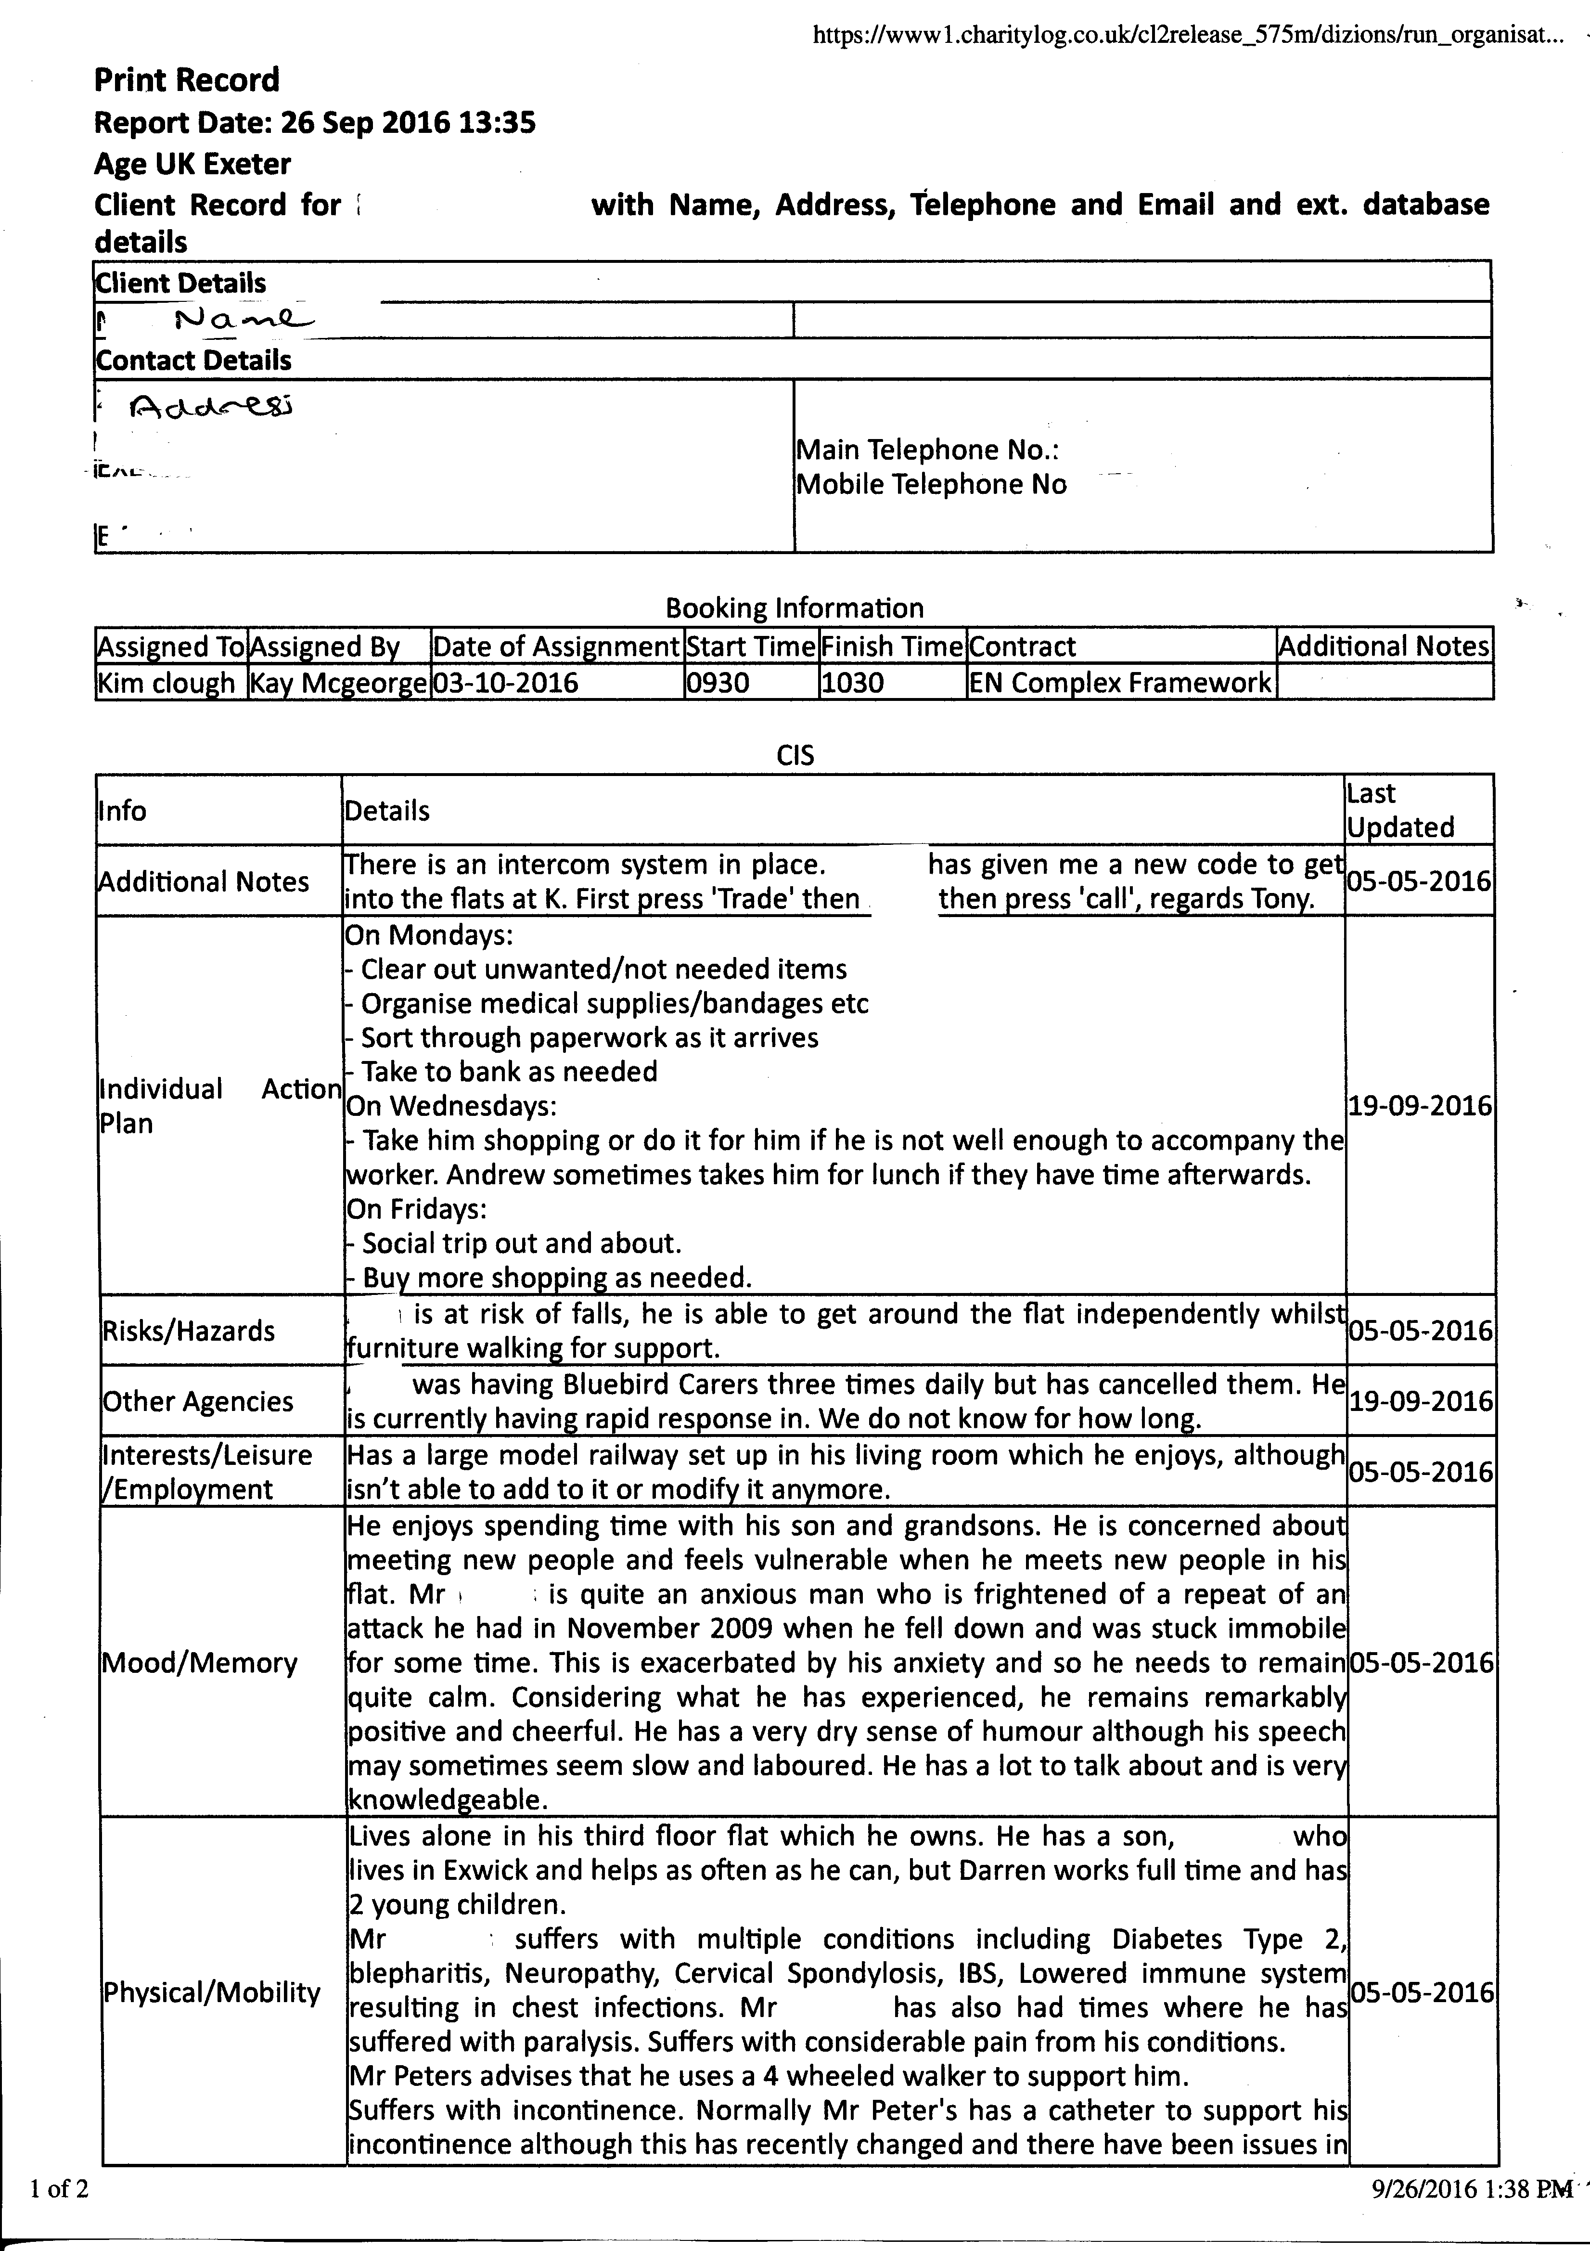

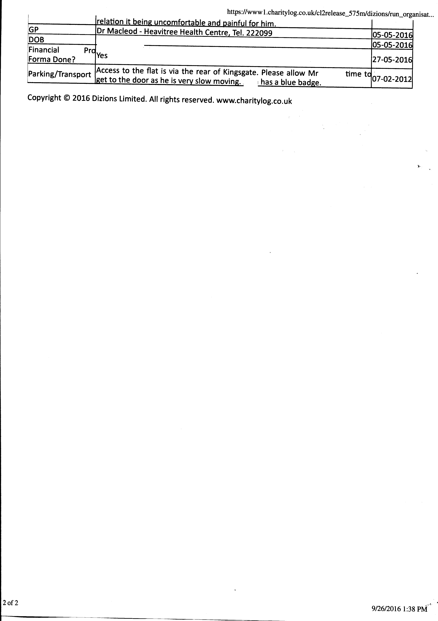

**Appendix 2**

**Enabling and Sitting / Escort Service**

**Name of client ___________________________**

I agree and give permission that my regular worker _____________________ or other occasional replacement workers employed by Age UK Exeter, is able to: *(please tick all that apply)*

make cash withdrawals on my behalf from the cash point using my debit card. In order for them to do so I give permission for my Age UK workers to know my card’s pin number

withdraw my pension on my behalf, using my pension card. In order for them to do so I give permission for my Age UK workers to know my card’s pin number

handle cash on my behalf for the payment of bills and for shopping.

I understand that receipts will be provided for all transactions

assist me in managing my paperwork and finances

I understand that a record will be kept by the workers of every withdrawal made; and that receipts will be provided, so that they can be satisfactorily reconciled against my bank statements.

I understand that if I have any concerns about the service I receive, or if I would like to request any additional tasks or changes to the service, that I can ring Karen Brooks or   
Tony Harvey at the office on 01392 202092

Signed:_____________________________________ Date: _______________________

Regular worker signature:______________________ Date:_______________________

This arrangement will be reviewed on an annual basis.