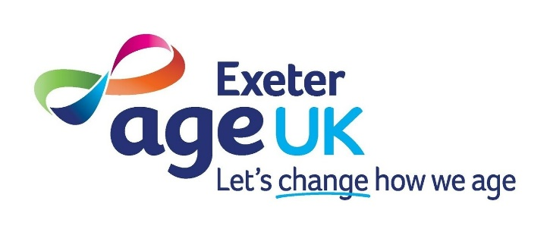

Community Café Volunteer Role Description

Role & Service | Community Café Volunteer – Outreach
Purpose of Service | To offer a welcoming community space for people to catch up with friends and enjoy light refreshments prepared in house.
Place of work | Sycamores, Mount Pleasant Road, Exeter, EX4 7AE
Role Supervisor | Penny Unitt
Day & time | Monday 10am -1.30pm
What we need from you: | - Have a warm and friendly personality  - Committed and reliable  - Willingness to complete role relevant training  - You must be 18+ to undertake this role
What we offer you: | - A very warm welcome  - Good induction with role relevant training  - Reimbursement of travel costs  - Free on-site parking
How to apply/ more information: | You will need to complete a volunteer application form. This can be done via our website www.ageukexeter.org.uk or by ringing Exeter 01392 202092 to request a form. Please ask to speak to the Volunteers Officer if you have any questions about the role.
What will happen next: | You will be invited to attend an informal interview. We will then request 2 references, and a DBS application will be made.
Main Tasks of Volunteer Role

- To support with setting up the room – laying tables, arranging chairs
- To help serve light refreshments
- Help with clearing up at the end of service
- Provide a warm, friendly environment for guests

Disclosure and Barring Service (DBS)

This post is covered by the Rehabilitation of Offenders Act 1974. We only ask applicants to disclose convictions which are not yet spent under the Rehabilitation of Offenders Act 1974. If you are not sure whether your convictions are spent, please contact Nacro for further advice. If successful in being invited to interview, you will be asked to fill in our Criminal Record Declaration Form, which will be confidentially returned to our HR and Finance Manager. We guarantee that the information you provide will be used fairly and will only be seen by those who need to see it as part of the recruitment process.

A person’s criminal record will not, in itself, debar that person from being appointed to this role. Suitable applicants will not be refused roles because of offences which are not relevant to, and do not place them at or make them a risk in, the role for which they are applying. All cases will be examined on an individual basis. However, failure to reveal this information could lead to the withdrawal of an offer of employment, a role as a volunteer, or disciplinary action.

If you are the chosen candidate for this role, it will be subject to a satisfactory basic DBS check.

Health and Safety
All volunteers have responsibility for their own health and safety and for that of others who may be affected by their acts or omissions. Volunteers are required to adhere to all health and safety regulations, guidance and procedures at all times.

Confidentiality
All volunteers are expected to respect confidentiality in relation to Age UK Exeter business, client and service user data.

