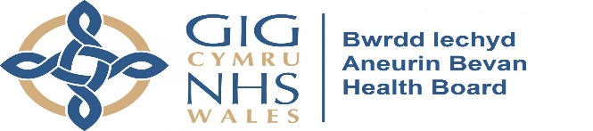
WORKING IN PARTNERSHIP WITH

Dear Doctor/Podiatrist

Your patient has given consent for us to make contact with you as they wish to use our toe nail cutting services. This service provides simple toe nail cutting following the guidelines of the Society of Chiropodists and Podiatrists. Our staff have attended foot care awareness sessions provided by Aneurin Bevan Health Board Podiatry Service.

We are currently unable to provide a toe nail cutting service to the following patient groups:-

Ischemia Corticosteroids (oral-long term), Rheumatoid Arthritis (on long term steroids),
circulatory problems (immune suppressants), those on Warfarin, or who suffer
ingrown toe nails.

- We are able to offer treatment to “low risk” diabetic patients who have been assessed as having – No Neuropathy or foot complications by their Doctor/Podiatrist.
- All diabetic patients taken on will require written confirmation of no changes on an annual basis.
- We are not able to offer treatment to Warfarin patients.
- We may treat rheumatoid arthritis patients after assessment by a Podiatrist if they do not have foot problems and are not taking steroid tablets long term.
- Doctors who wish a patient to be treated by Age Cymru Gwent Choices who are immune suppressed are asked to confirm this in writing.
- We may treat some patients who have leg ulcers after we receive a letter from the doctor confirming there are no other problems.
- The Assessment Form incorporates a patient disclaimer stating that they accept full responsibility for their treatment.

Patient Name |  |  |  | REF
Patient Address
Postcode |  | Tel No
Doctor Name:
Surgery Address
Post Code |  | Tel No

To the best of my knowledge and belief this patient (please tick appropriate box):
Is “low risk” diabetic | YES | NO
Is NOT on Warfarin | YES | NO
Is NOT on long term steroids | YES | NO
Does NOT have any circulatory problems (Ischemia) | YES | NO
Is NOT diagnosed as immune suppressed | YES | NO
Does NOT suffer from ingrown toe nails | YES | NO

GP Print Name: |  | DATE:
GP Signature:

Please return completed form to:
Age Cymru Gwent Choices, Beaumont House, Bloomfield Road, Blackwood, NP12 1QB
Email: helpathome@agecymrugwent.org Telephone: (01495) 360159

Age Cymru Gwent is a registered Charitable Incorporated Organisation, RCN 1155903

