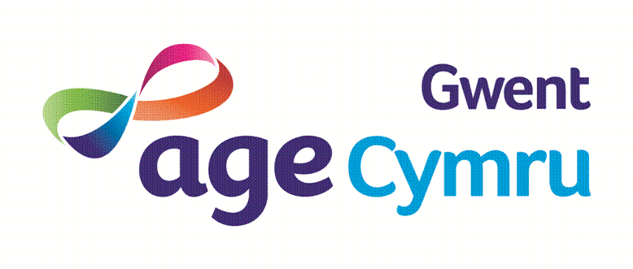

**Who We Are**

Age Cymru Gwent has been a leading Older Persons Charity in the delivery of innovative and quality services for over 50 years within Gwent.

Last year was the busiest in our history and we are looking to continue growing and providing life changing support to people in need. We provide a wide range of services across the five local authorities of Gwent. We are an independent charity working in partnership with the wider Age UK/Age Cymru network.

**The Opportunity**

We're looking for dedicated, passionate people, of all ages, with a range of professional and life experience, to join our Board of Trustees. As a trustee, you’ll help set our direction, provide governance and oversight to make sure we’re always doing the best we possibly can to fulfil our objectives to supporting Older People in Gwent.

Its responsibilities:

* Setting the overall strategic direction of Age Cymru Gwent.
* Work in partnership with the CEO and Senior Leadership Team.
* Provide governance oversight to ensure compliance with charity law and good governance
* Safeguard the charities assets, including responsibility for financial sustainability

The Board meets four times a year but also has three committees supporting the work and an annual strategic away day. We are looking for someone with a legal or healthcare background.to complement our existing skills and diversity.

**How to Apply**

Please send a CV and short covering letter outlining your interest in the role and the skills you would bring to the Chief Operating Officer, Gail Gordon via email to: [g.gordon@agecymrugwent.org](mailto:g.gordon@agecymrugwent.org)

If you require any further information this can also be requested by email.

The deadline for applications is 27th June.