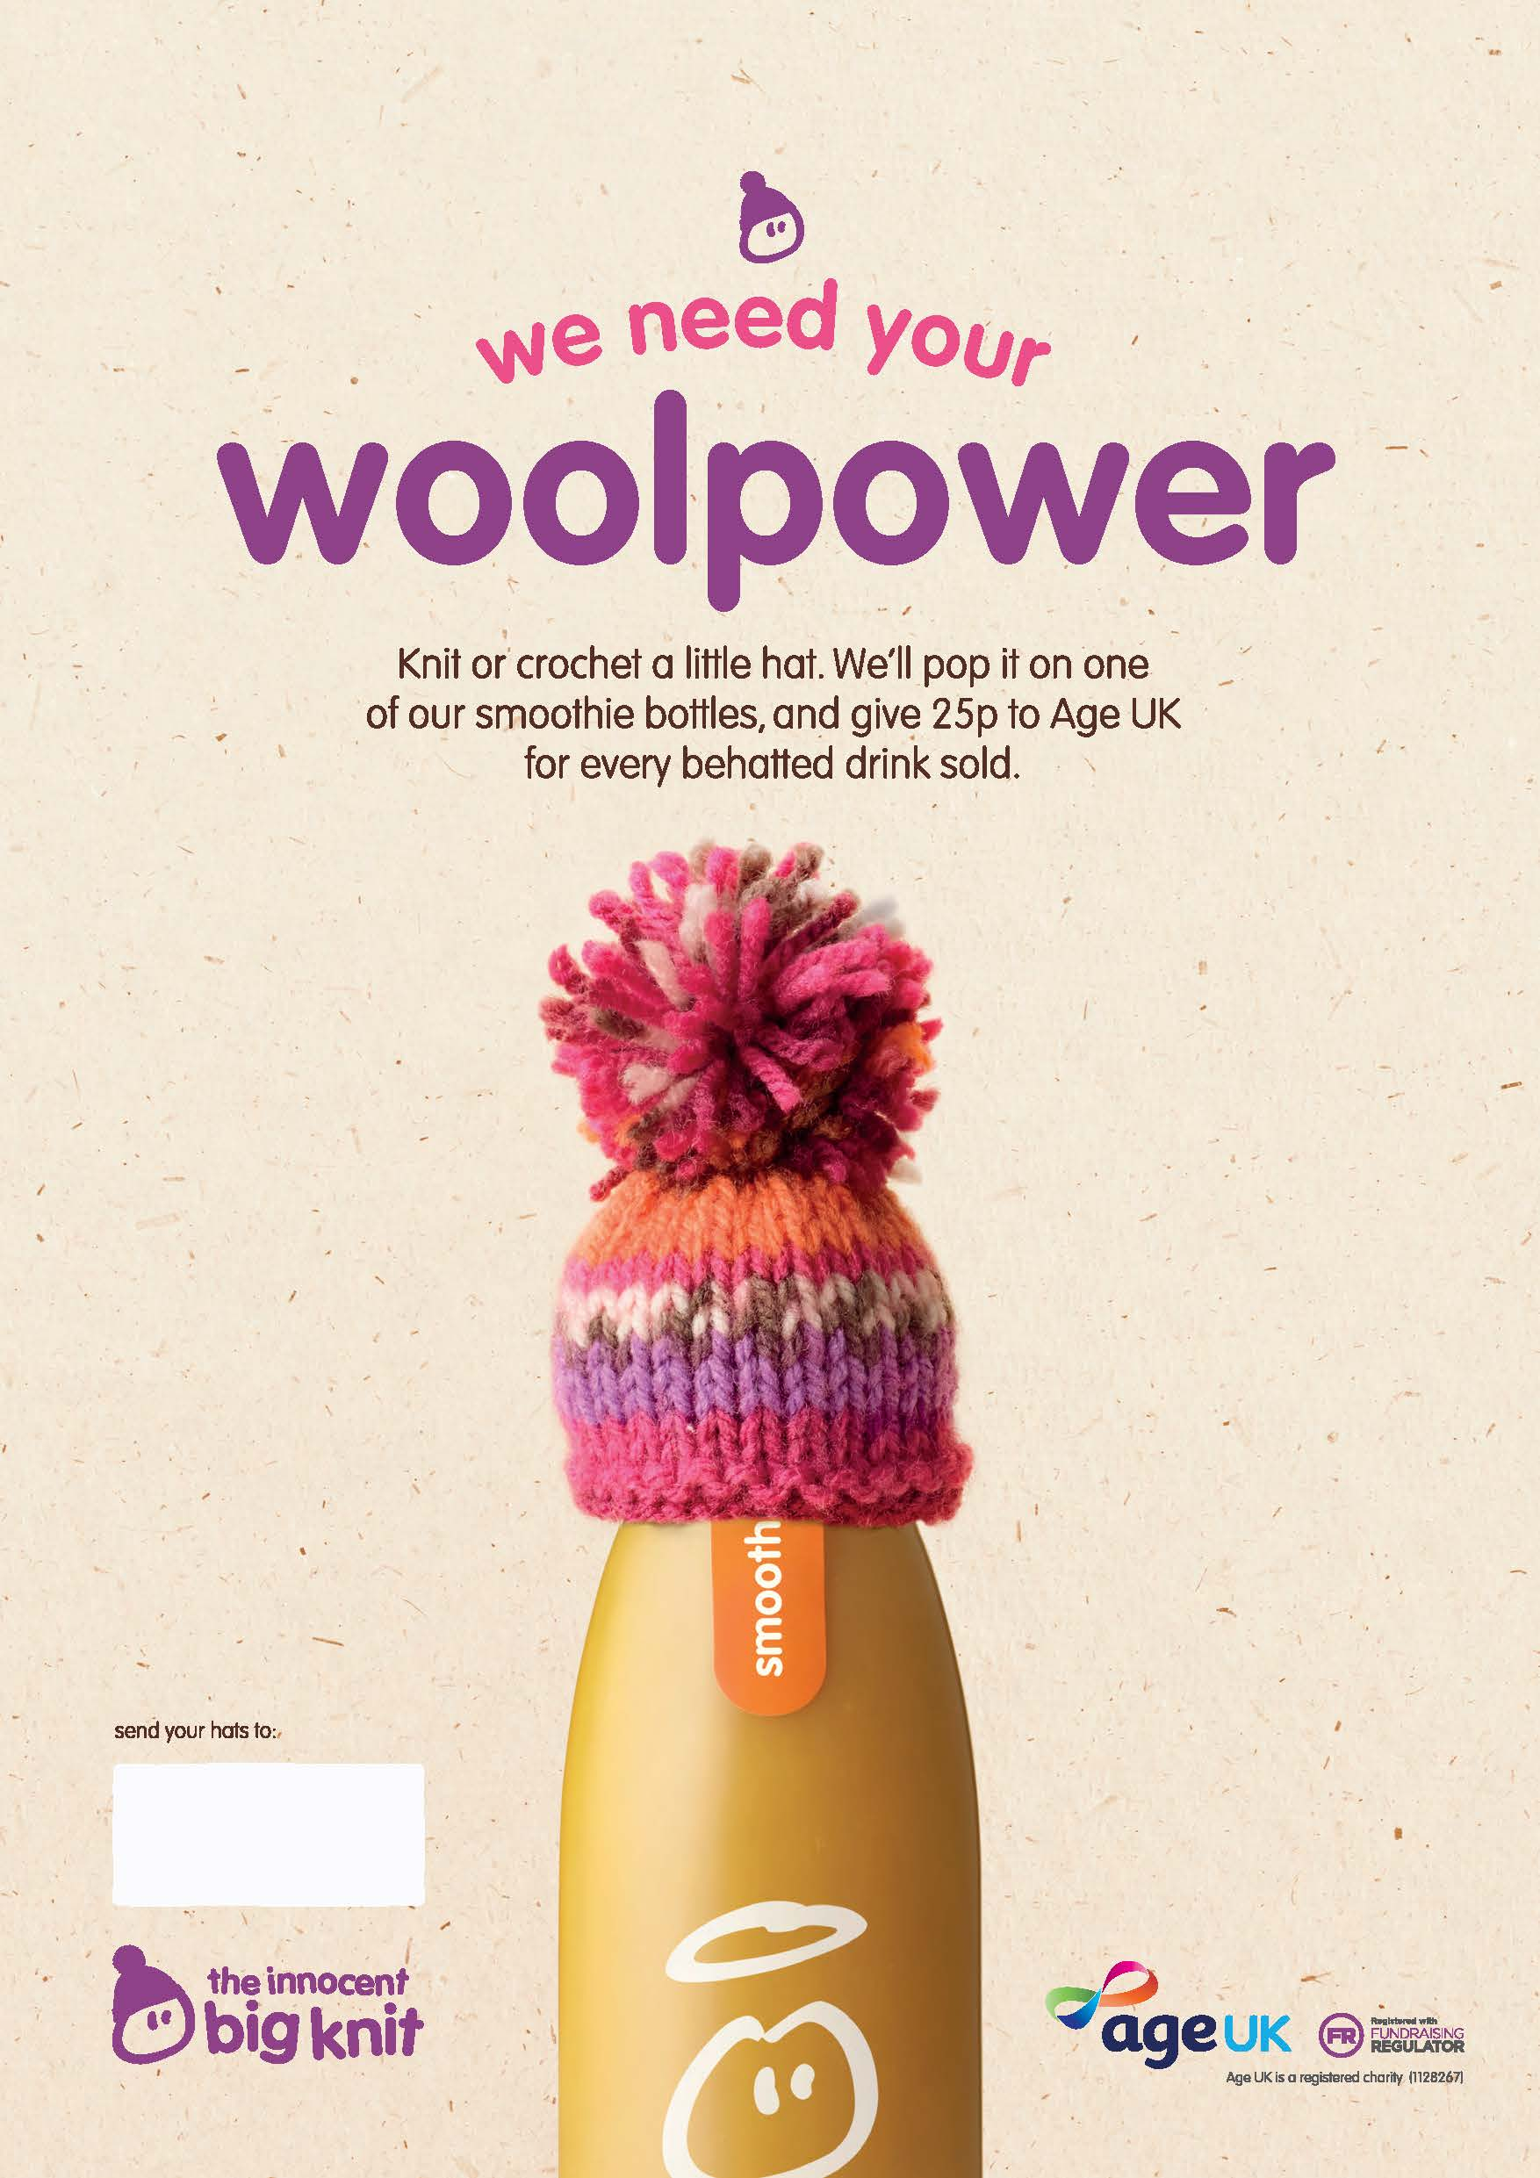
Big Knit 21 Age UK H&W
Malvern Gate
Bromwich Road
Worcester
WR2 4BN
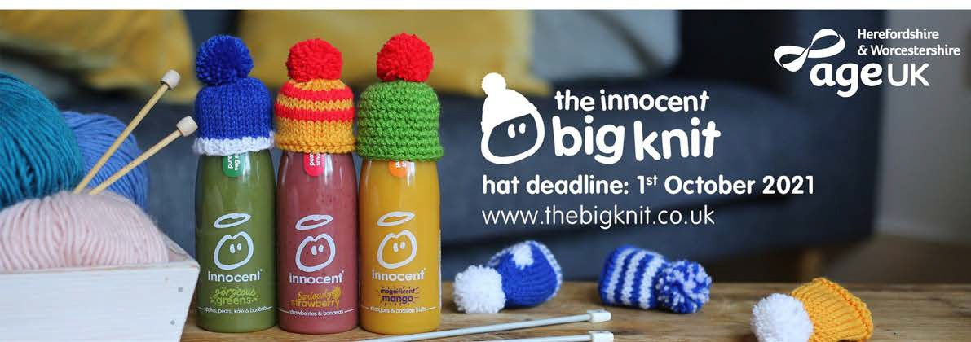 The Big Knit is back!
you've knitted and contact details so we can send you a thank you!
Ensure to enclose your name, how many hats

Join us for this year's Big Knit campaign by knitting mini hats!
The 2020/2021 campaign is underway and we need your help to get to our target of 6000 hats!
How you can get involved:
- Grab your knitting needles and any colour wool

- Follow the big knit patterns to make your creations

- Once you’ve completed your hats, send them in the post to our Malvern Gate office. If you wish to be contacted about future Big Knit campaigns including a thank you letter to let you know the outcome of this year’s campaign, complete the consent form in this pack.

- You can also drop your hats in our Big Knit box at Sainsburys St Johns in Worcester. Please be sure to pop them in a bag or envelope and let us know how many you have dropped off by contacting us.
1. Grab your knitting needles and any colour wool

2. Follow the big knit patterns to make your creations

3. Once you've completed your hats, send them in the post to our Malvern Gate oﬃce.

44.. You can also drop your hats in our Big Knit box at Sainsburys
St Johns in Worcester. Please be sure to pop them in a bag or envelope and let us know how many you have dropped oﬀ by contacting us.

Find out more on our website or by contacting us:

www.ageukhw.org.uk
www.ageukhw.org.uk
0800 008 6077

Post to:
Big Knit 21 Age UK H&W Malvern Gate
Bromwich Road Worcester
WR2 4BN

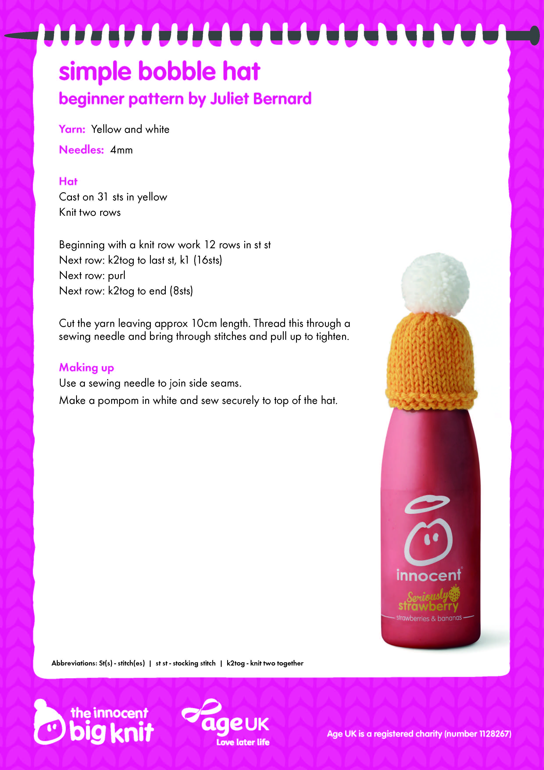
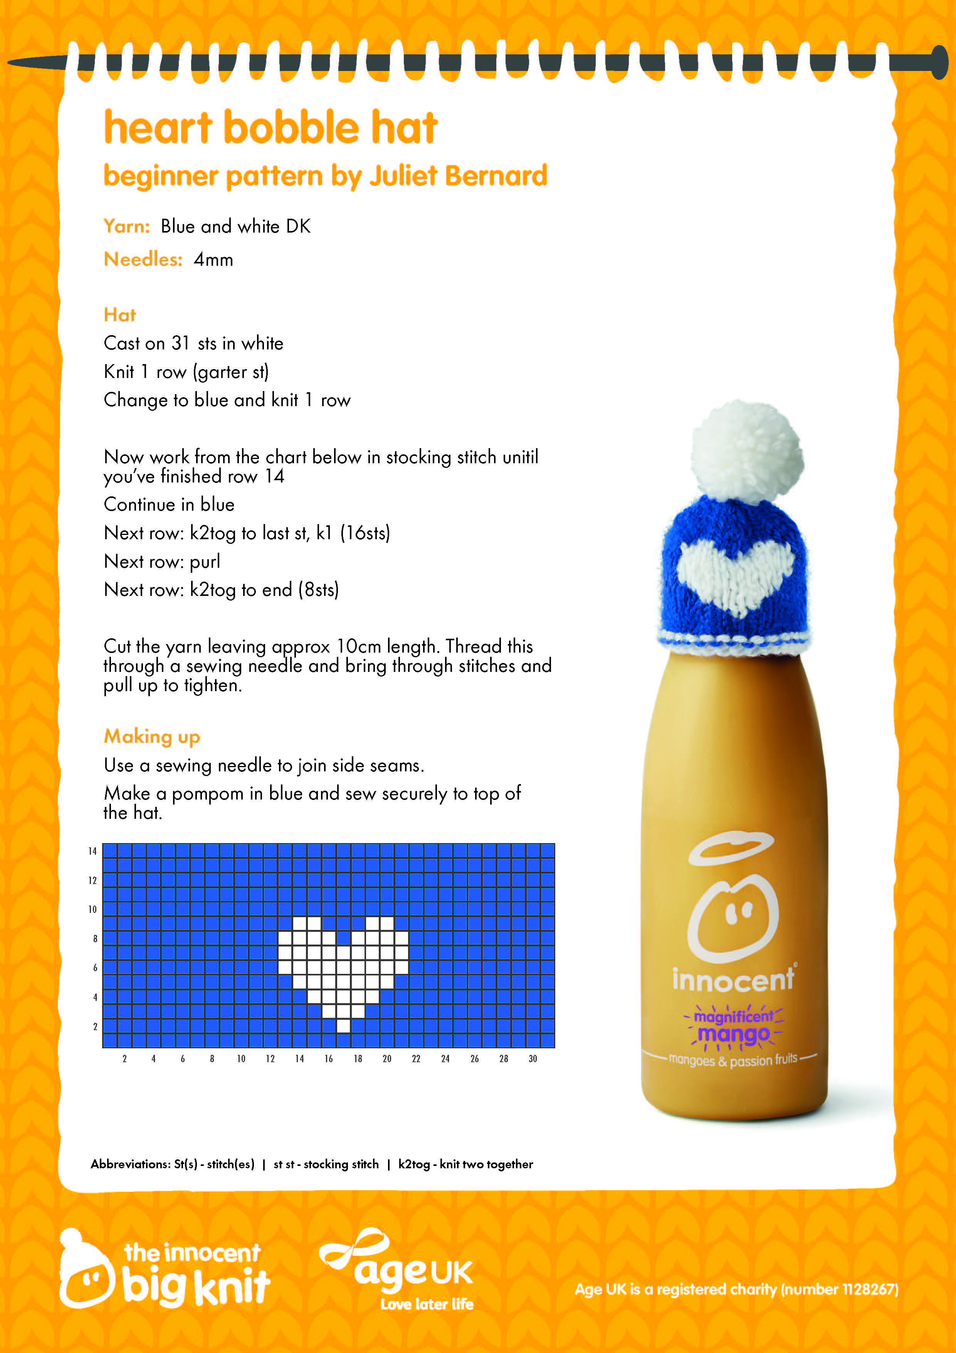
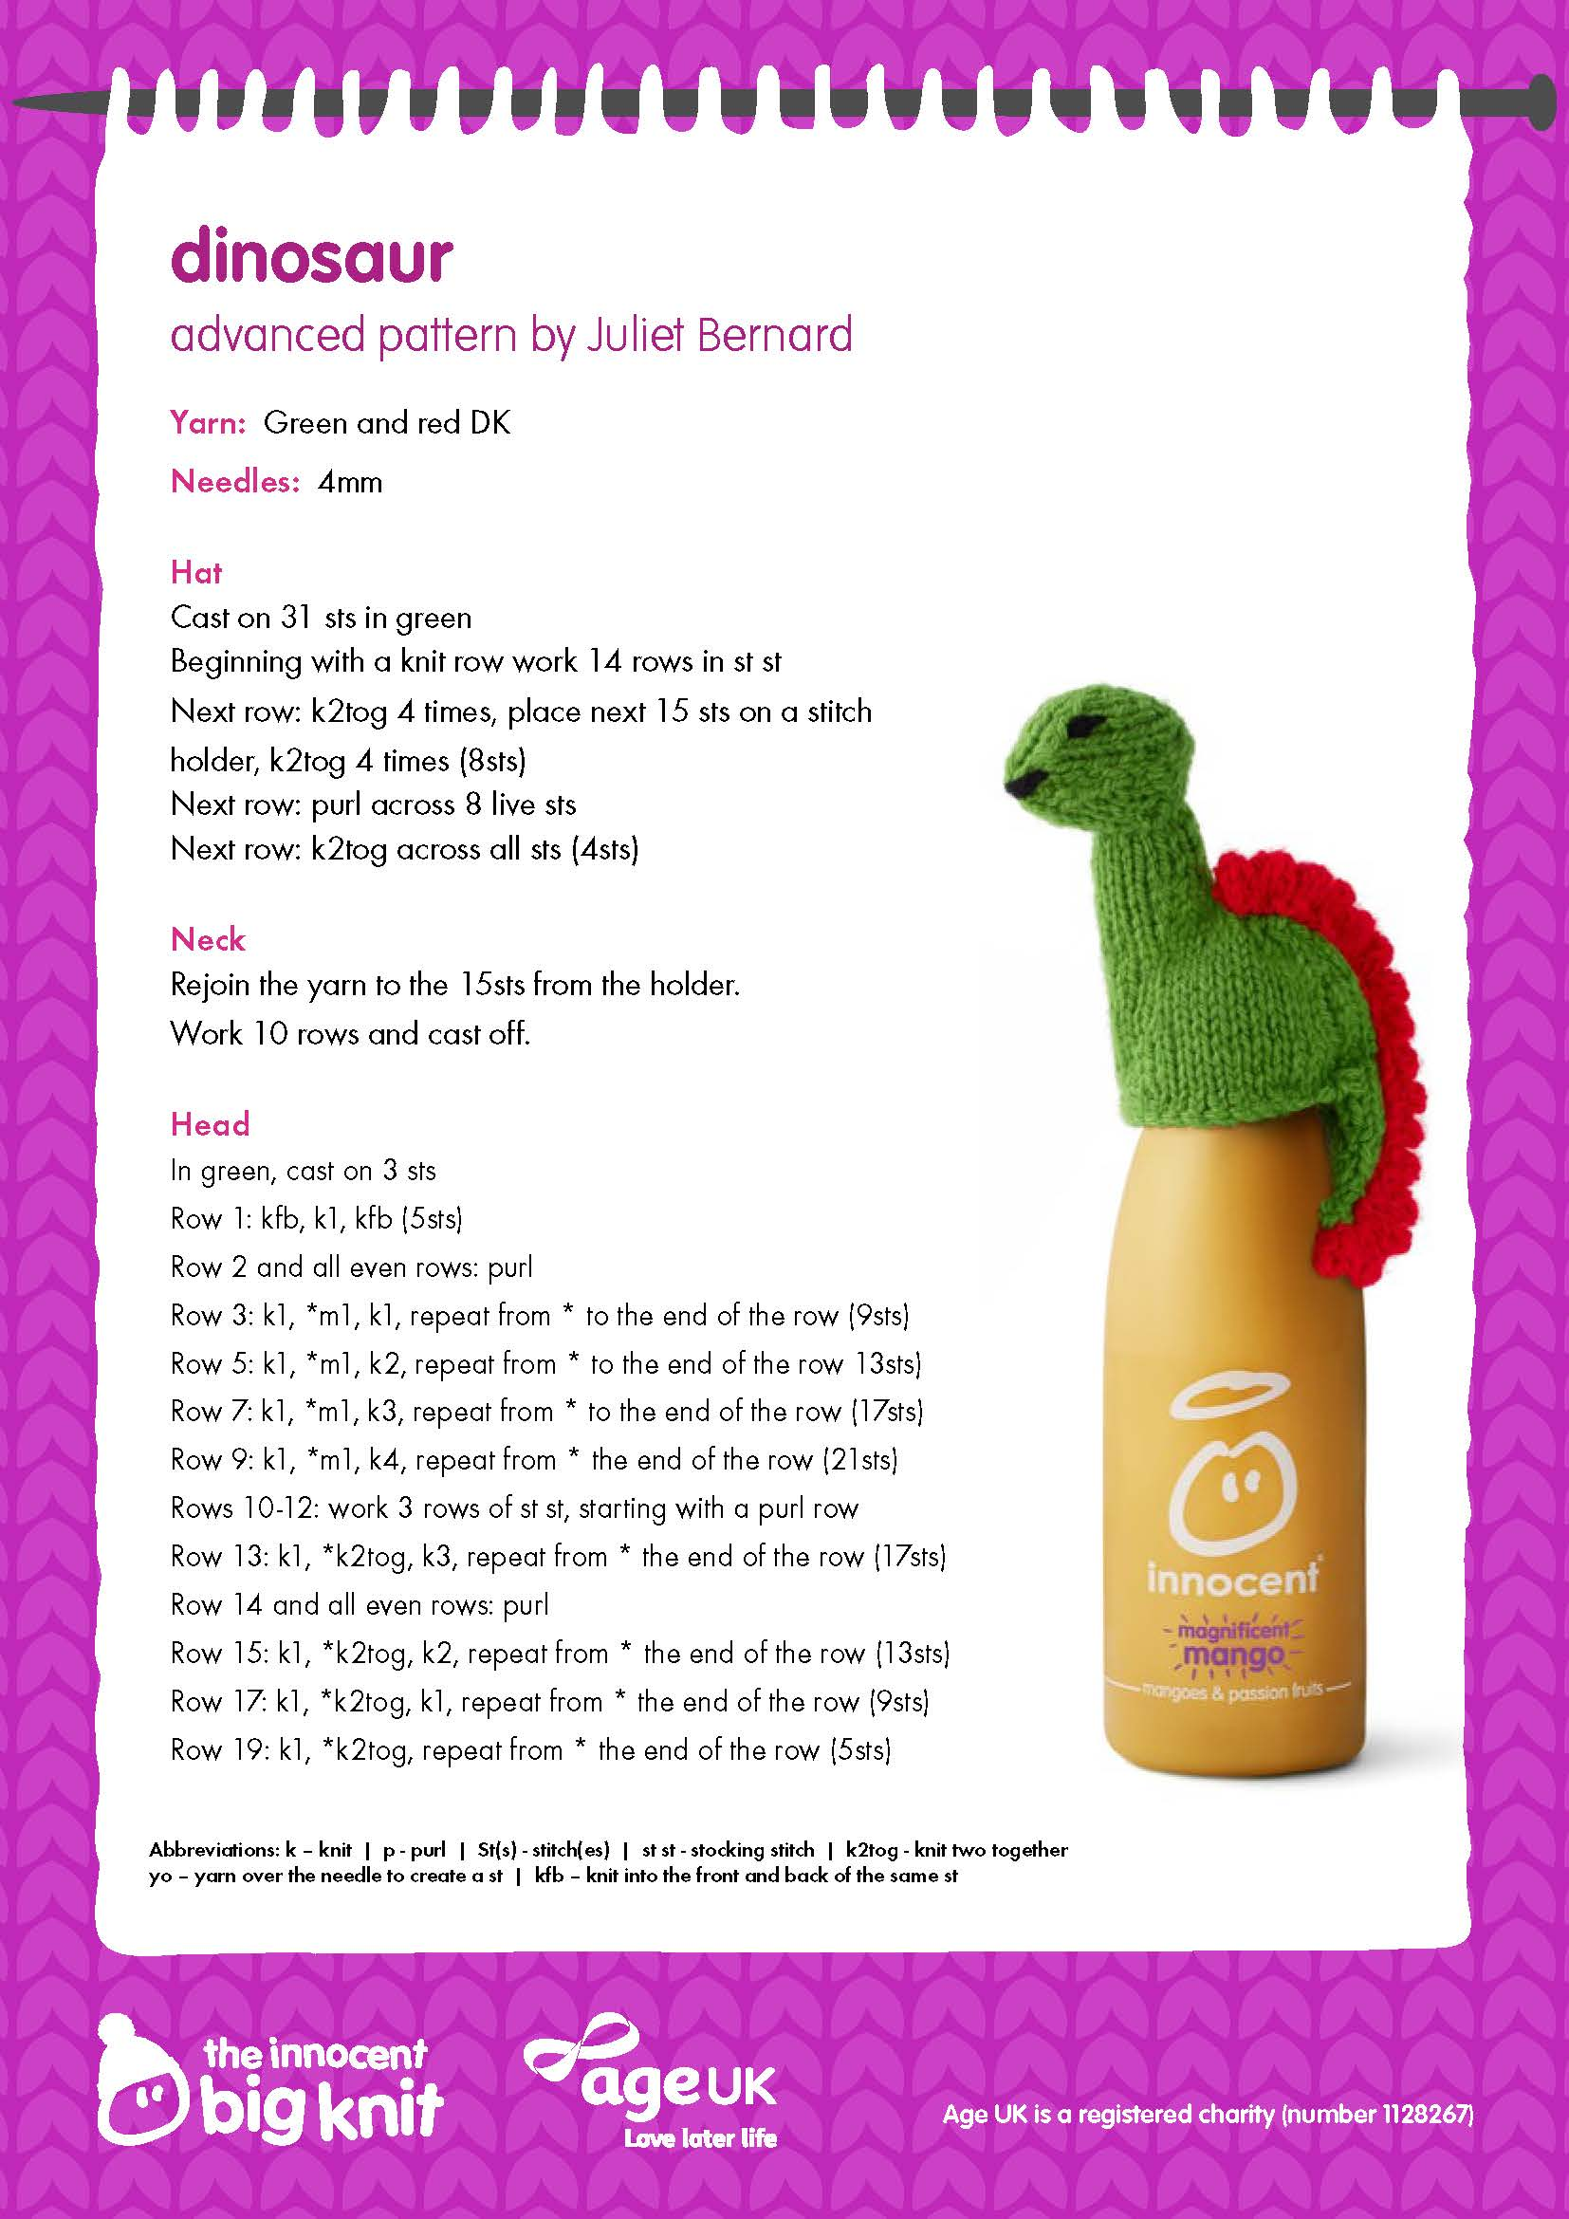
Find more Big Knit patterns here:
www.thebigknit.co.uk/knitting-patterns

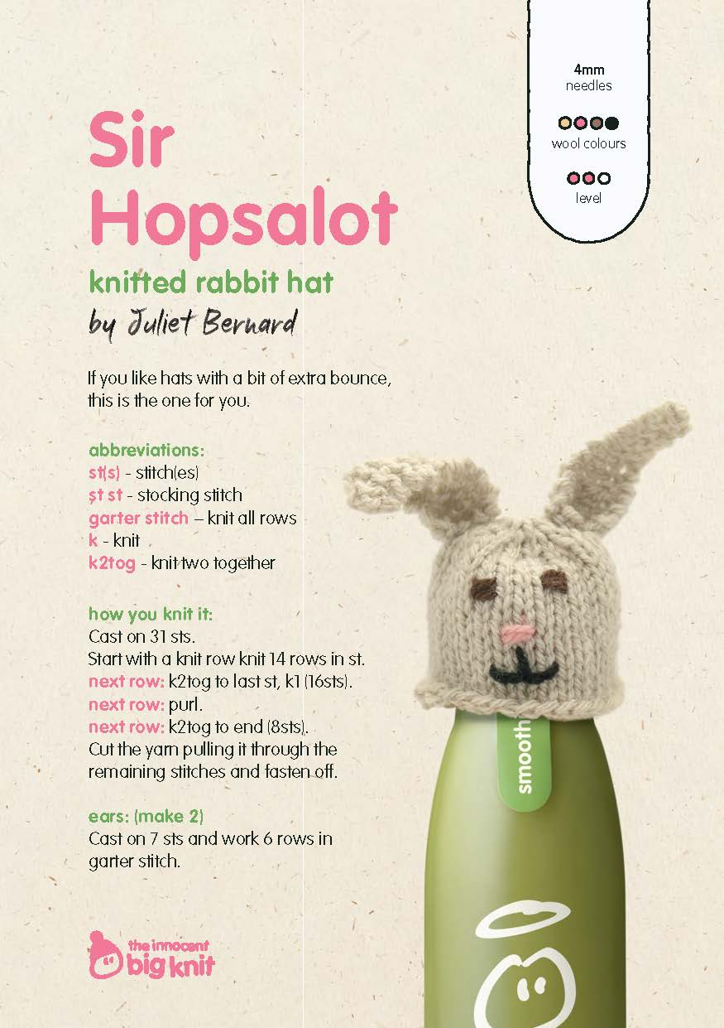
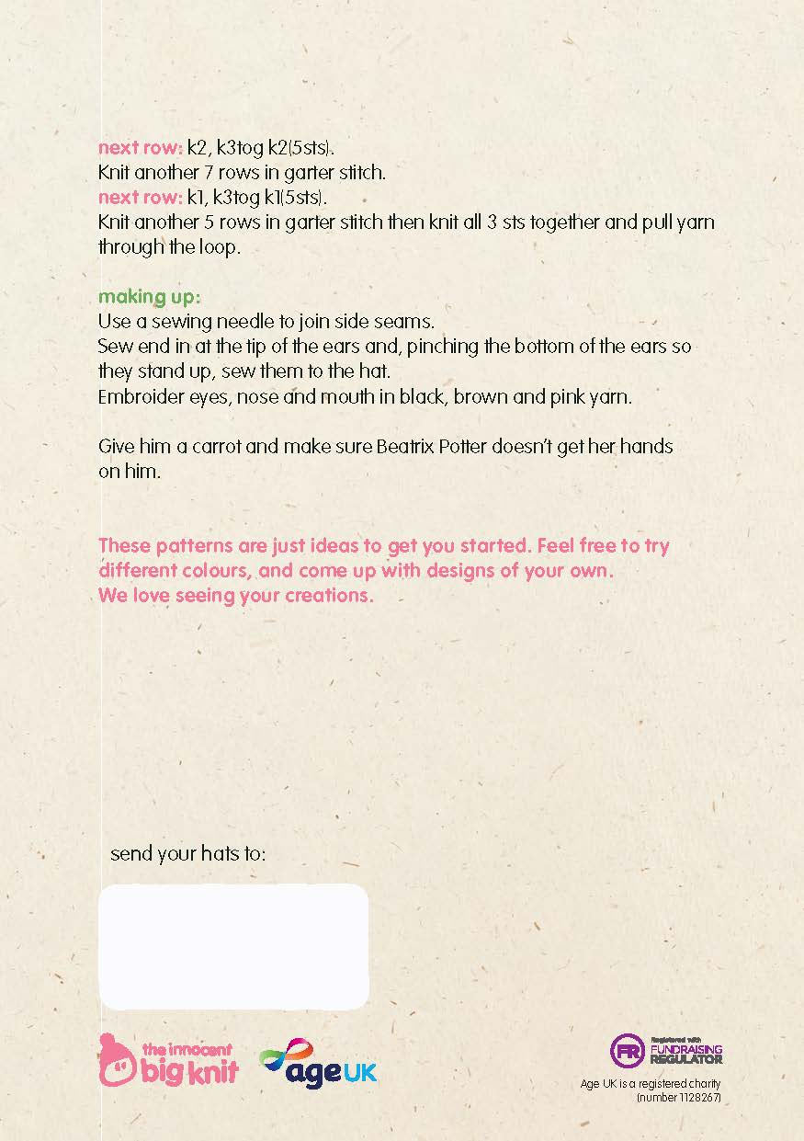
Big Knit 21 Age UK H&W
Malvern Gate
Bromwich Road
Worcester
WR2 4BN
Age UK Herefordshire & Worcestershire –
The Big Knit consent form

If you would like to be kept up to date about future Big Knit campaigns please complete the form below.
Return your form by either emailing it to: marketing@ageukhw.org.uk Or by post to:

FAO Big Knit, Age UK Herefordshire & Worcestershire, Malvern Gate, Bromwich Road, Worcester, WR2 4BN
*Please note we can’t send you a thank you for your hats if you chose not to complete the below form.*

Full Name: | Full Address:
Email: | Contact number:

Please advise us of the best way to contact you by ticking the applicable boxes below:

Post
Telephone
Email

Age UK Herefordshire & Worcestershire (Age UK H&W) will use the information you have provided to keep in touch with you about our Big Knit campaigns. All data will be stored securely in line with GDPR and the Data Protection Act 2018.

Age UK H&W would like to keep you informed of other news, events, activities and services we provide. If you are happy for Age UK H&W to keep in touch, please tick yes or no below.

Yes No

If you wish to be removed from receiving any communications, please contact Age UK H&W: E: marketing@ageukhw.org.uk
T: 0800 008 6077
You can view our Privacy Statement on our website here
If you would like a copy of the statement in the post please get in touch with us.

www.ageukhw.org.uk

