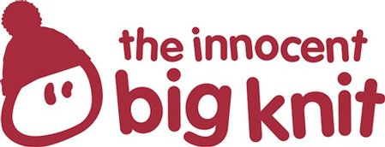
the Big Knit 2018-19
Elf Hat
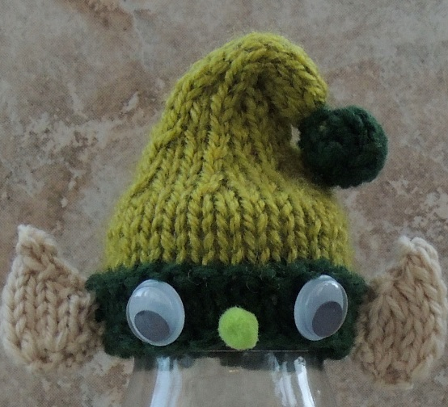
Colour A
Using 4mm needles cast on 28 stitches
Starting with a K row, work 3 rows in SS
Next row: Knit
Colour B
Starting with a K row, work 6 rows in SS
(K2, K2tog) repeat to end
SS 3 rows
(K1, K2tog) repeat to end
SS 3 rows
(K2tog) repeat to end
SS 7 rows
Change back to Colour A
SS 6 rows
B&T tightly.
Ears - Make 2
Cast on 5
Increase K wise into every st.
Starting with a P row, SS 3 rows.
Dec 1 st each end of every row until 2 stitches remain.
B&T tightly.
Making Up
Oversew the row ends together. Put a few ends of wool into the bobble, gather around the bottom edge and sew to the side of the hat as illustrated.
Fold the ears in half with the right side out. Oversew the row ends together and stitch an ear to each side of the hat. Sew a little pom pom in place for the nose and stick on two googly eyes
http://www.thebigknit.devonartist.co.uk/Elf.html
Please send your completed hats to:
Age UK Herefordshire & Worcestershire, Malvern Gate, Bromwich Road, Worcester, WR2 4BN (and include a reply name and address)
THANK YOU!

