the Big Knit 2018-19
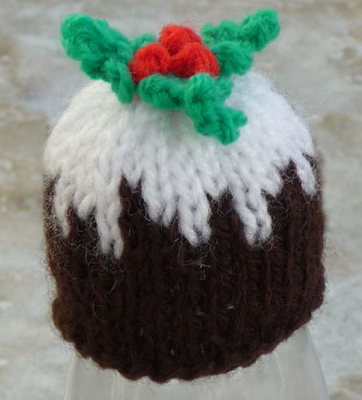
Christmas Pudding Hat
(W = white, B = brown)
Pudding
Using 4mm needles cast on 28st in B and P2 rows
Continue in SS and work 5 rows.
Next row: (1W, 1B, 1W, 4B, 1W, 2B) repeat to end
Next row: (1W, 1B, 1W, 2B) repeat to end
Next row: (3W, 1B, 2W, 1B, 2W, 1B) repeat to end
Next row: 4W (1B, 9W) repeat to end
SS 3 more rows in white
(K2 tog) repeat to end
(P2 tog) repeat to end
B & T tightly
Holly Leaves - use 3.25mm needles
Cast on 1 in green. * inc in this one stitch
# K into front of st and put the created st back on the needle. Cast off 1, K1. Repeat from # twice. K2 tog. ^
Repeat from * to ^ to create 2nd leaf, cut off the wool to leave 40cm and thread this through the last stitch and down the leaf to the centre.
Pick up a loop in the centre and repeat from * to ^ to create the 3rd leaf using the 40cm of wool. B&T.
Make up
Sew up the row ends of the pudding. Sew the holly leaves to the top of the pudding.
Use 50cm of red wool - doubled in the needle to create 3 french knot, berries, I found 4 winds around the needle ideal. But substitute with red beads if you don't like doing french knots!
http://www.thebigknit.devonartist.co.uk/Pudding.html

Please send your completed hats to:
Age UK Herefordshire & Worcestershire, Malvern Gate, Bromwich Road, Worcester, WR2 4BN (and include a reply name and address)
THANK YOU!

